**5 Step by Step Instructions to run first basic Selenium Program**

1. Install Java and Set Java Home Path in System variables
2. Install Eclipse and Create new Maven Project with Selenium Dependencies
3. Understand creation of WebDriver object and its related classes
4. Run the First Selenium WebDriver Program with Browser Invocation
5. Different ways of setting Browser Driver executable files.

**What can Kind of Interview Questions I can expect from above Concepts?**

1. **What is Interface in Java?**

An interface is a group of related methods with empty bodies.

Its class responsibility to implement the methods declared in the Interface

When class agreed to implement the interface, they must need to provide implementation/bodies to all the defined methods in Interface

In simple terms, Interface enforces the Contract to class to follow.

2. **WebDriver is an Interface which provides Set of Browser Automation methods with empty bodies (Abstract methods)**

Classes like ChromeDriver, FirefoxDriver, MicrosoftEdgeDriver , SafariDriver etc implement the WebDriver Interface

and provide their own implementation to the WebDriver methods

3. **We need to create the object of the class to access the methods present in the class.**

ChromeDriver driver = new ChromeDriver ();

driver object here has access to all the methods of Chrome driver

WebDriver driver = new ChromeDriver ();

driver object here has access to the methods of Chrome driver which are defined in web Driver Interface

Selenium Web Driver Locators

* As part of Automation, Selenium Performs actions (such as click, typing) on the Page HTML Elements.
* The Locators are the way to identify an *HTML* element on a web page.   
  Selenium WebDriver uses any of the below locators to identify the element on the page and performs the Action

ID

Xpath

CSS Selector

name

Class Name

Tag Name

Link Text

Partial Link Text

<input type="text" placeholder="Username" id= “inputUsername” value=" ">

Input -> tag name

Red-> attribute   
Green-> attribute associated value.

**Css Selector-**

* **Class name -> tagname.classname ->** Button.signInBtn -> .error
* **Id -> tagname#id** -> input#inputUsername
* **Tagname[attribute=’value’]**

<input type="text" placeholder="Username” value=" ">

Input [placeholder=’ Username’]

* **//Tagname[@attribute=’value’]:nth-child(index). - Child items**
* **Parenttagname childtagname**
* **input[type*='pass'] – CSS**
* **tagname**

**Xpath –**

* **//Tagname[@attribute=’value’]**

**//input[@**placeholder=’ Username’’]

**<input type="text" placeholder="Name">**

**//input[@**placeholder=’ **Name’**]

* **//Tagname[@attribute=’value’][index]**
* **//parentTagname/childTagname**
* **//button[contains(@class,'submit')]. – Regular expression**
* **//tagname**
* **//header/div/button[1]/following-sibling::button[1]**
* **//header/div/button[1]/parent::div**

# EXAMPLES of SELECTORS

1. **mixed examples:**

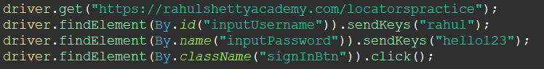

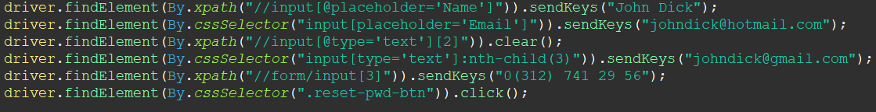

1. **Mixed 2:**

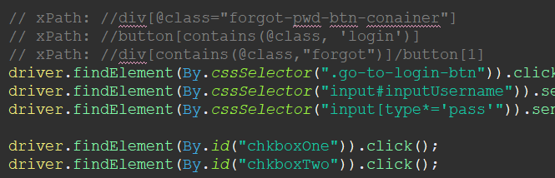

1. **website:**

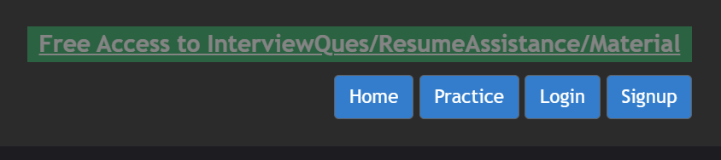

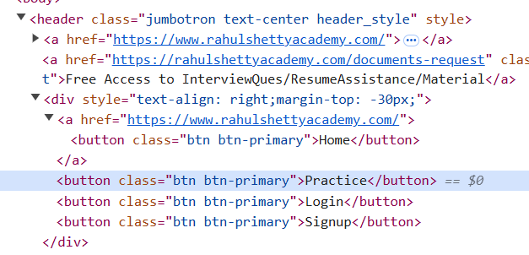

**xpaths and results:**

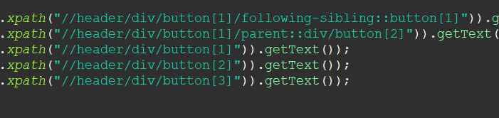 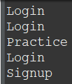

1. **static dropdown menu selection.**

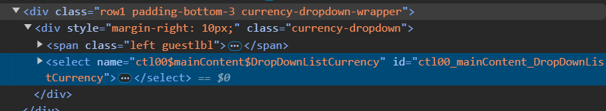

**CEVAP:**



1. **select according to text**

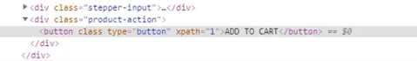

**CEVAP:**

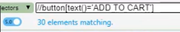 **--> 30 elements... so?**

1. **Parent to child traverse:** I need to reach h3 but there are also h3 in other placeses. So I give the parent name which is unique, then reach the child.

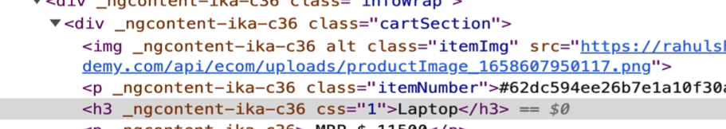

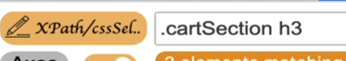



1. **Select childs:**

last-child, nth-child(), nth-last-child(), first-of-type, nth-last-of-type

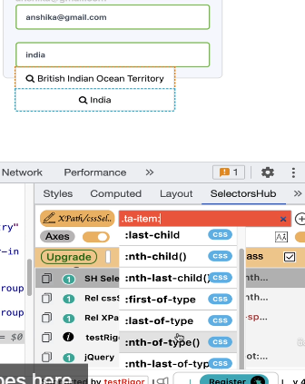



1. **df**
2. **df**

Interview Question -

**Core Java Basics needed to Get started with Automation –**

* **Variables & Data types in Java**
* **Working with Arrays**
* **Loops & Conditions**
* **Strings and its functions**
* **Importance of Array Lists**
* **Array list operations and conversion of Array to List**
* **Declaring Methods**
* **Accessing Methods in class & Static keyword**

**Note: Rest all topics are present in the last 2 sections of this course.**

# Section 7 – Selenium Webdriver -> Techniques to Automate Web Elements

Static Dropdowns

Dynamic Dropdowns

Autosuggestive Dropdowns

In this section, this website is used for tests:

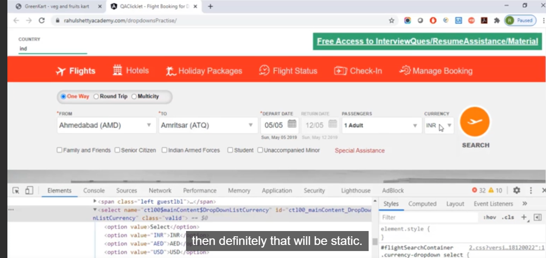

## 52. Static Dropdowns as in Currency...

Selection of dropdowns...

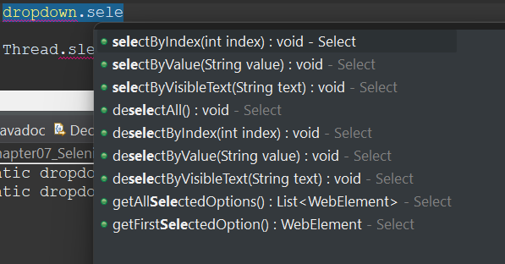

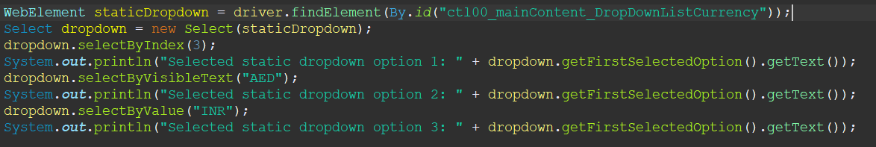

## 53. Updated Lecture on Latest Dropdown looping UI...

## 54. Handle Dynamic Dropdown

- if you use a one page app, some items does not appear on the screen if you don’t click a specific button or link. So, the reference only appears in specific conditions. It is called Dynamic!

## 56. Parent Child Locators

To Get rid of indexes, we can use parent child relationship

First select the whole section like this: (For parent xpath)

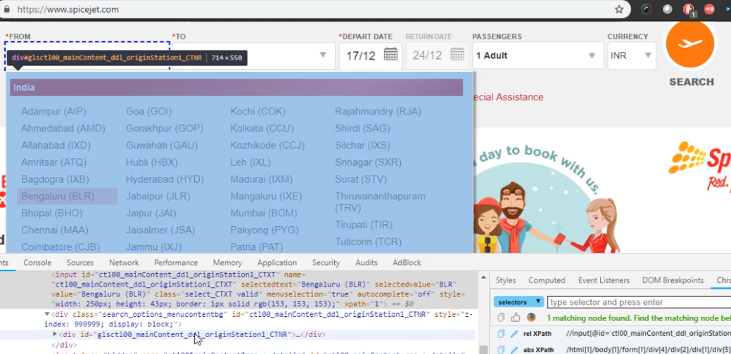



Then use this: (parent // child)

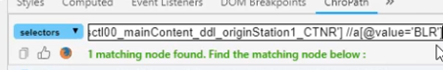

## 58. Handling Autosuggestive Dropdowns

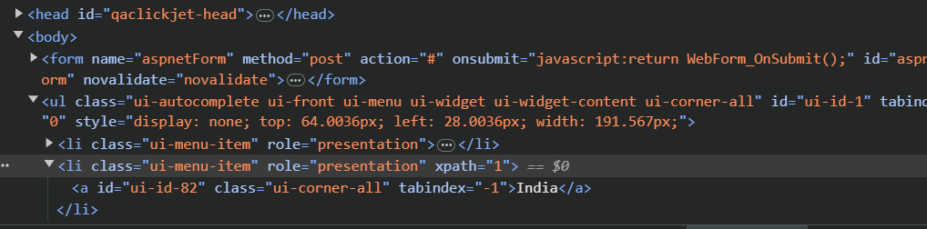

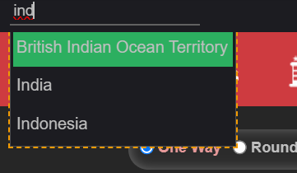

css Selector: ul[id='ui-id-1'] li:nth-child(2)

xpath: //ul[@id='ui-id-1']//li[2]

## 60. Handling Checkboxes and How to Get the Size of Them

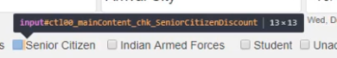



System.***out***.println(driver.findElements(By.*cssSelector*("input[type='checkbox']")).size());

this gives 6 in the current website

Note: I had a problem in making the code work. In the testing browser, it clicked the checkbox, but isSelected was false. Idk why... :s

## 60. Importance of Assertions and How to Use Them

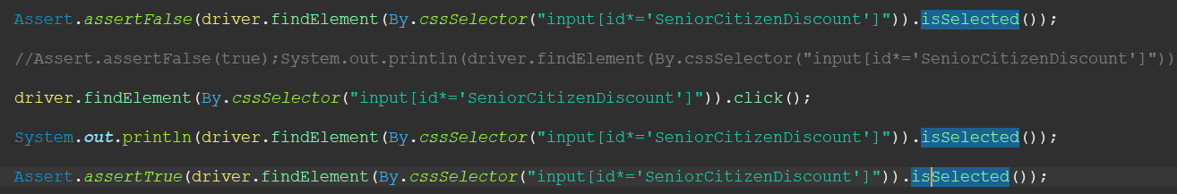

AssertTrue(true);

AssertFalse(false);

AssertEquals(actual, expected);

TESTING FRAMEWORKS:

TestNG

Junit

## ASSIGNMENT:

Navigate to Below URL:

<https://rahulshettyacademy.com/AutomationPractice/>

**There are 3 Checkboxes displayed in the Page. Refer below image**

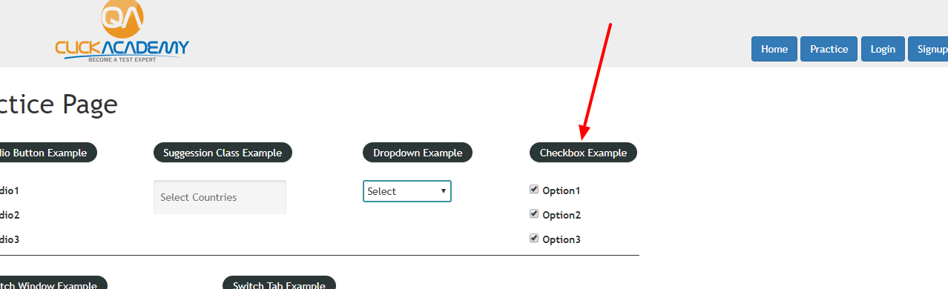

#### Questions for this assignment

Check the first  Checkbox and verify if it is successfully checked and Uncheck it again to verify if it is successfully Unchecked

How to get the Count of number of check boxes present in the page

My solution:

1-----------------------------------------------------------------------------------------------------------------------------------String first_checkbox_selector = "input[id='checkBoxOption1']";

String all_checkboxes_selector = "input[type='checkbox']";

// 1- Check

driver.findElement(By.cssSelector(first_checkbox_selector)).click();

Thread.sleep(500);

// 2- Verify

System.out.println("is checkbox selected? (1):" + driver.findElement(By.cssSelector(first_checkbox_selector)).isSelected());

Assert.assertTrue(driver.findElement(By.cssSelector(first_checkbox_selector)).isSelected());

// 3- Uncheck

driver.findElement(By.cssSelector(first_checkbox_selector)).click();

Thread.sleep(500);

// 4- Verify

System.out.println("is checkbox selected? (2):" + driver.findElement(By.cssSelector(first_checkbox_selector)).isSelected());

Assert.assertFalse(driver.findElement(By.cssSelector(first_checkbox_selector)).isSelected());

2----------------------------------------------------------------------------------------------------------------------------------

How to get the Count of number of check boxes present in the page

// 5- Count the number of the checkboxes

System.out.println(driver.findElements(By.cssSelector(all_checkboxes_selector)).size());

Solution 2:

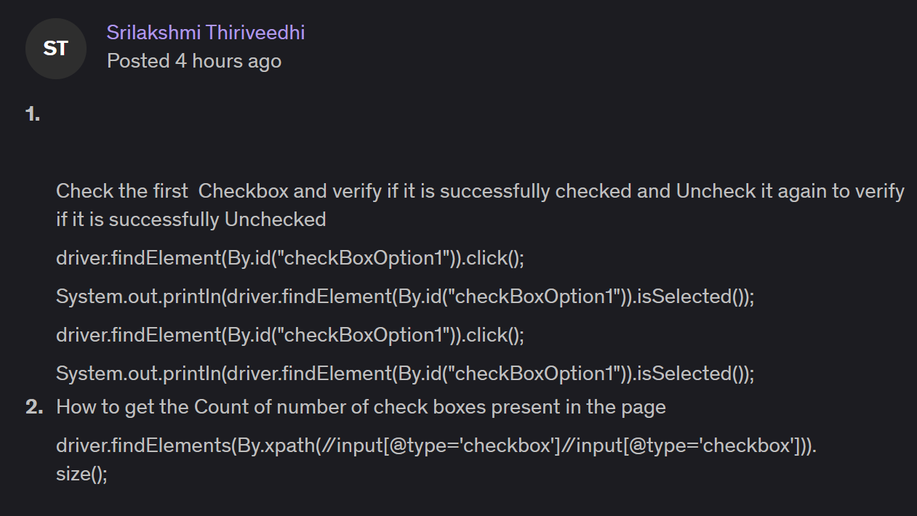

## 63. Handling Calendar UI in Travel Websites using Selenium

Need to learn a few more topics (about 30 videos more) to select a future date.

Thus, for now, only the current date will be selected for test.

Interview Question:

How do you handle in the script that some links are greyed out?

* Using the styles maybe!

## 64. Validating if UI Elements are Disabled or Enabled with Attributes

It is inconsistent to validate UI elements with Selenium.

Enabled: (opacity: 1)

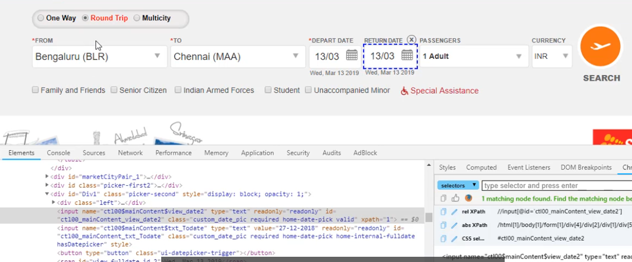

Disabled: (opacity: 0.5)

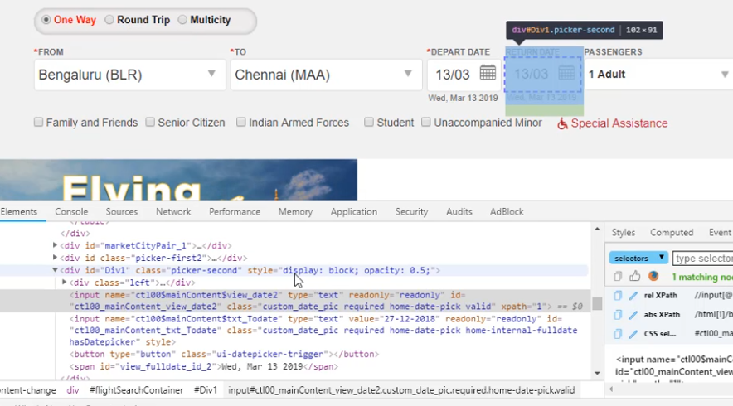

Protractor ?

Cucumber ?

Typescript ?

ANSWER to the previous question:

Many a time a test fails to click on an element or enter text in a field as the element is disabled or exists in the DOM, but is not displayed on the page; this will result in an error being thrown and the test resulting in failures. For building reliable tests that can run unattended, a robust exception and error handling is needed in the test flow.

We can handle these problems by checking the state of elements. The WebElement class provides the following methods to check the state of an element:

Method Purpose

isEnabled() This method checks if an element is enabled. Returns true if enabled, else false for disabled.

isSelected() This method checks if element is selected (radio button, checkbox, and so on). It returns true if selected, else false for deselected

isDisplayed() This method checks if element is displayed.

In this recipe, we will use some of these methods to check the status and handle possible errors.

## 68. Handling Java Alerts using Selenium Webdriver

Java Alerts: Popups that open when you first load a website

Alert:

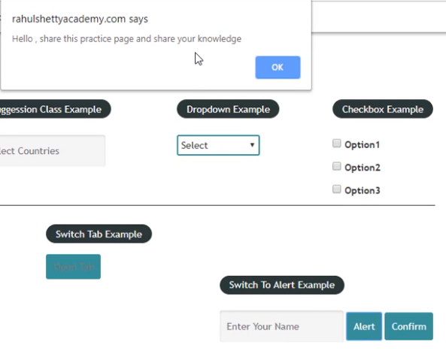

Confirm:

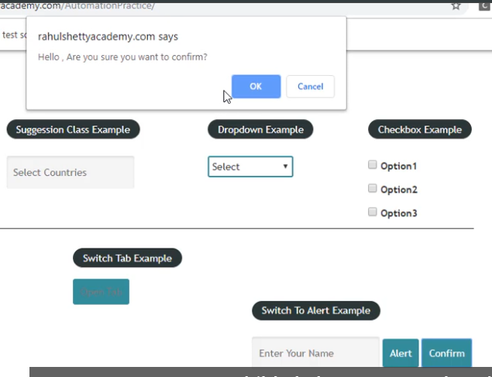

There are other pop-up that will be covered in the upcoming lectures!

Code below:

//ALERT

driver.findElement(By.id("name")).sendKeys("Anil");

driver.findElement(By.id("alertbtn")).click();

String message = driver.switchTo().alert().getText();

driver.switchTo().alert().accept();

//CONFIRM (Yes or No) or (Confirm or Cancel)

driver.findElement(By.id("name")).sendKeys("Anil");

driver.findElement(By.id("confirmbtn")).click();

String message2 = driver.switchTo().alert().getText();

// accept() --> positive

// dismiss()--> negative

driver.switchTo().alert().dismiss();

// driver.switchTo().alert().accept();

# Section 8 – Deep Dive into Functional Testing with Selenium

## 70. Code Formatting and Debugging

1 How to format and align code in Eclipse?

2 Naming Conventions in defining class, variable and method names

3 How to debug the code in Eclipse?

1 Autoformat in Eclipse: CONTROL + SHIFT + F

2 Naming Conventions

* ClassName
* camelCase ---> String name, String rowCount
* Eclipse gives warnings for wrong conventions.
* Method name --> same as variables

3 Breakpoints,

## 71-75. Debugging – Adding Items to Cart

Interview Questions 2

How to write a code in generic so that it supports multiple datasets?

* You need to take into account all the changing values and keep them generic.

In next section, we will get data from TestNG DataProvider or Excel!

array.length

ArrayList.size()

# Section 9 – Synchronization Usage in Selenium Webdriver

Implicit Wait

Explicit Wait

Thread.Sleep

Fluent Wait

## 77. What is Implicit Wait?

Hey! Wait for n seconds before failing.

Implicit wait applies globally.

driver.manage().timeouts().implicitlyWait(Duration.*ofSeconds*(5));

Practical usage: Max 10 seconds...

PROs

* readable code (global: applies everywhere with just one line of code)

CONs:

* Hides performance issues

## 78. What is Explicit Wait?

dfd

Interview Questions 3

What is ideal strategy of using synchronization in Selenium Webdriver?

* It is ideal to combine implicit and explicit waits .

Thread.sleep: It is a method of Java. It is not recommended to use Thread.sleep in our Selenium Test Scenarios!

UTILITY: methods

Two types of Explicit Wait

* Webdriver Wait
* Fluent Wait

PROs

* Wait is applied only to the targetted element. So there is no performance issue. You can use it whenever you need.

CONs:

* More code

How different Fluent Wait ?

timeout = 10 seconds

1. WebDriverWait : 10 seconds
2. FluentWait: 10 seconds, polling 2 seconds

Fluent wait finds the web element repeatedly at regular intervals of time until the timeout or till the object is found.

Unlike WebDriver wait, we need to build customized wait methods based on conditions

Both WebDriver wait and Fluent Wait classes implement Wait Interface!

## ASSIGNMENT:

public static void main(String[] args) throws InterruptedException, AWTException {

WebDriver driver = new ChromeDriver(chromeOptions);

// Implicit Wait - Explicit Wait

// Choose one of them and comment out the other to test.

driver.manage().timeouts().implicitlyWait(Duration.ofSeconds(5));

WebDriverWait w = new WebDriverWait(driver, Duration.ofSeconds(5));

driver.get("https://rahulshettyacademy.com/loginpagePractise");

driver.manage().window().maximize();

// Enter Username

driver.findElement(By.name("username")).sendKeys("rahulshettyacademy");

// Enter Password

driver.findElement(By.name("password")).sendKeys("learning");

// Select User RadioButton

driver.findElement(By.xpath("//label[2]//span[2]")).click();

// rahul's solution:

//driver.findElement(By.cssSelector(".customradio:nth-child(2)")).click();

// Okay to Proceed

// Wait until this popup show up

w.until(ExpectedConditions.visibilityOfElementLocated(By.cssSelector(".modal-content")));

driver.findElement(By.id("okayBtn")).click();

// Select Consultant from Dropdown menu

// w.until(ExpectedConditions.visibilityOfElementLocated(By.xpath("//select[@class='form-control']")));

driver.findElement(By.xpath("//select[@class='form-control']")).click();

WebElement dropdown = driver.findElement(By.xpath("//select[@class='form-control']"));

Select drop = new Select(dropdown);

drop.selectByVisibleText("Consultant");

// rahul's solution:

//WebElement options = driver.findElement(By.xpath("//select[@class='form-control']"));

// Select Checkbox

driver.findElement(By.name("terms")).click();

// Sign in

driver.findElement(By.name("signin")).click();

// Add all the element dynamically!

addAllItems(driver);

// Select Checkout

driver.findElement(By.xpath("//a[contains(text(),'Checkout')]")).click();

}

public static void addAllItems(WebDriver driver) {

List<WebElement> products = driver.findElements(By.xpath("//button[contains(text(),'Add')]"));

// rahul's solution

//List <WebElement> products = driver.findElements(By.cssSelector(".card-footer .btn-info"));

for (WebElement p : products)

p.click();

}

QUIZ:

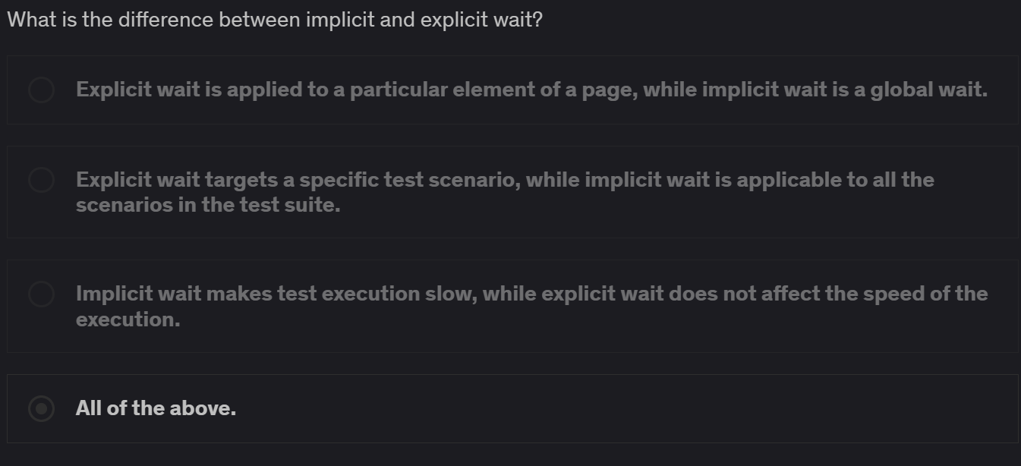



Duration.ofSeconds(5) --> New syntax for the duration...

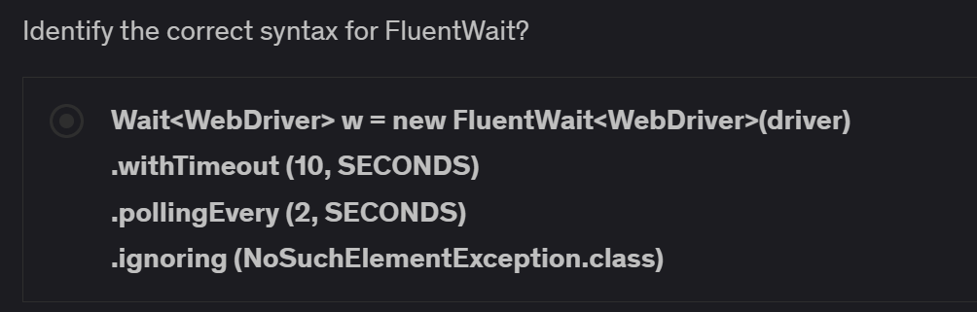

# Section 10 – Techniques to Automate Ajax Calls, Child Windows, and IFrames

**Actions:**

* How to MouseOver on object with Selenium?
* Performing Mouse and Keyboard interactions with Selenium
* Using CAPITAL LETTERS?
* Context click on element
* Double click on element
* Drag and dropping the element

**Frames:**

* What are Frames
* How to identify Frames in application?
* How to handle frames?
* Best practices when working with Frames application.

Interview Questions

One of the most interesting interview questions:

How to handle right click in Selenium?

* contextClick()

## 86. Handling Ajax/Mouse Interactions

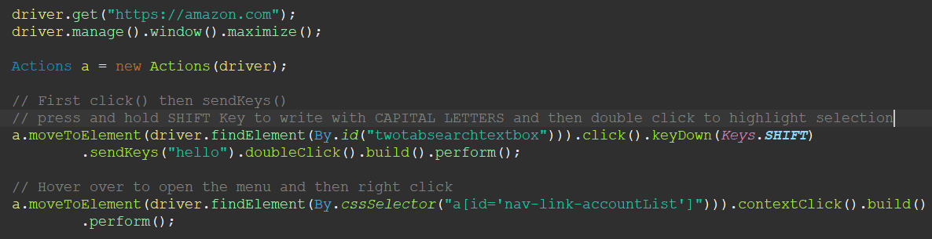

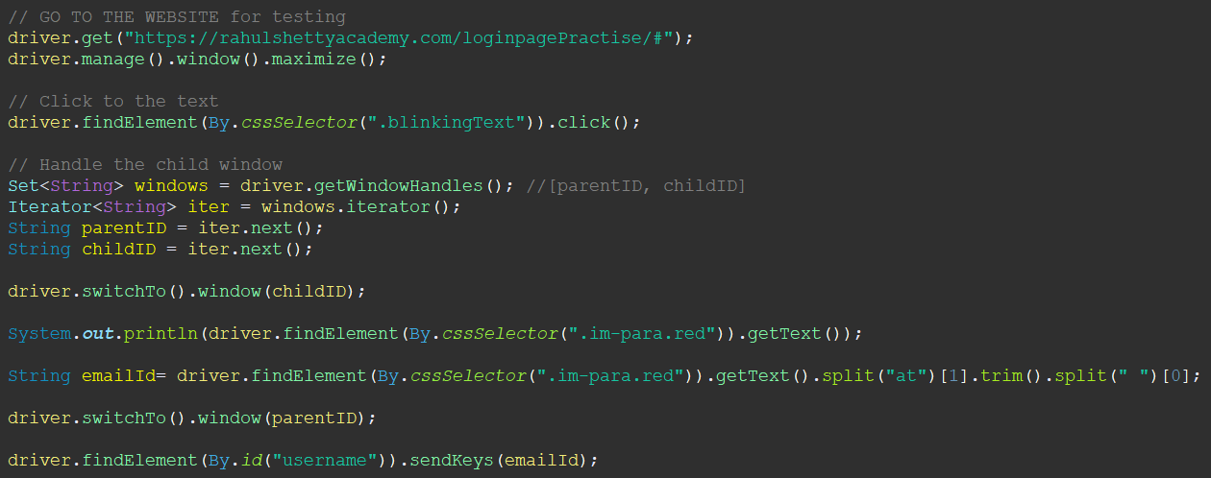

ASSIGNMENT 4

Click a link and turn back to the original tab.

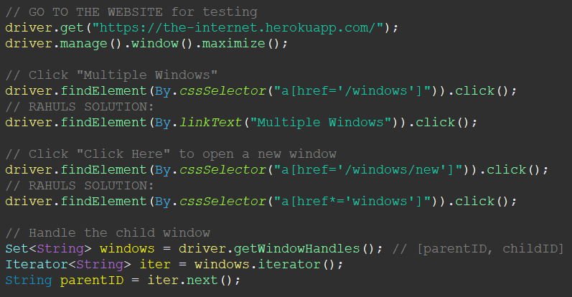

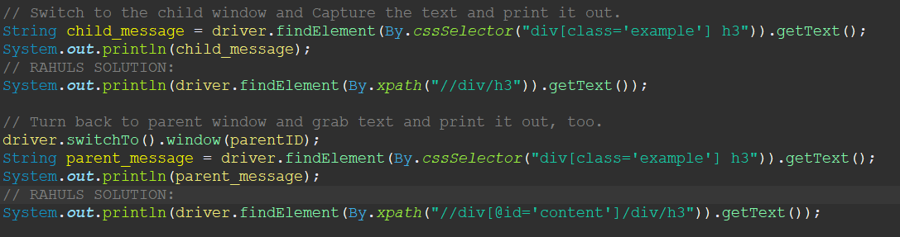

## 91. How to Handle Frames

Reading:

<https://courtneyzhan.medium.com/automated-testing-frames-in-selenium-webdriver-c1888f92bc20>

driver.switchTo().frame(WebElement we);

Actions a = new Actions(driver);

a.dragAndDrop(WebElement source, WebElement target);

ASSIGNMENT 5

Go to website and get the test from nested frames!

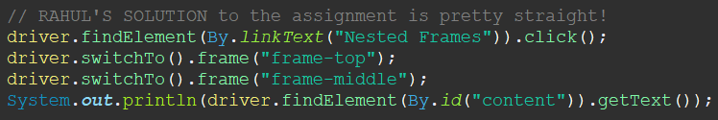

my solution:

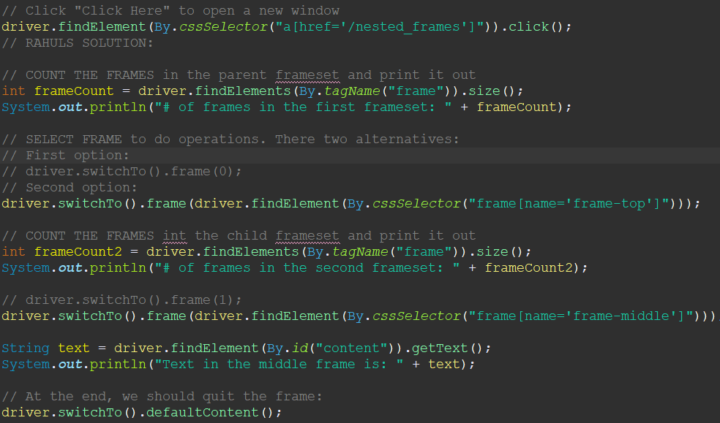

# Section 11 – Real Time Excercises

part 1:

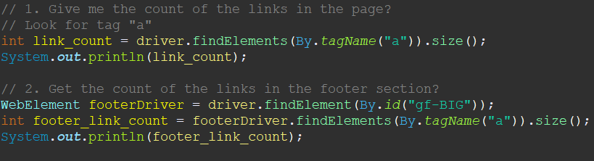

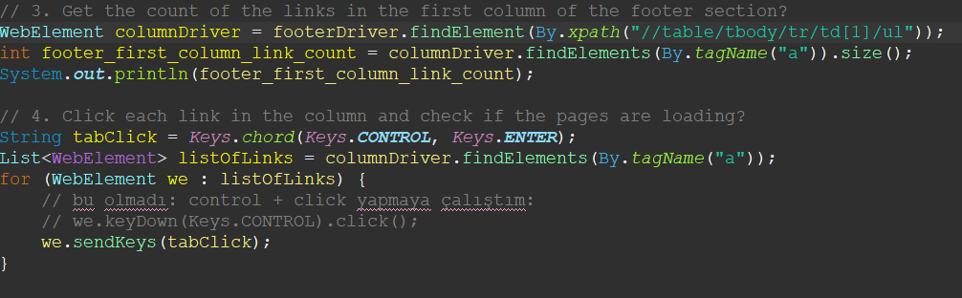

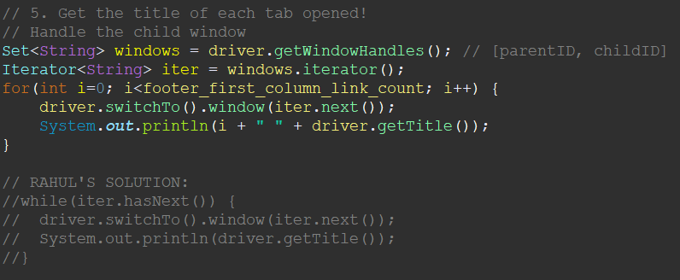

part2:

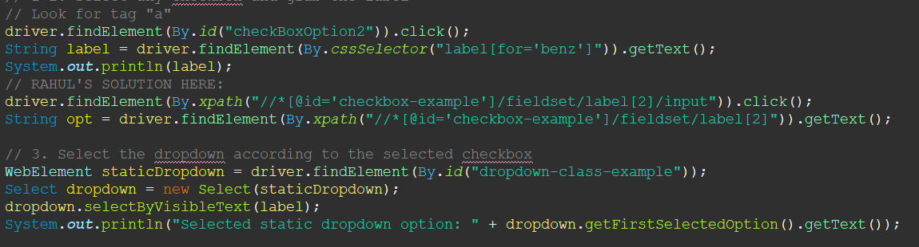

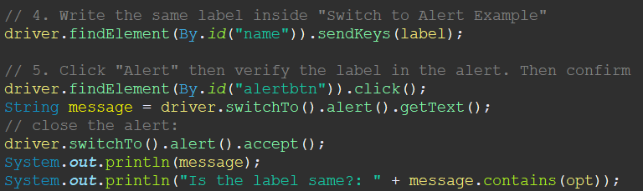

part 3:

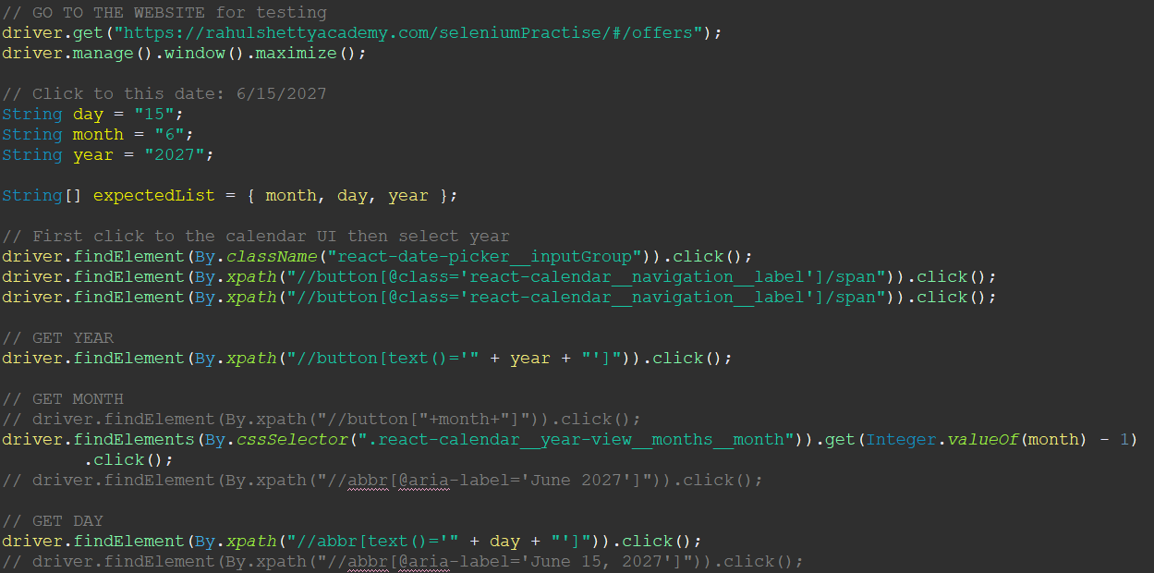

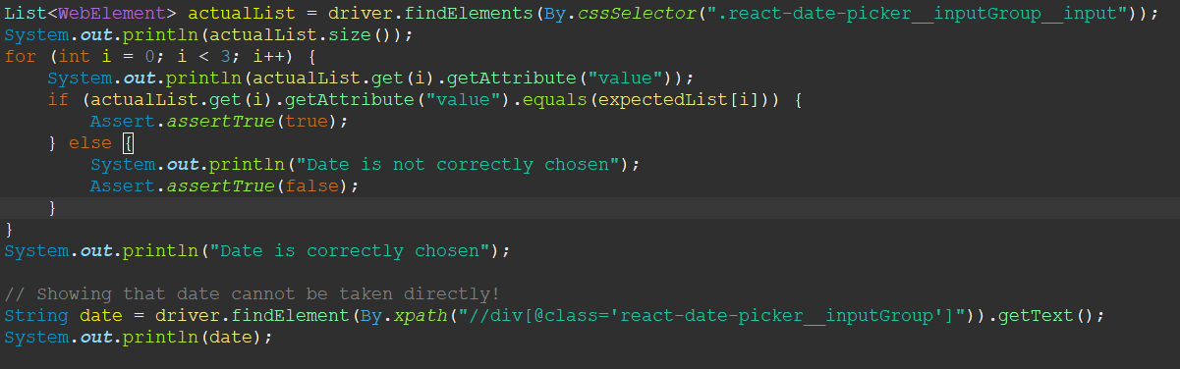

QUIZ:

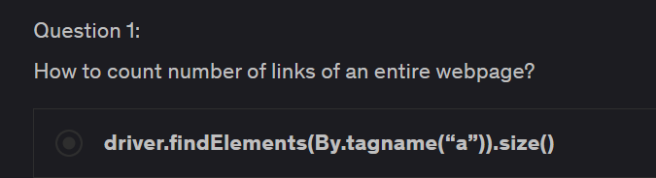

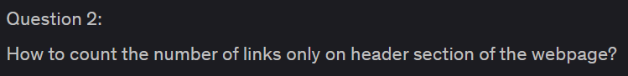

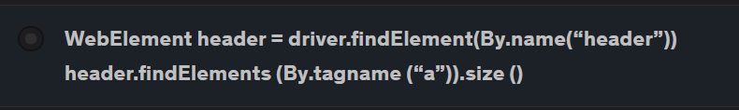

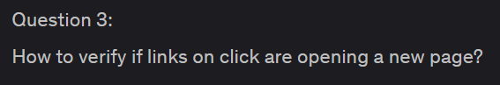

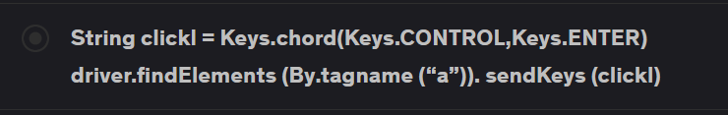

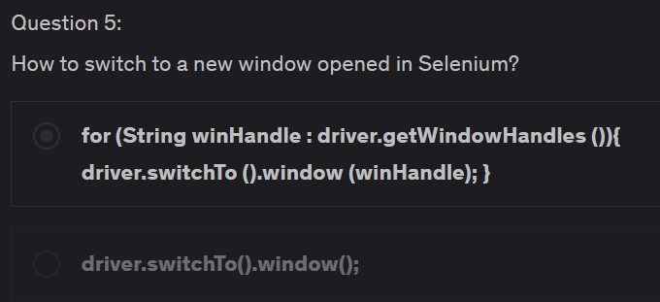

# Section 12 – Practical Problems and Methods to Handle Them with Selenium

What is headless mode? Why is it important?

How to scroll in a page or in a table?

USE JavascriptExecuter

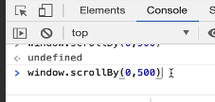

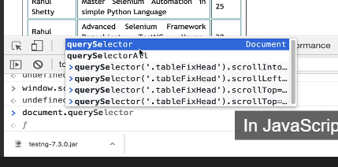

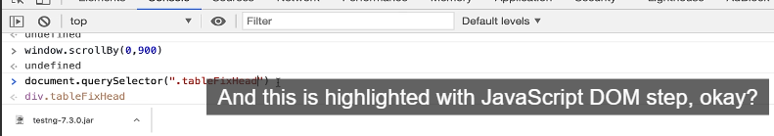

When debugging, we can change values with WATCH. We did it when dealing with Window Handles...

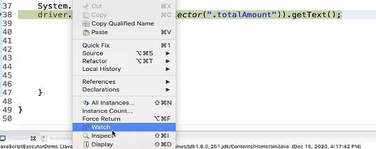

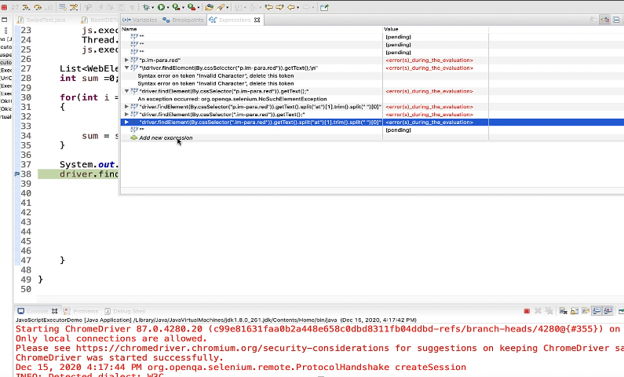

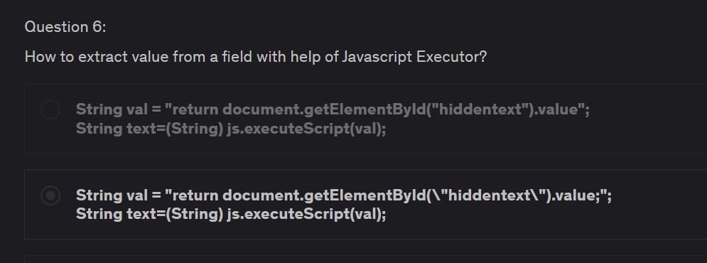

1:

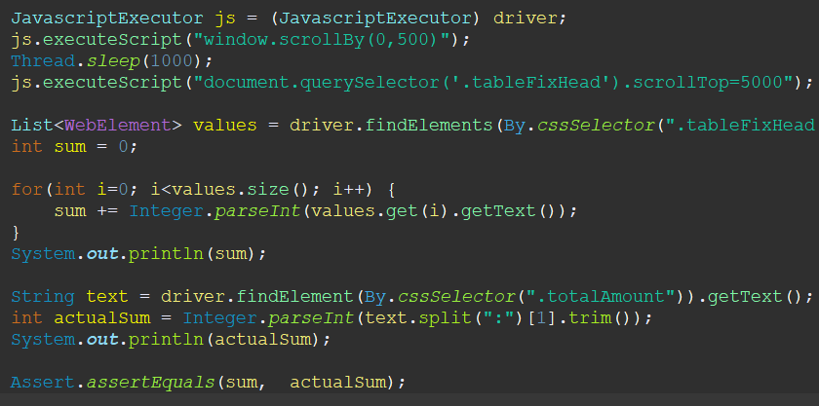

## ASSIGNMENT 7:

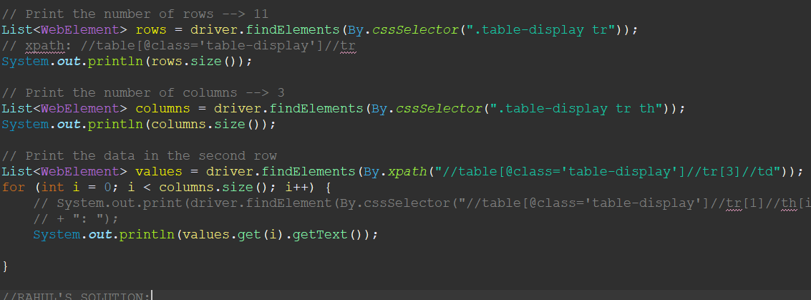

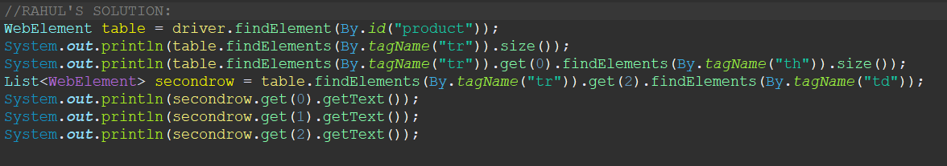

## ASSIGNMENT 8

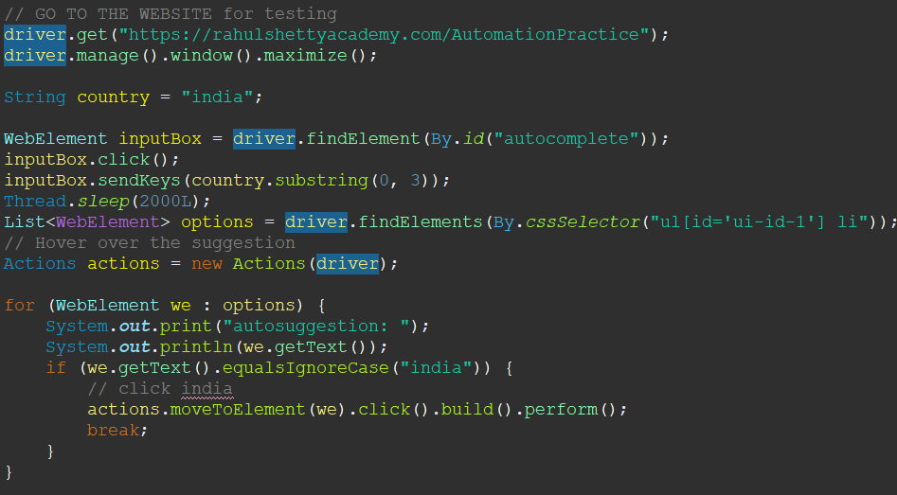

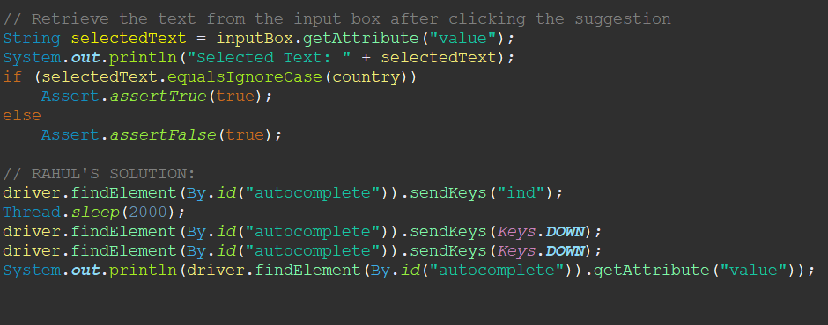

# Section 13 – Miscellaneous Topics in Selenium Webdriver

<https://developer.chrome.com/docs/chromedriver/capabilities>

Interview Question:

Is there any way to tweak your existing automation behavior by setting up your proxy or processor?

YES. There is chromeOptions

Interview Question:

You want to automate a login session. But, after the first time you enter your credentials, then the page is starts already logged in. How do you start a new session so that you are not logged in..

* Click a url
* login page... Verify login page url...

By deleting a specific cookie about session log in... “SessionKey” or sth like that.

Interview Question:

* How to handle broken links?

# Section 14 – Selenium Java Streams – Automate Sort, Pagination, Filtering the Web Tables

What are Streams?

Stream API is new feature available from Java8.

By using streams, we can perform various aggregate operations on the data returned from collections classes by drastically reduce the complexity of code.

What is Lambda Expression?

Lambda expressions introduce the new arrow operator --> Into Java. It divides the lambda expressions in two parts:

* The left side specifies the parameters required by the expression, which could also be empty if no parameters are required.
* The right side is the lambda body which specifies the actions of the lambda expressions.

The working of stream can be explained in three stages:

1. Create a stream
2. Perform intermediate operations on the initial stream to transform it into another
3. Perform terminal operation on the final stream to get the result.

An important characteristic of intermediate operations is laziness.

When executing this code snippet, nothing is printed to the console. That is because intermediate operations will only be executed when a terminal operation is present.

Note: The aggregate operations that we perform on the collection, array or any other data source do not change the data of the source. They simply return a new stream.

Without streams:

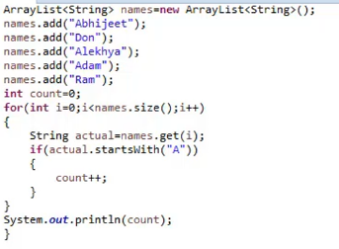

this can be done with streams like:

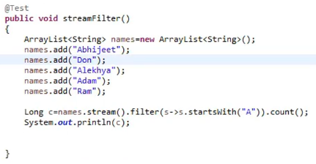

Long count = names.stream().filter(s-->s.startswith(“A”)).count();

new variable “count” is created.

“names” is untouched (does not change)

You can create a stream like this:



You cannot return false inside the filter... This results as 0!

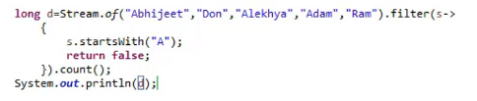

SECOND FILTER EXAMPLE: Print all the names longer than 4 letters...



YOU CAN LIMIT THE RESULTS:



THIRD FILTER EXAMPLE: Print names ending with “a” in uppercase



convert array to list:



FOURTH FILTER EXAMPLE:

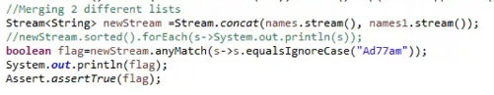

FIFTH EXAMPLE:



SIXTH EXAMPLE:

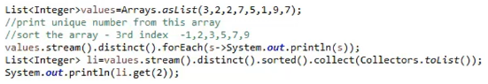

## 116. Perform Web Table Sorting using Streams

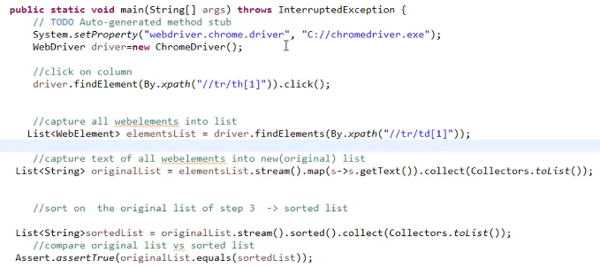

## 117. Build custom Selenium Methods using Streams Mapper

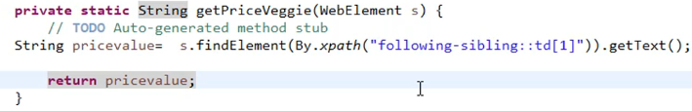

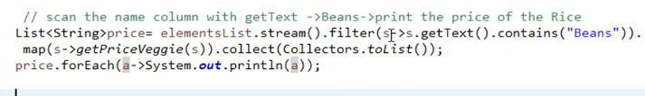

But, how do you know that “Beans” present in the first page?   
You need to look every page if it is not in the first page!!!

## 118. Automating Pagination Scenarios to Search the Data using Do While loop

# Section 15 – Selenium 4.0 – Latest Features

Selenium Relative Locators – Friendly Locators:

* above()
* below()
* toLeftOf()
* toRightOf()

Syntax:

driver.findElement(with(By.tagName(“XX”).above(WebElement))

# Section 16 – Framework part 1 – TestNG

This chapter is same for

* Selenium
* Apium
* RestAPI testing...

So learn all of them... Do not be a one platform guy!

Importance of TestNG

Installation and configuration in Eclipse

TestNG XML file importance

Controlling Tesetcase executions from TestNG XML files

Include – Exclude Mechanism

Understanding TestNG Annotations

Groups

Data Provider Annotation

Annotation helper attributes

Parametrization in TestNG XML Files

Running tests in parallel with TestNG

TestNG Listeners

How to run tests with TestNG?

* You need to have @Test Annotation followed by methods.
* You can define multiple tests from single class file.
* You can modularize test cases based upon functionality and trigger them accordingly.

SUITE?

Test Suite --> Test Folder(Shell) --> Test Cases

Include or exclude test cases using regex (.*) :

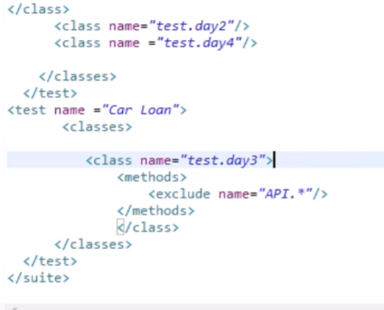

Running tests from a package:

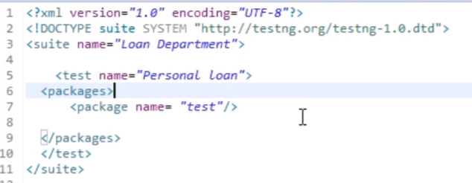

NOTE: All tests are executed in ALPHABETICAL ORDER!

@BeforeMethod, @BeforeClass, @BeforeTest, @BeforeSuite

@BeforeTest - @AfterTest - @

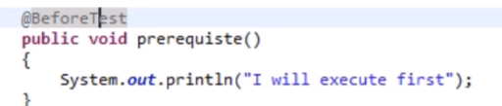

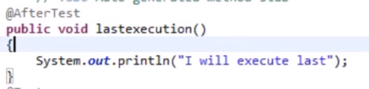

@BeforeSuite - @AfterSuite

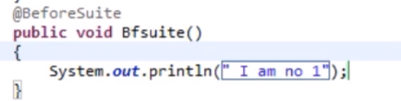

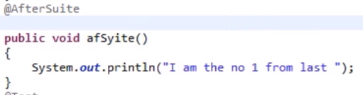

@BeforeMethod - @AfterMethod

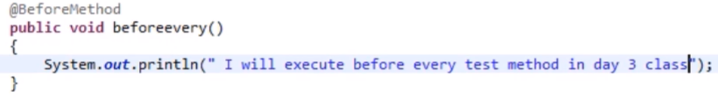

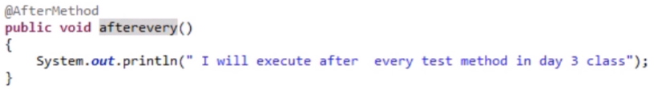

@BeforeClass - @AfterClass

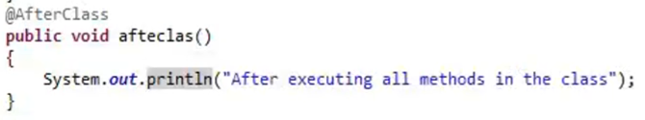

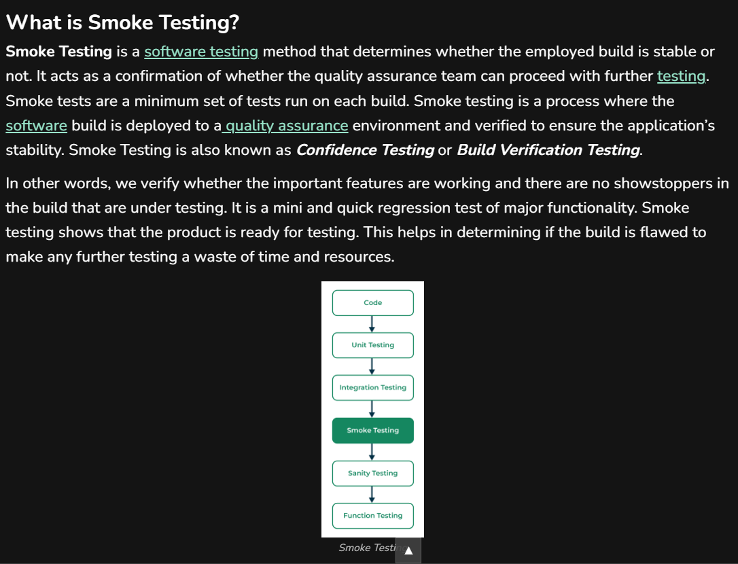

Groups: A group is created with the name “Smoke”

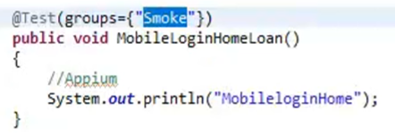

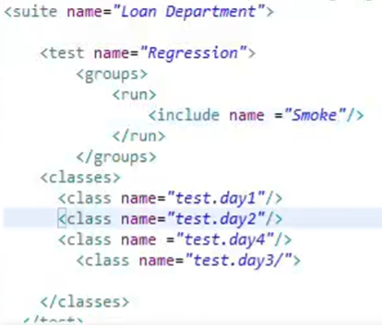

You want ApicarLoan to execute last, but it is alphabetically in the first order. What can you do?

You can use dependsOnMethods for the Test which will be the last alphabetically.

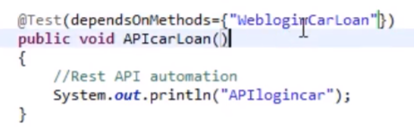

Or:

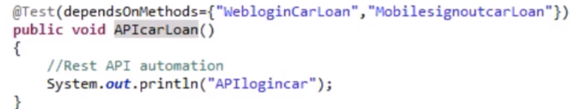

Exclude a test using enabled method:

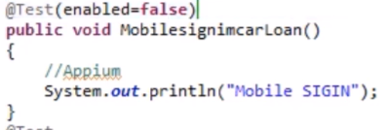

Set timeout for a specific test:

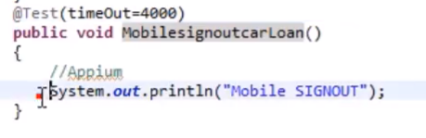

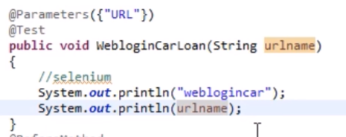

in xml:

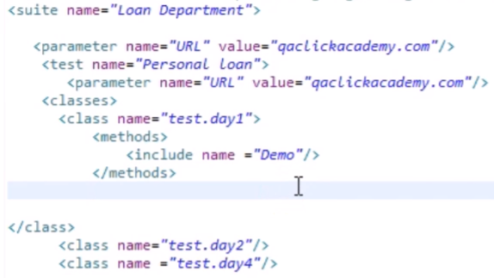

Parametrizing using Data Provider:

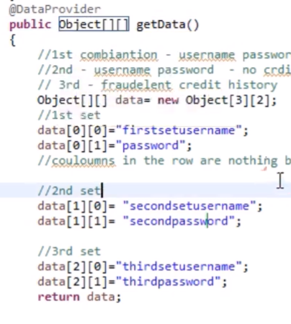

then:

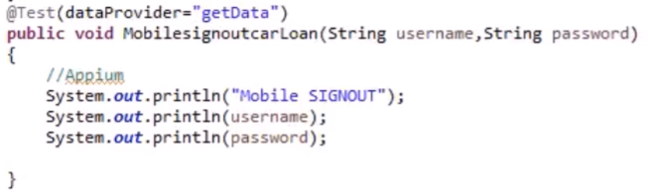

Listeners: when you want to print a report before failing...

in the code:

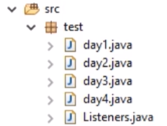

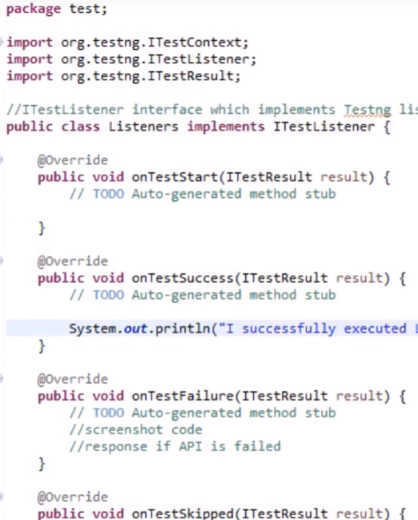

in xml:

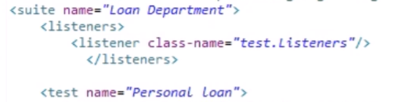

Running parallel tests: (In this example, 6 tests can be run at the same time)

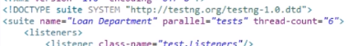

Sometimes you can run test classes in parallel.

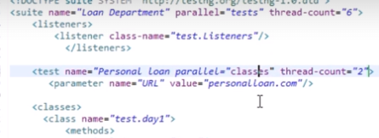

# Section 17 – Learn Java Object Oriented Principles needed for Framework

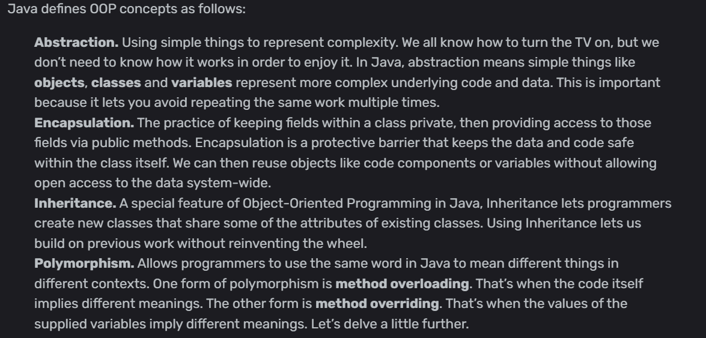

Abstraction:

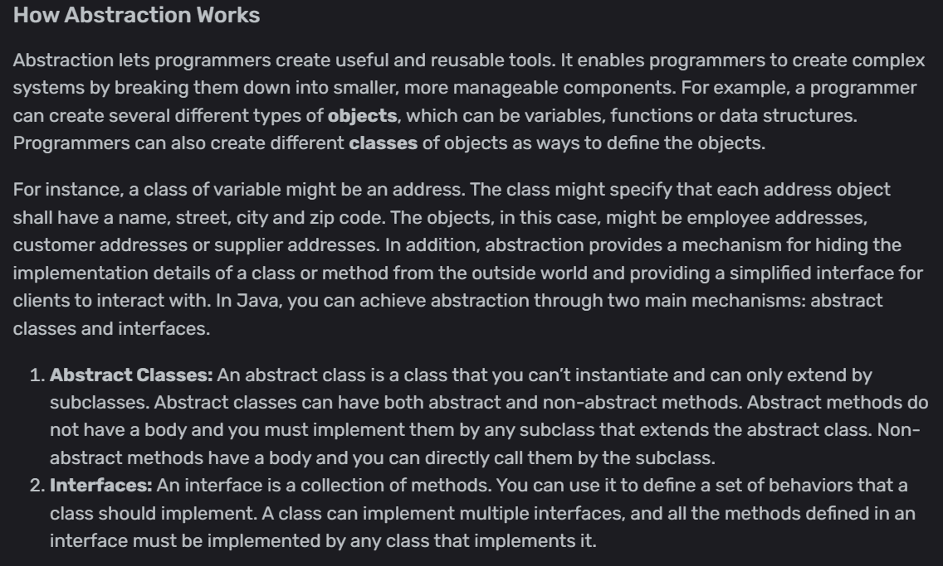

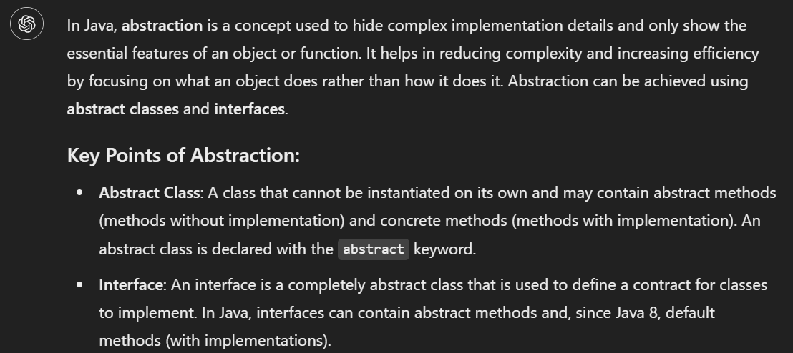

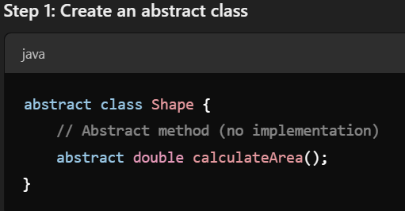



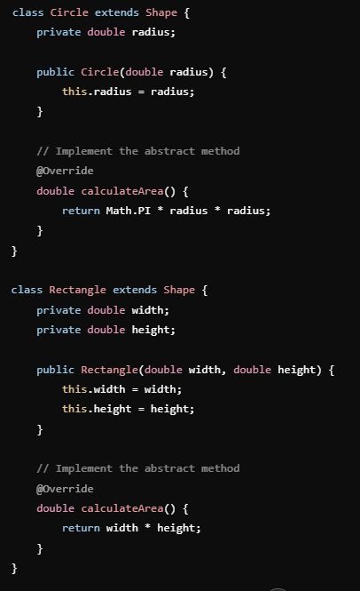

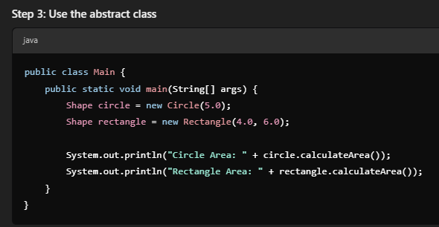

Encapsulation:

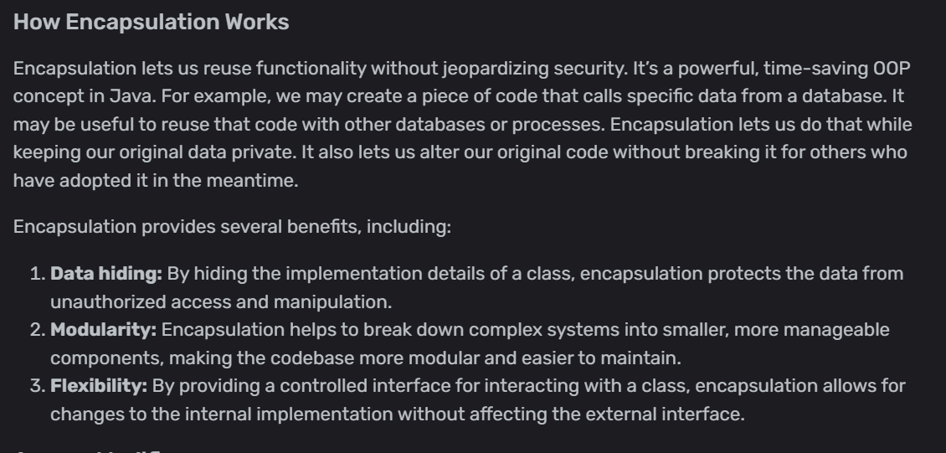

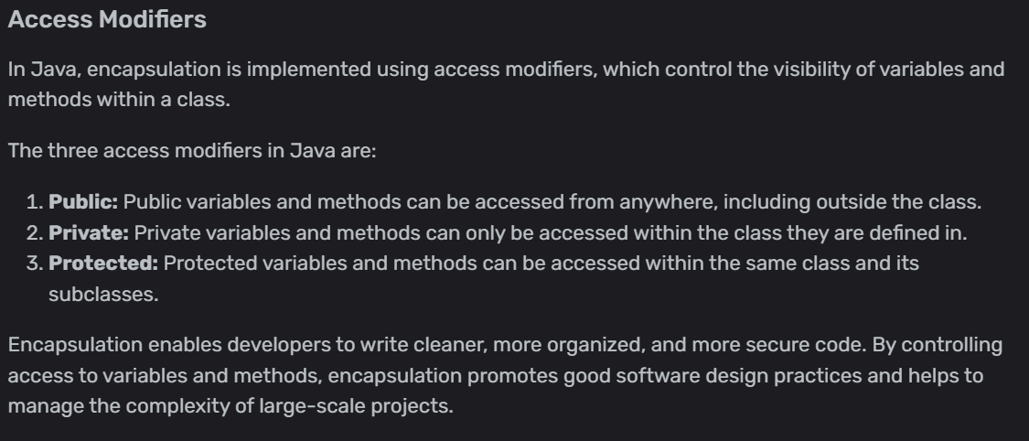

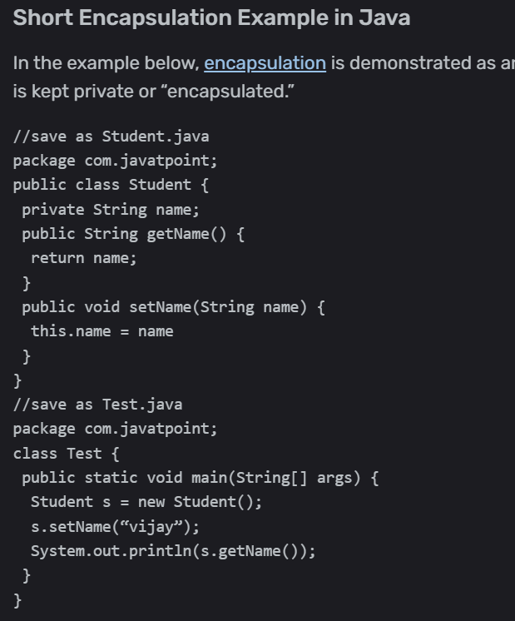

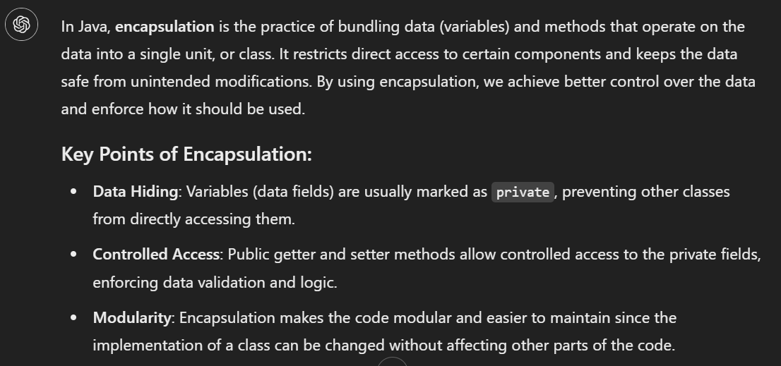

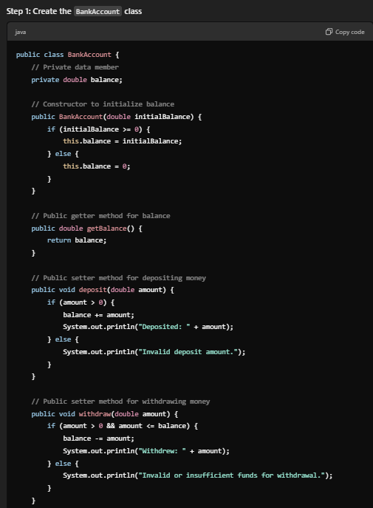

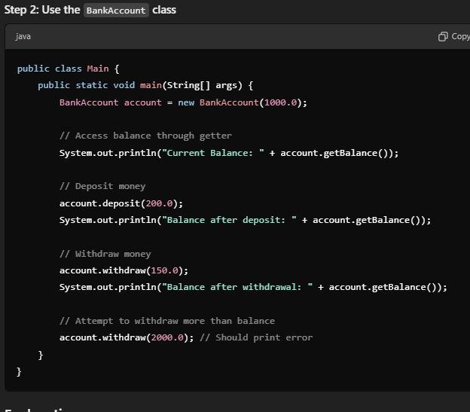

Inheritance:

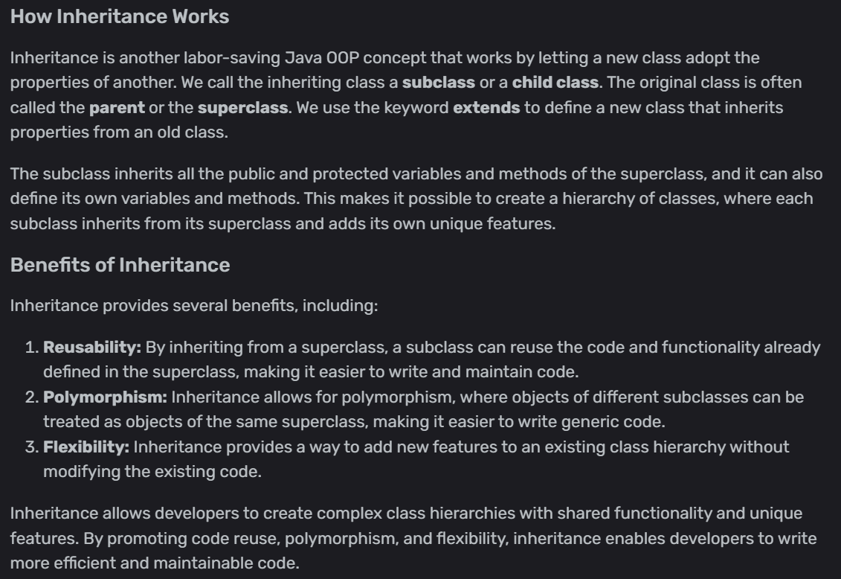

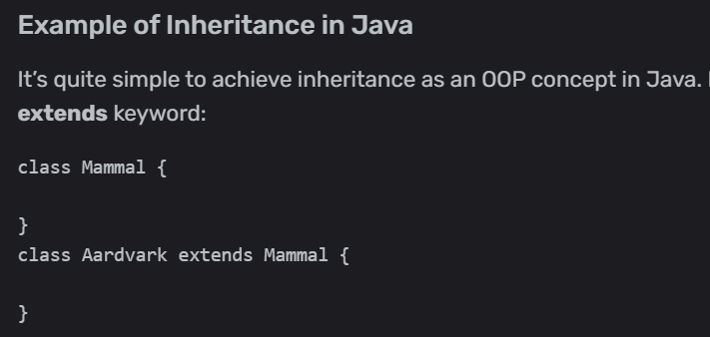

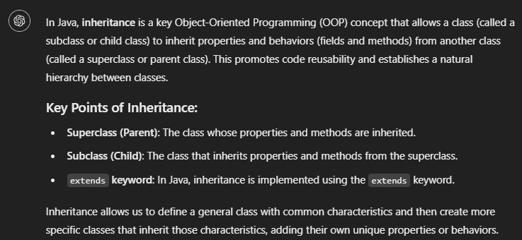

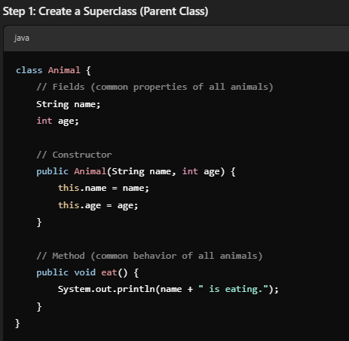 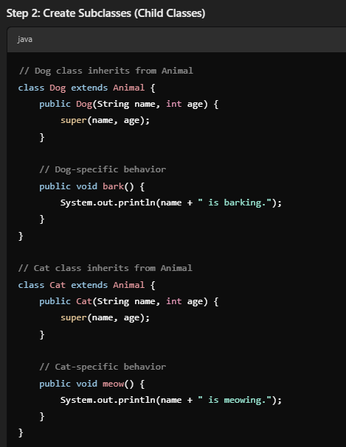

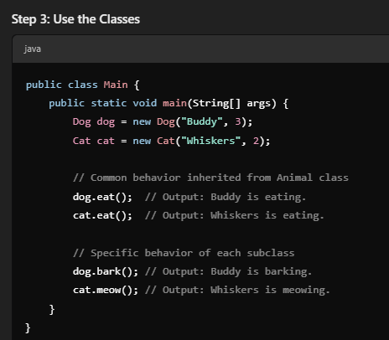

Polymorphism:

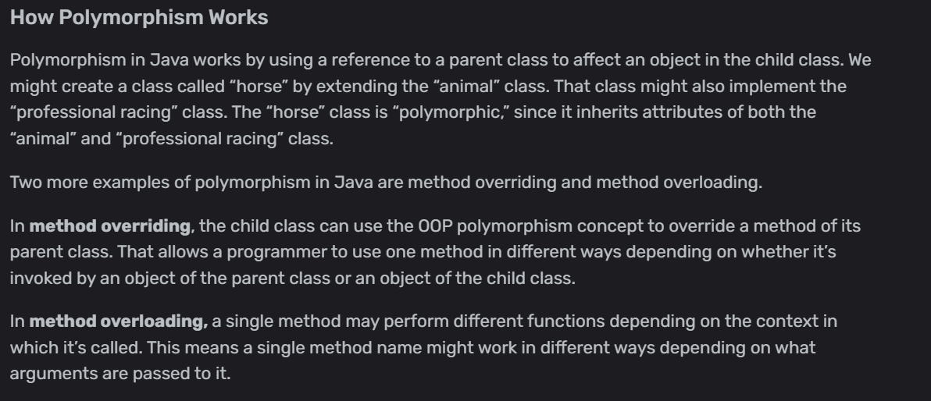

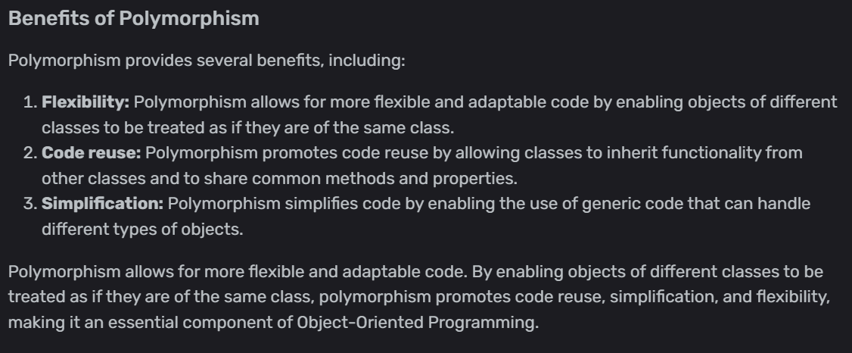

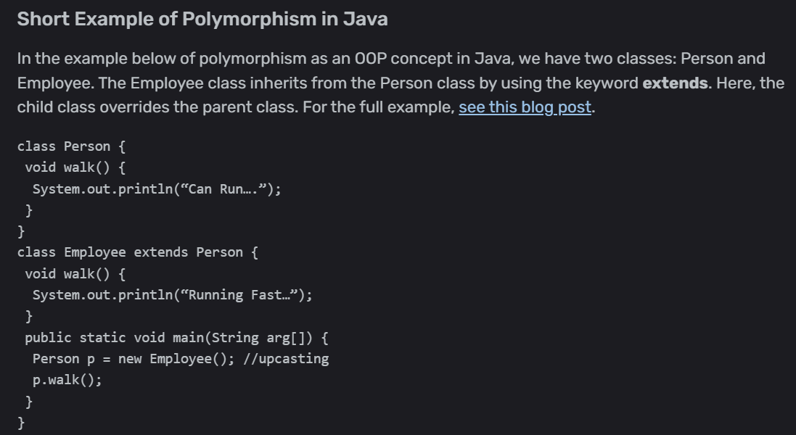

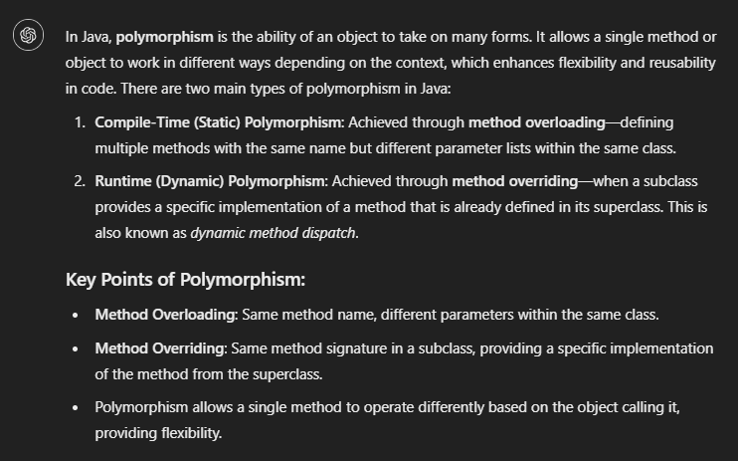

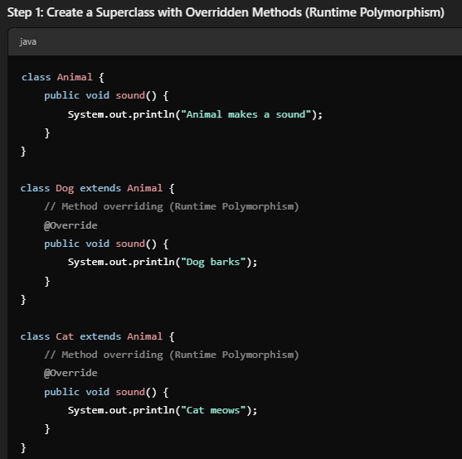

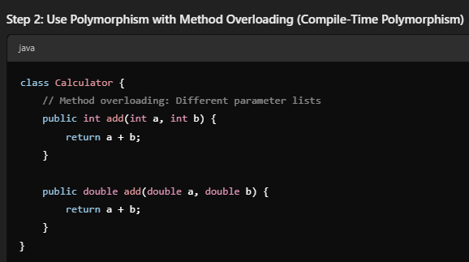

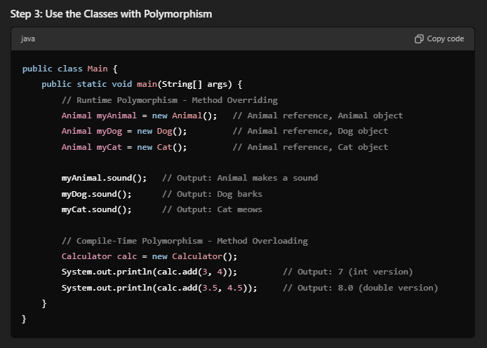

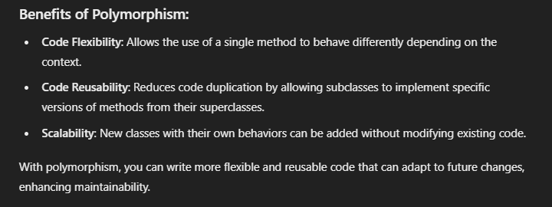

Super keyword:

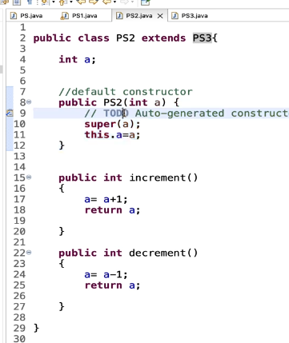

# Section 18 – Framework Part 1 – Create Maven Project and Prepare Functional End to End Test

* Why framework? Its advantages
* Create **Maven** Structured Framework with all necessary Automation dependencies
* Select Sample Ecommerce Application to Automate the end-to-end flow
* Implement **Page object model** mechanism to drive the locators from respective classes
* Drive object creation within Page object classes **encapsulating** if from Tests
* Create Base Test which sets browser configuration details and **Global** **properties**
* Decide the **Test Strategy**, how tests should be clubbed & distributed with ap propriate annotations.
* Create **TestNG runner** file to trigger the tests with one Single point of execution control
* Introduce **Grouping in TestNG.xml** to categorize tests with different tags of execution.
* Implement **Data driven testing & parametrization** using TestNG Data provider HashMap & JSon file readers.
* Implement **TestNG Listeners** to capture Screenshot on automatic test failures and logging.
* Create Extent Report wrapper to generate **excellent HTML reports** for the application.
* Make Framework necessary changes to support **parallel execution** with Thread safe mechanism.
* Implement TestNG **retry mechanism** to rerun the failed flaky tests in the application.
* Run the framework tests with Maven commands with **TestNG Maven Integration plugin**
* Implement Maven **Run time variables** to replace global parameters of test data at run time
* Integrate the framework with **Jenkins** with Parametrized Build Pipeline Jobs &Schedule the jobs on specific time frames.
* Add **Cucumber Wrapper** to existing framework with Cucumber TestNG Runner.
* Create **Feature files & Step definitions** to support cucumber execution of Selenium Tests
* Understand how **Cucumber tags, Data driven & Parametrization** works in running the tests.

First create a maven project! Use a template :

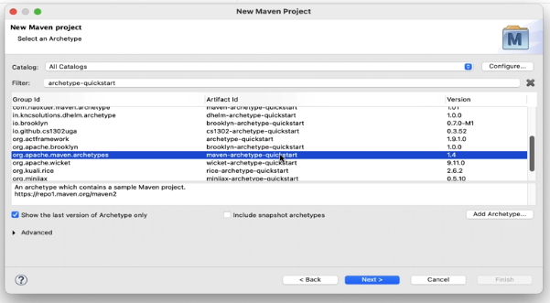

Click add to cart for item named ZARA COAT 3

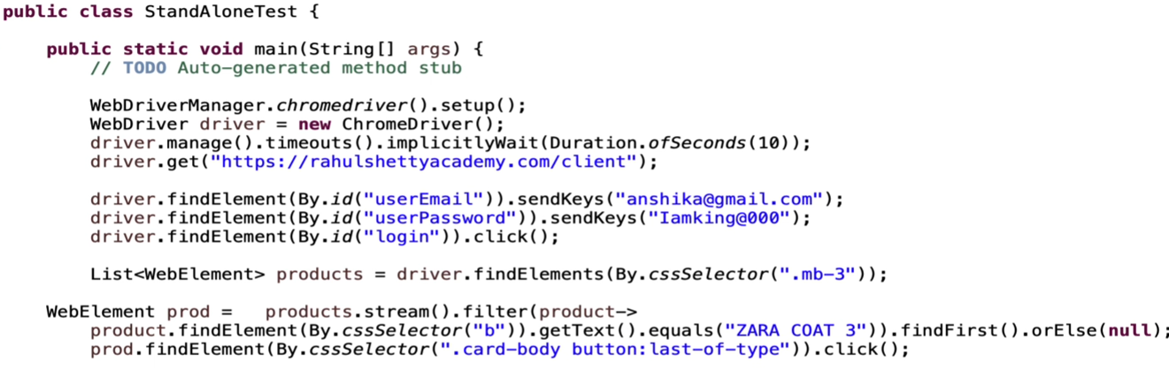

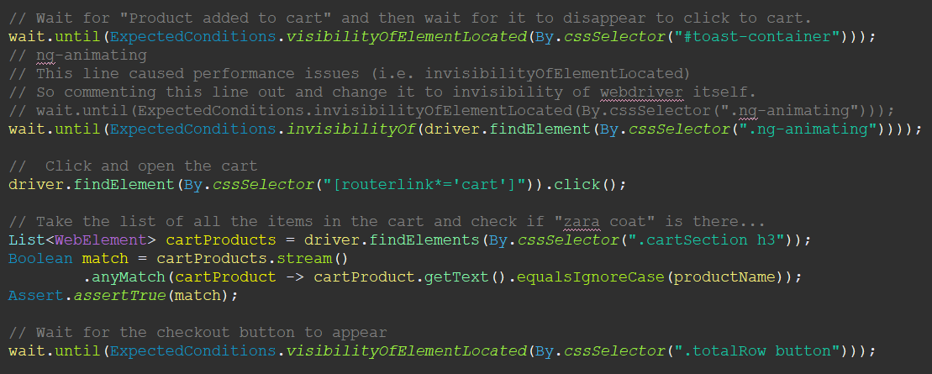

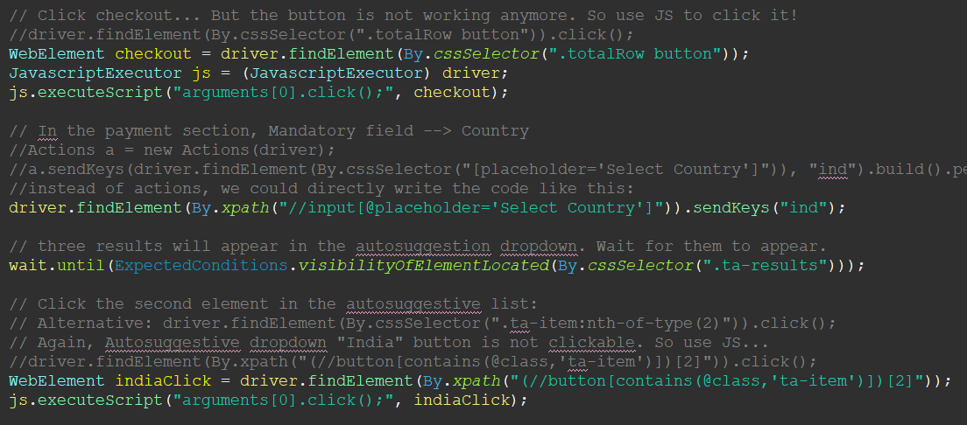

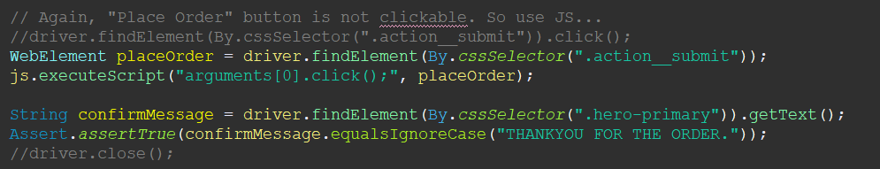

In the code, some lines did not work giving “not clickable” error.

They are changed to javascript executor elements... so they worked...

Wait is important!!!

Using stream() and checking elements with their titles are important.

# Section 19 – Framework Part 2 – Design Pattern – Page Object & Factory Implementation

Instead of defining everything in a code block, some objects should be separated for the sake of maintenance and easiness.

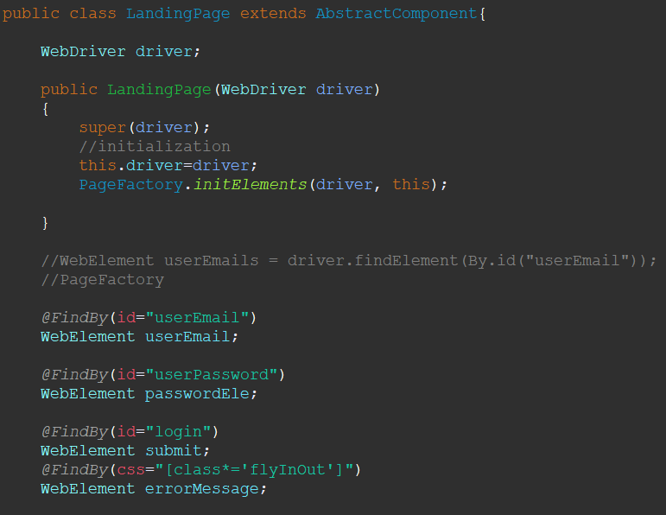

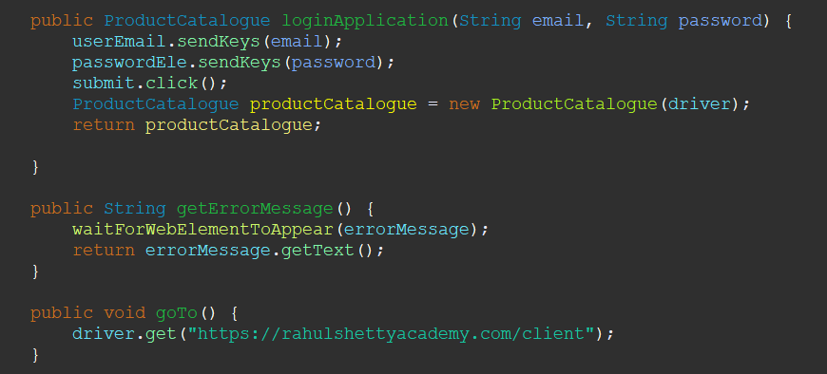

Another example:

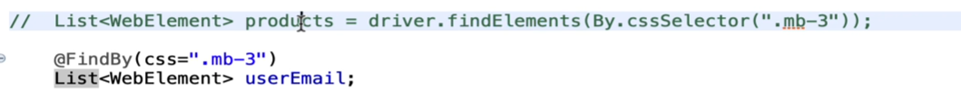

Using Abstract Classes: You can use abstract methods for :





# Section 20 – Framework Part 3 – Test Configuration Methods, Global Properties & Parallel Runs

In every test, we define chromedriver and related configurations. We can take these configurations to elsewhere and call it from there for easiness. Like a baseTest class. We can also create a file with .properties

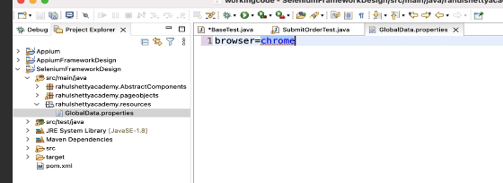

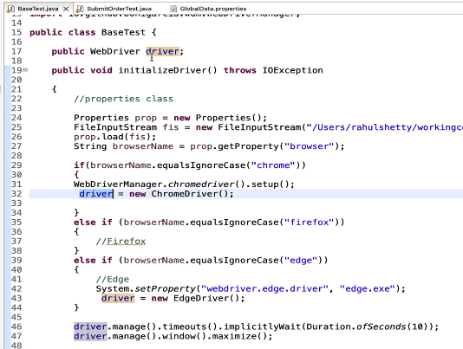

Test Strategy:

100 test cases --> 100 classes will make things complicated...

May be 20 classes is ok...

Divide the test classes like:

* login page – 5 classes
* submit order, order check, etc. – 5 classes
* Product catalogue tests – 3 classes... etc.

Also, you can run them parallel! You can either

* run test methods parallelly or
* or java classes parallelly...

Now, create an “order history” test. But to have an “order history, we need to order sth. That why “order history” method must DEPEND ON “submit order” test! Look below:

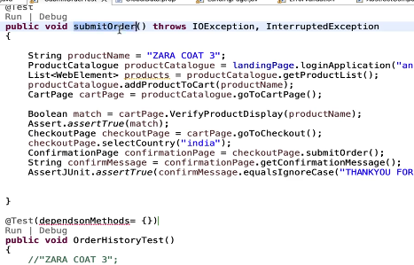

Grouping:

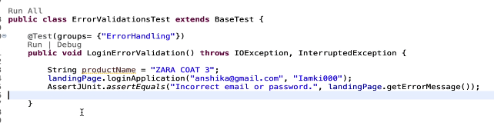

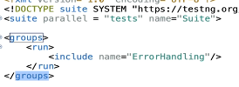

If you want to run beforeMethod or afterMethod for a group, you can use:

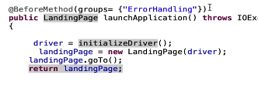

or you can use “always”

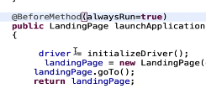

# Section 21 – Framework Part 4 – Test Strategy – Control Tests Execution – Run Parallel Tests

Now, how to use DataProvider in this test:

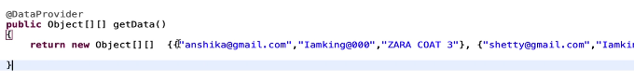

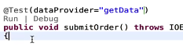

Extend DataProvider with the usage of HashMaps:

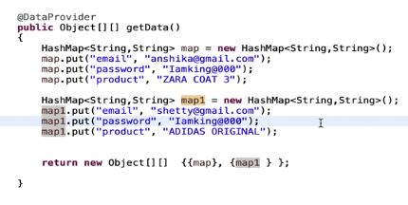

But at the end it will look like this with the addition of JSON file:

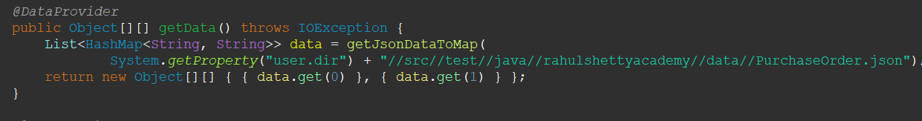

JSON:   
[ {

"email" : "anshika@gmail.com",

"password": "Iamking@000",

"product" : "ZARA COAT 3"

},

{

"email" : "shetty@gmail.com",

"password": "Iamking@000",

"product" : "ADIDAS ORIGINAL"

} ]

DataReader.java:

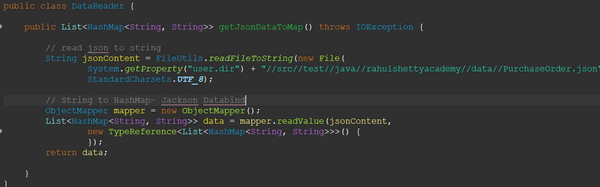

in the BaseTest class, you can separate Purchase tests using grouping:

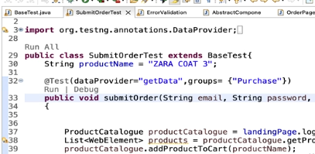

Take screenshot:

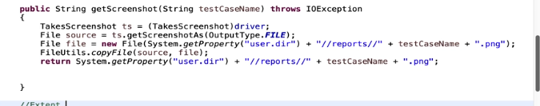

# Section 22 – Framework Part 5 – Extent HTML Reports & TestNG Listeners & Thread Safe Execution

PHASE 1:

What are extent reports?

Understanding Basic Configuration of Extent Reports with Standalone Test

PHASE 2:

Generate Reports for Parallel Test Execution

Extent Report + TestNG Listeners

This is what extentReport looks like:

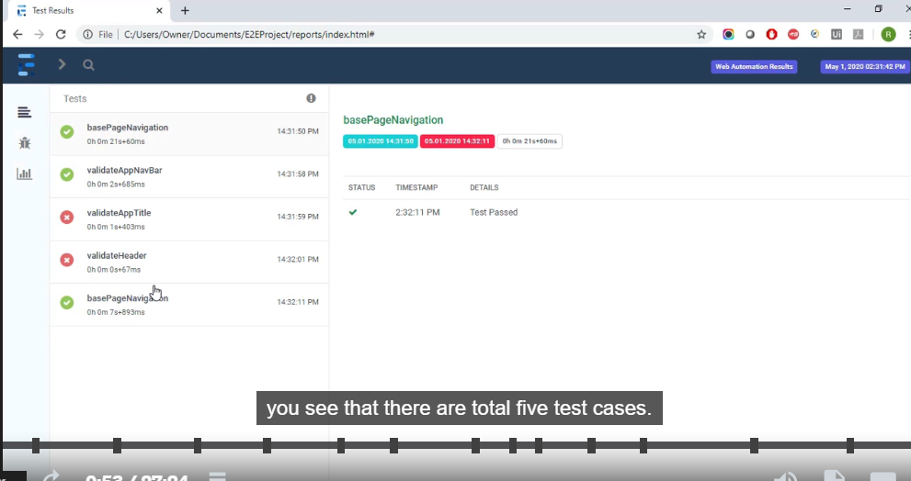

Basic extent report schema:

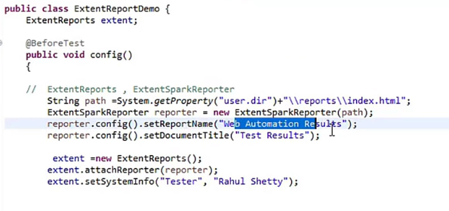

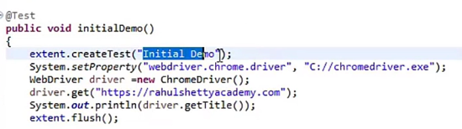

extent.createTest --> creates the test

OR Using extentTest:

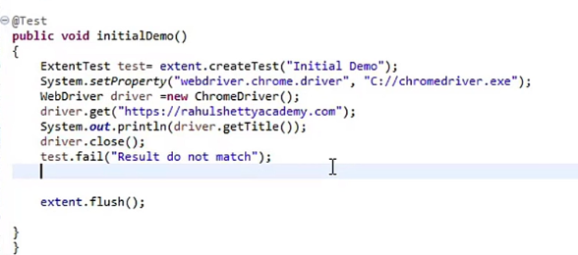

APPLY ExtentReports to our existing project:

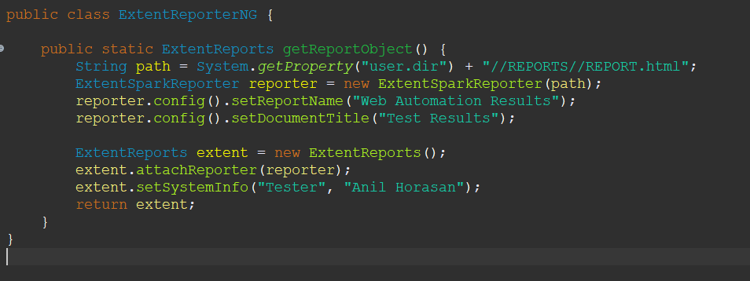

Use Listeners:

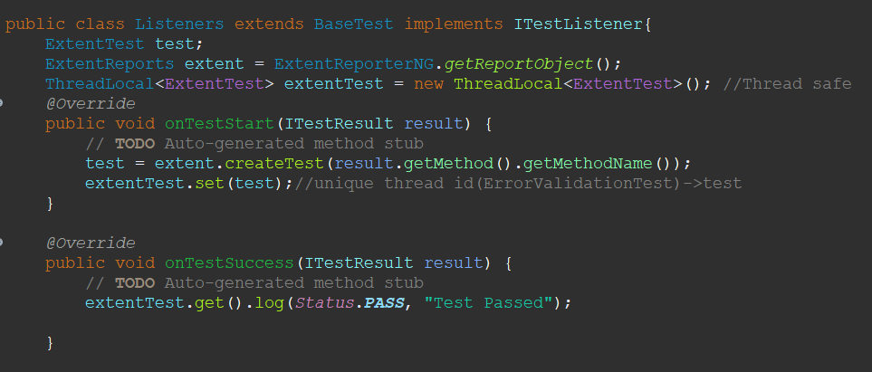

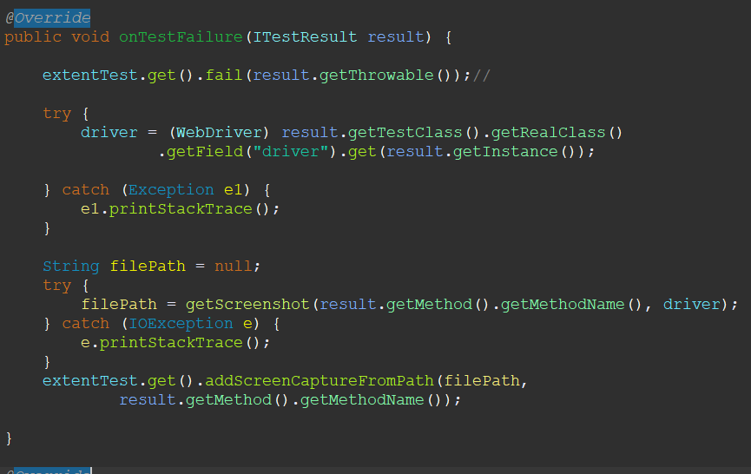

at the end, flush() is crucial:

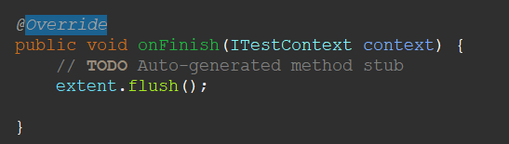

Note: if you don’t run your tests in series, your report cannot identify which test failed.

To make it thread-safe, we can use ThreadLocal:

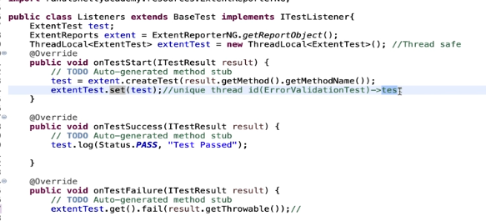

ThreadLocal assigns a unique id to each test so that tests are trackable.

We accomplish it in onTestStart(ITestResult result) so it is created for each test.

Also use extentTest.get() instead of “test” to indicate it is still the same test.

Last topic of this section: IRetry Analyzer:

TentNG Retry mechanism

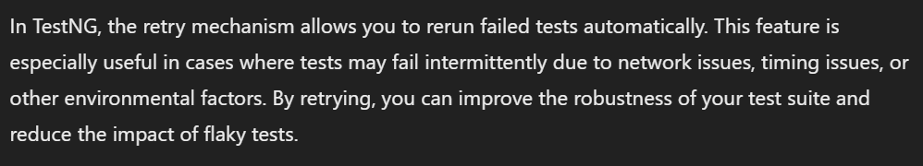

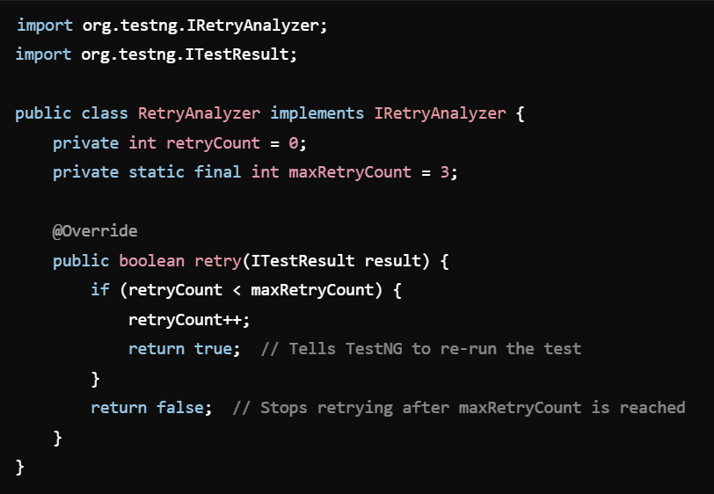

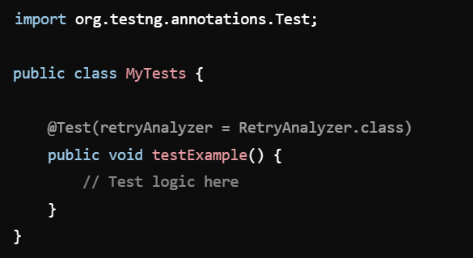

optional: 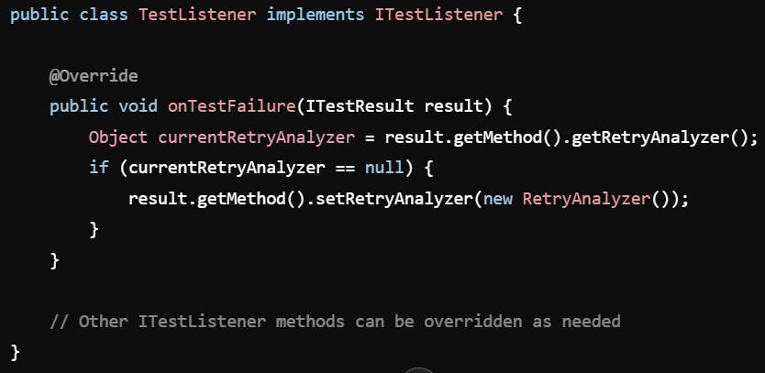

or in our example: (just retry the problematic test!)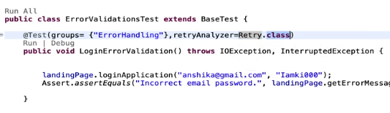

# Section 23 – Framework Part 6 – Test Execution from Maven & Integration with Jenkins CI/CD

Running maven commands from the command line:

mvn -version

mvn test

-P Regression (-P: profile, Regression: profile name)

-D browser=firefox (-D:parameters, browser:a parameter name defined in test classes)

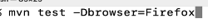

ternary operator in java:



String s = a!=null ? x : y;

CHROME HEADLESS MODE:

ChromeOptions options = new ChromeOptions();

options.addArgument(“headless”);

driver = new ChromeDriver(options);

MAXIMIZE MODE:

driver.manage().window().maximize(); (This does not work in headless mode)

driver.manage().window().setSize(new Dimension(1440,900)); (You can use thjs one)

JENKINS:

Dashboard:

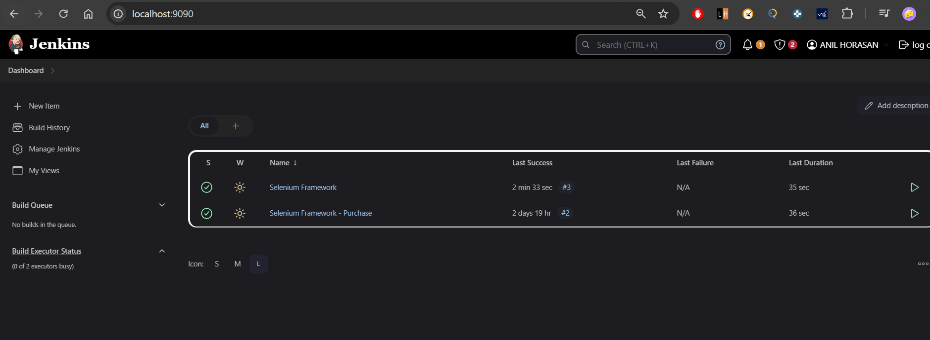

Project page:

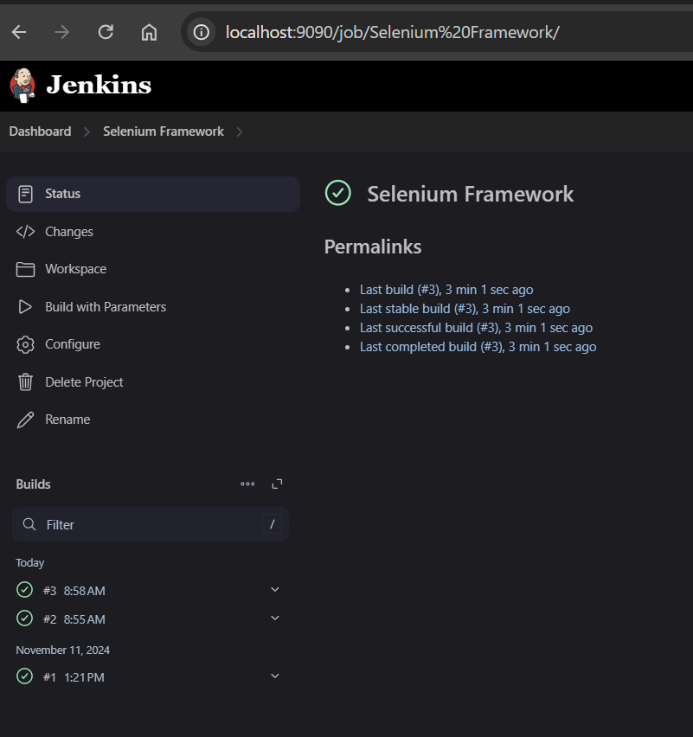

Configure the project so that it is parametrized:

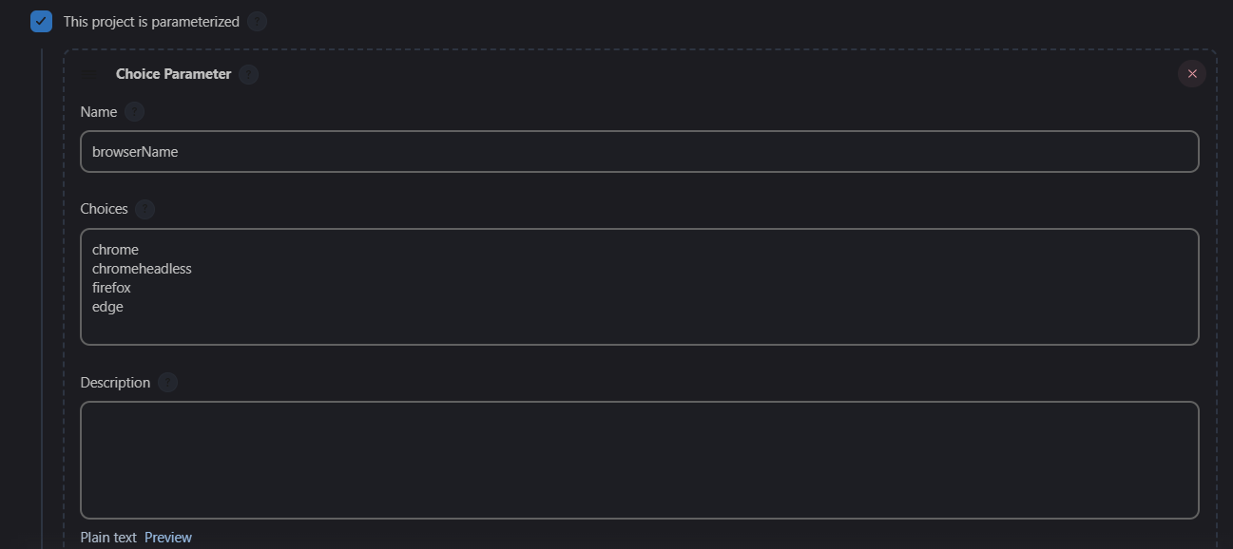

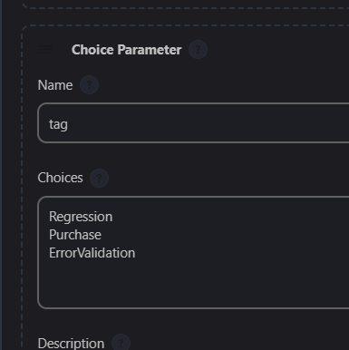

Configure the project’s build steps:

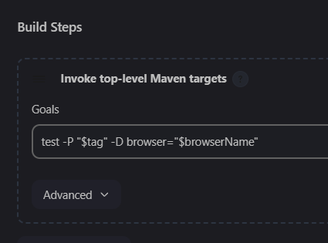

WHY JENKINS IS IMPORTANT: (By chatGPT)

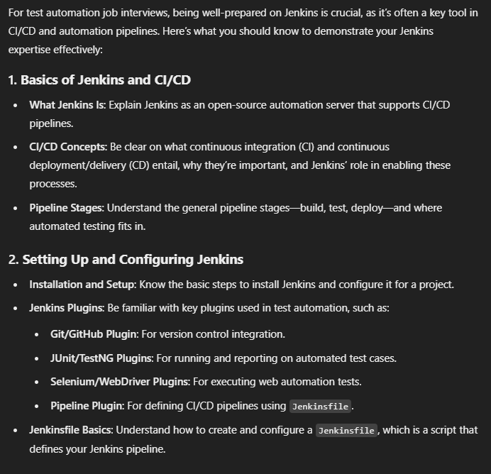

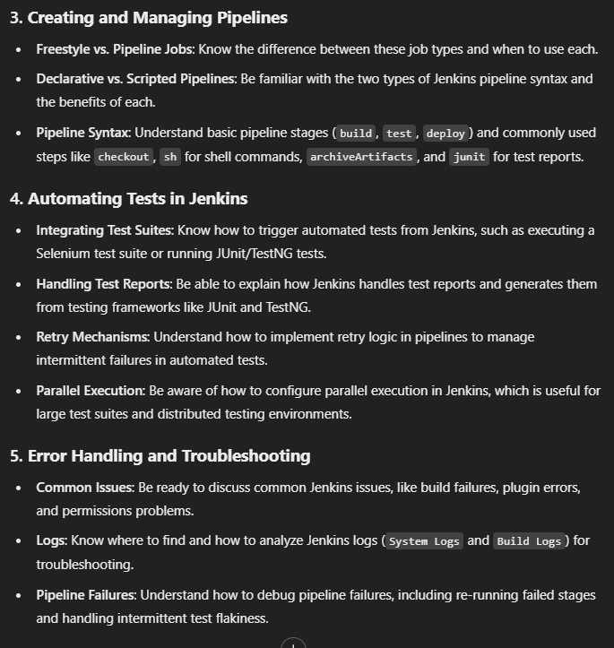

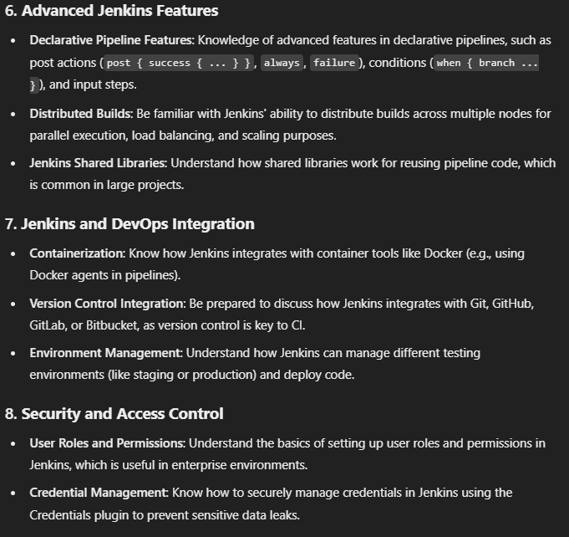

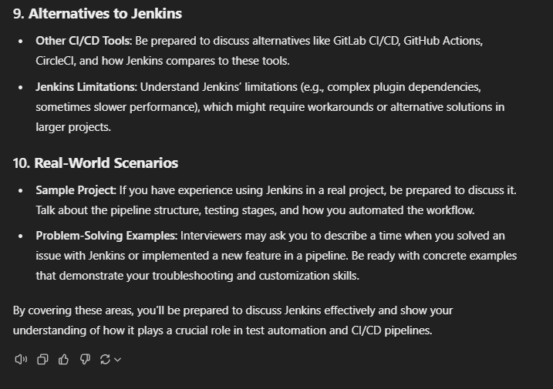

Schedule Jenkins so that it runs periodically:

this is for 7 am every day

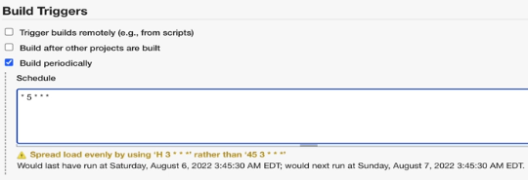

this is for 3:45 every day:

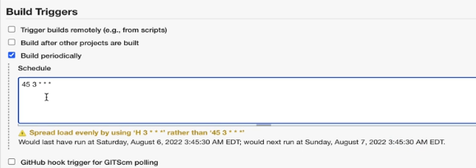

24th of every month at 5 am:

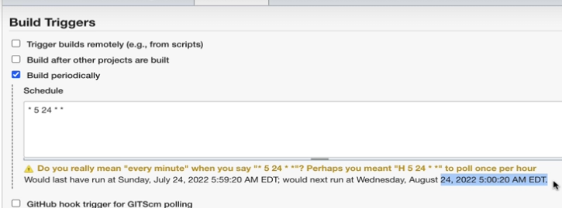

Daily in december:

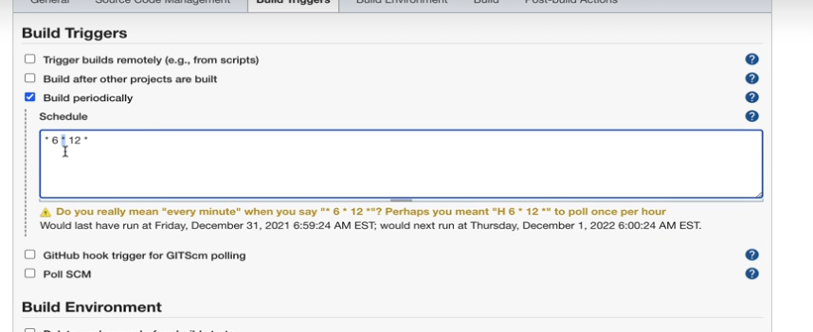

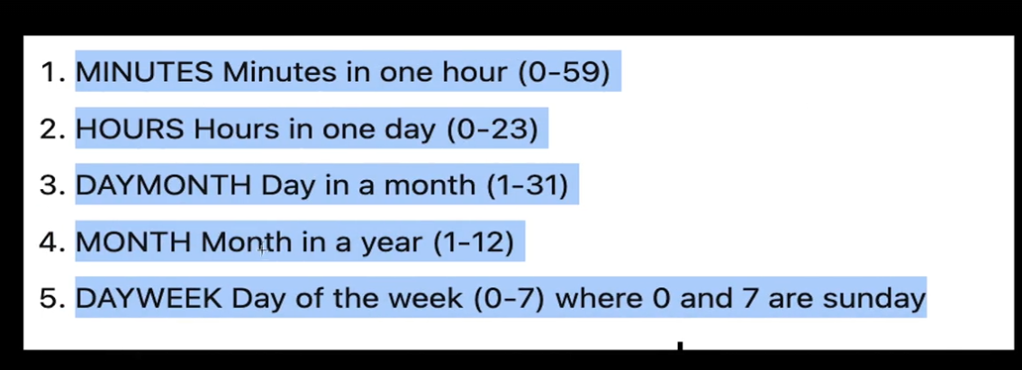

December every Sunday:

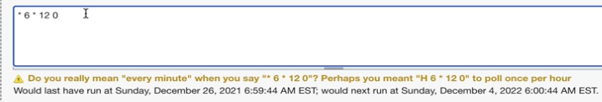

Typically people set their build period daily.

For the yellow error to go, we can use H parameter:

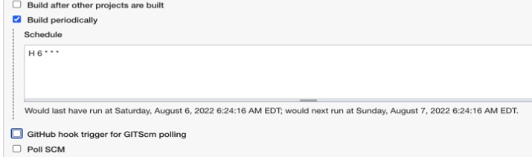

Without H, it is at 6 but every minute of 6... But with H, it says exactly once between 6 and 7 am.

# Section 24 – Framework Part 7 – Common Selenium Framework OOPS Interview Questions

This section is in the end. First complete every section, then start working on interviews!!

FOLLOW the Link

# Section 25 – Framework Part 8 – Integrating Cucumber Wrapper into Selenium Framework

Cucumber is like a Selenium Framework. Every test we have done so far can also be done using Cucumber. However, we will now learn how to mix Cucumber and Selenium Framework!

There is a separate course for only Cucumber without TestNG. But now, we will only consider the high-level concepts here.

This section is a two-part section:

1. Understanding of cucumber
2. Cucumber integration to existing framework

From chatGPT:

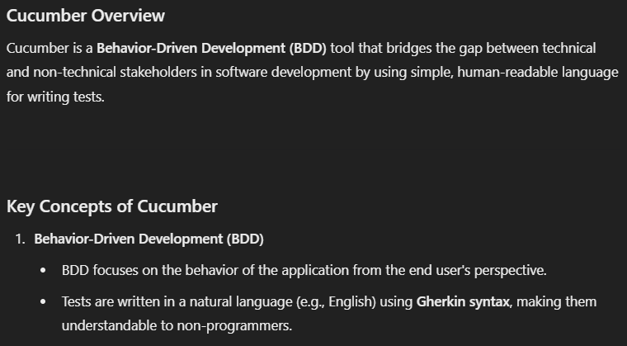

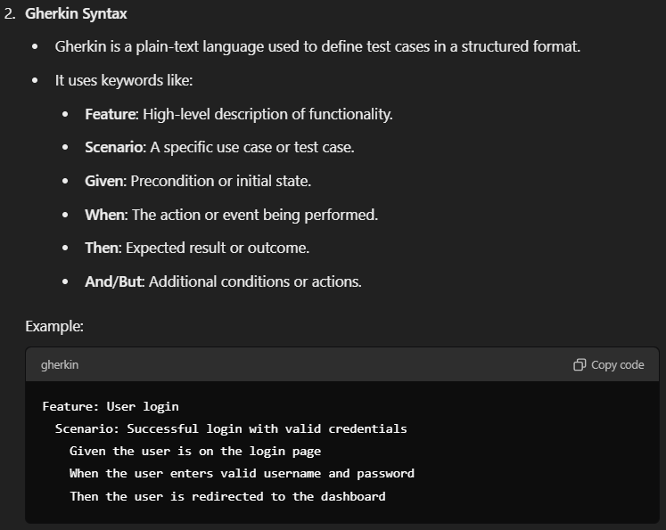

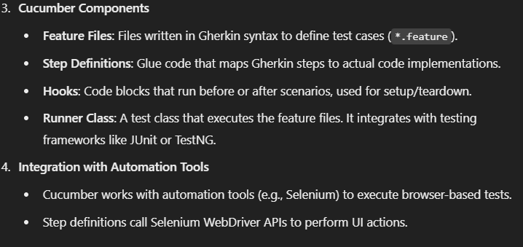

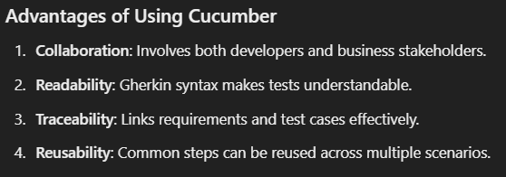

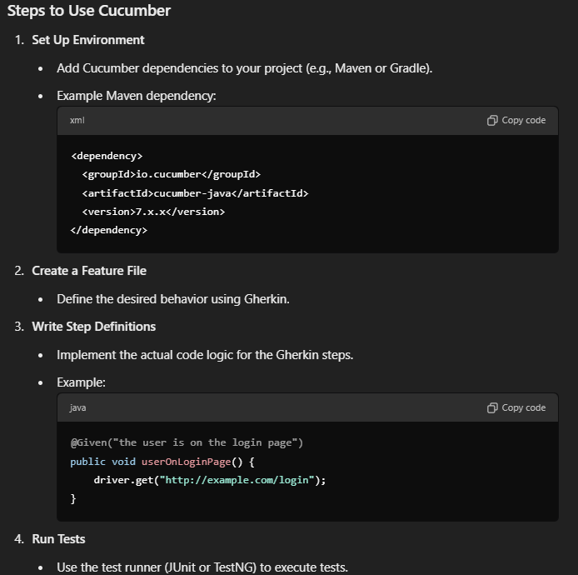

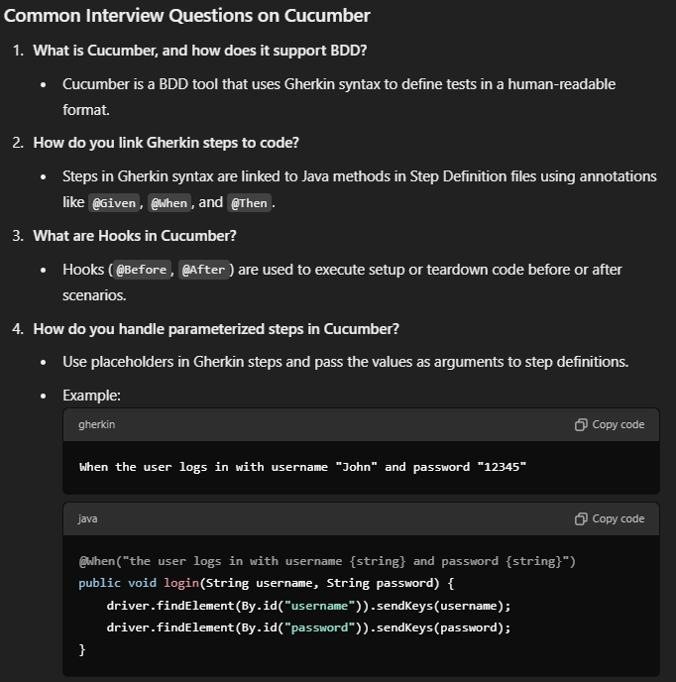

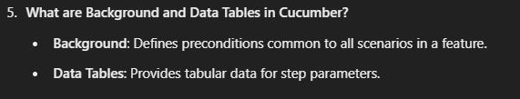

Gherkin is a Business Readable, Domain Specific Language.

Keywords:

* Scenario
* Feature
* Feature file
* Scenario outline
* Step definition

FEATURE: Credit Card Payment

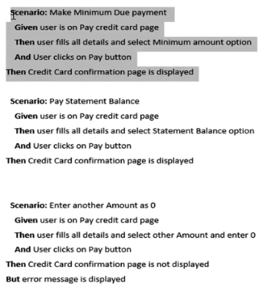

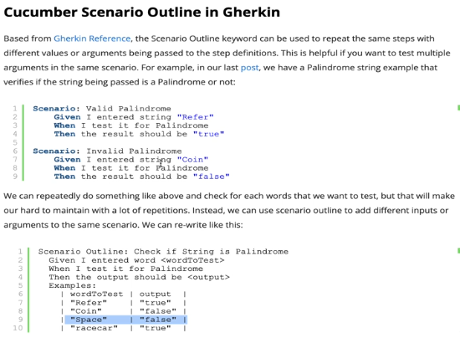

DEPENDENCIES:

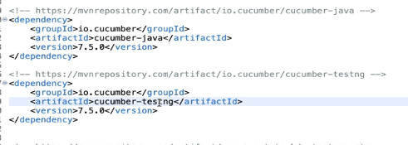

If you have cucumber plugin in your eclipse and you create a .feature file, then a template will be ready in your file as:

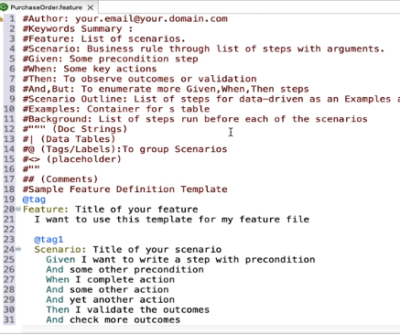

Applying to our case:

Explorer:

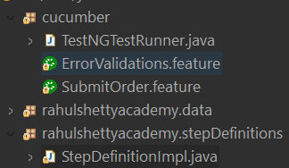

StepDefinitionImpl.java

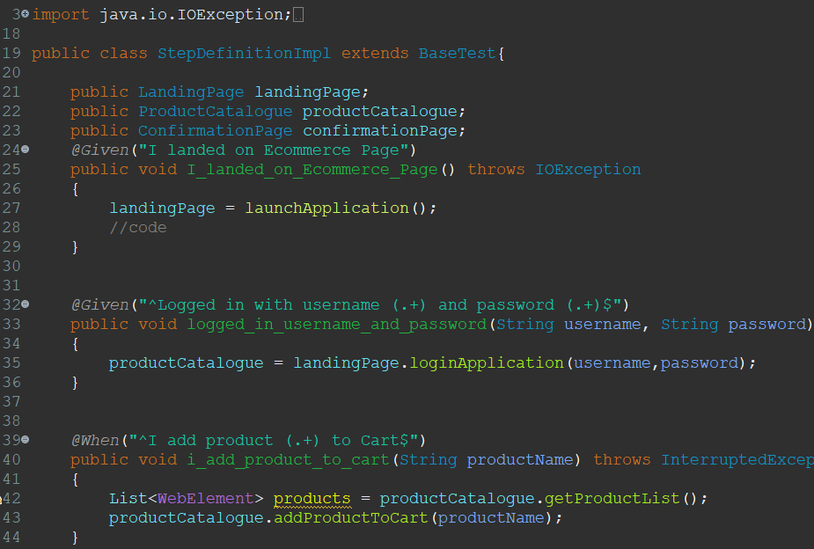

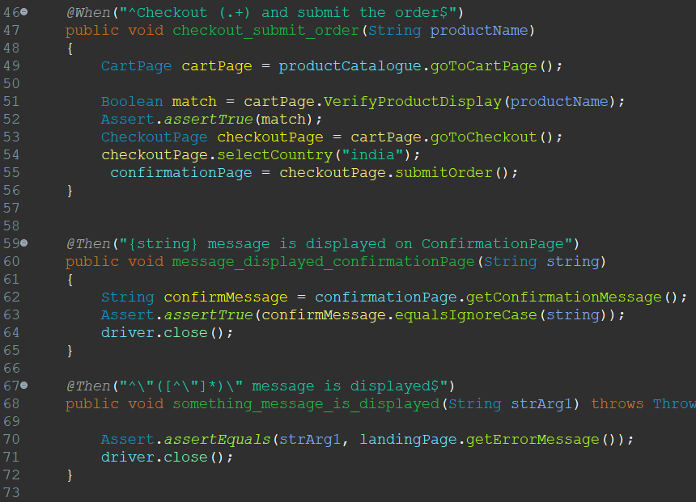

SubmitOrder.feature:

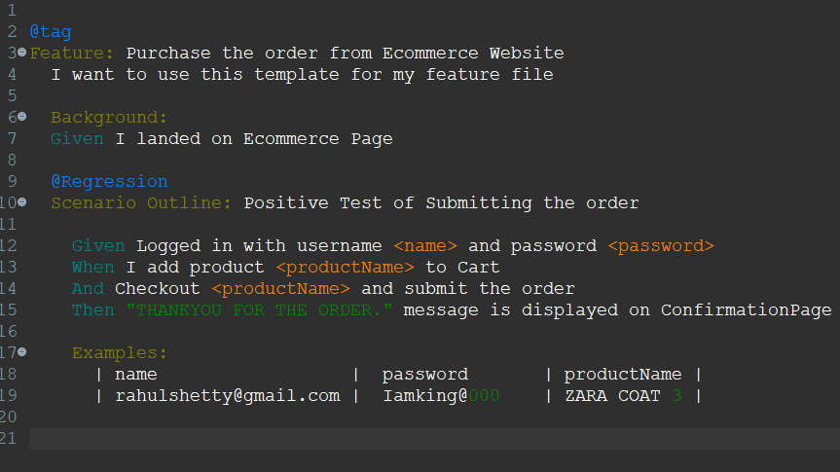

ErrorValidations.feature:

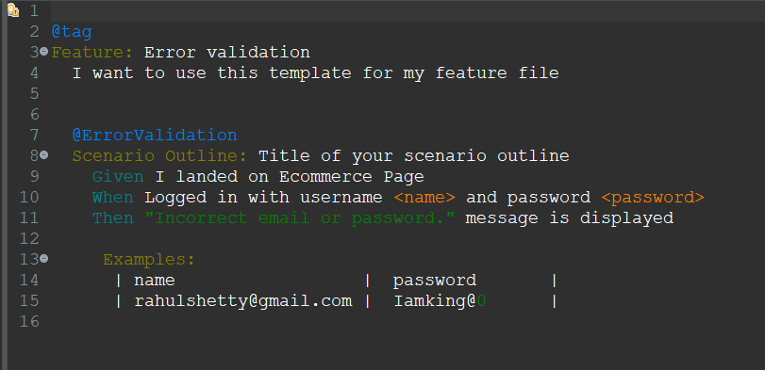

TestNGTestRunner.java: (This file is needed to run the Gherkin file)

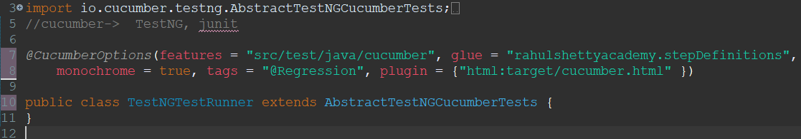

BUT for this there is a nice plugin called TIDY GERKIN in google chrome

OR use chatGPT to generate the java file for you!

Tidy Gerkin Result from the course videos:

input:

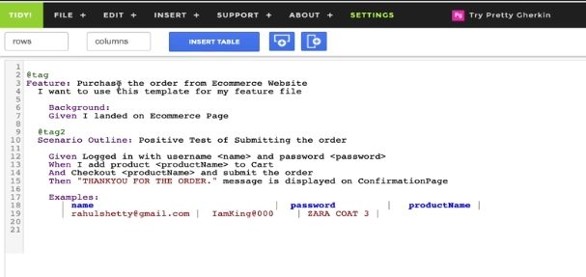

Output:

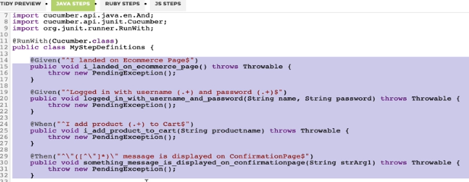

ChatGPT result:

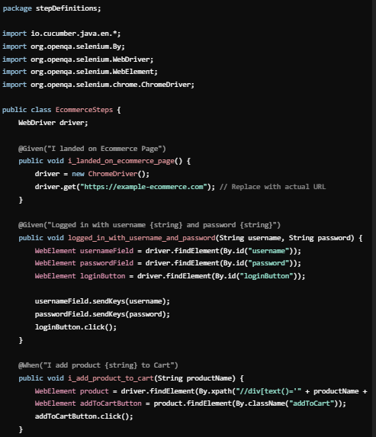

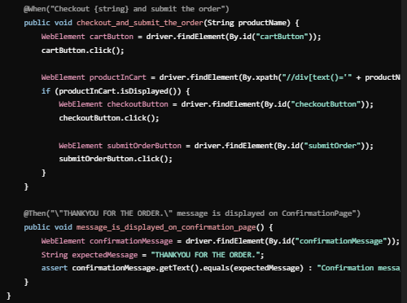

Also ChatGPT writes TestNg runner code for you! :

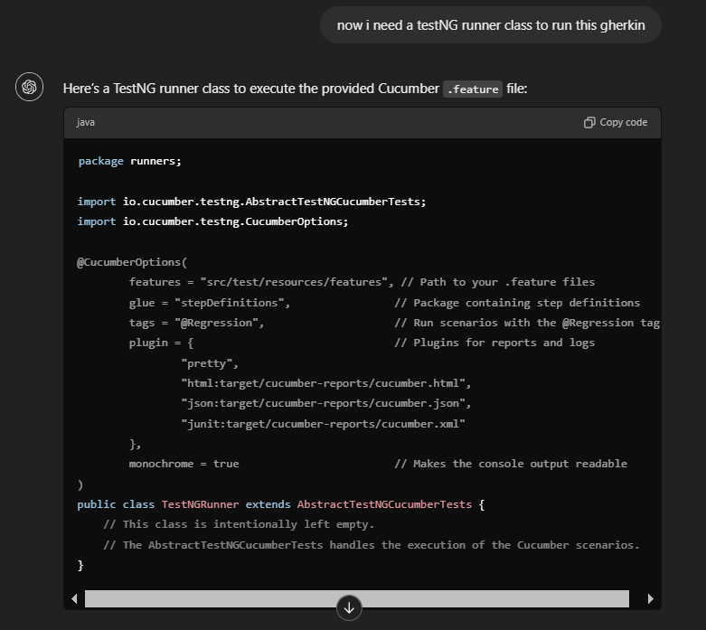

This is how you should implement your test in pom.xml:

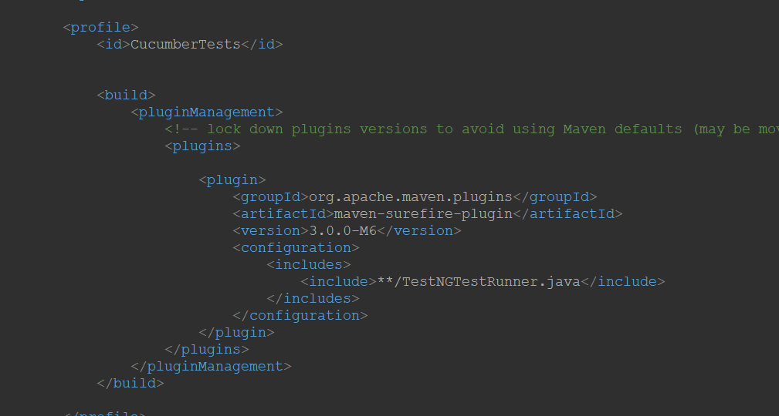

here **/ means search for all folders in your project folder.

# Section 26 – HIGH FIVE! You Are Amazing!

There are more sections to go to advance in Selenium. 20 hours to go :(

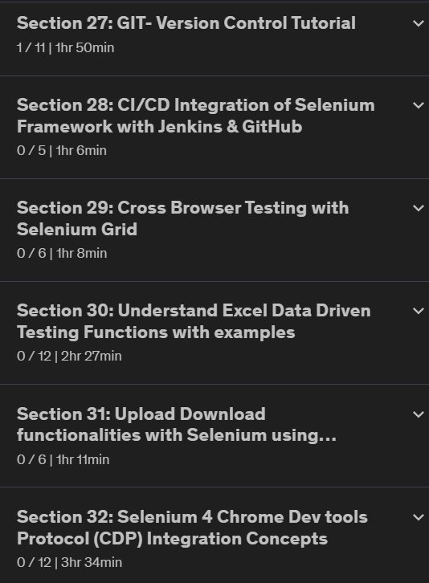 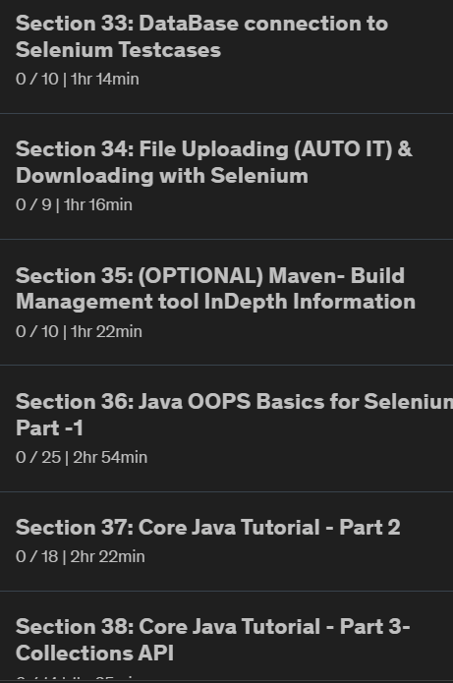

# Section 27 – GIT – Version Control Tutorial

There are alternative ways to control Git projects like:

* Tortoise git – for UI Git controls
* Eclipse add-on
* Intellij add-on

However, we will use command line for Git commands.

Basic Git commands: <https://confluence.atlassian.com/bitbucketserver/basic-git-commands-776639767.html>

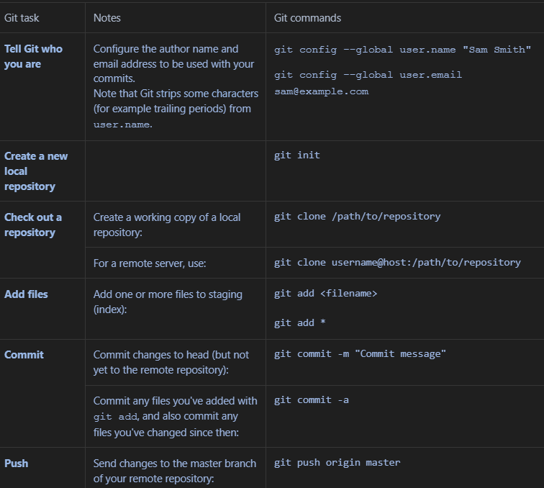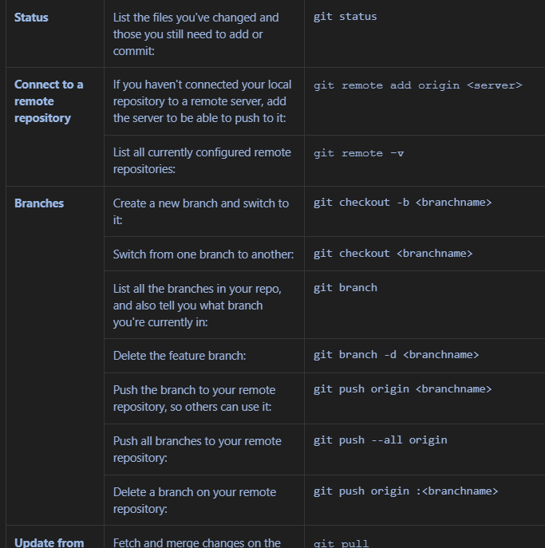

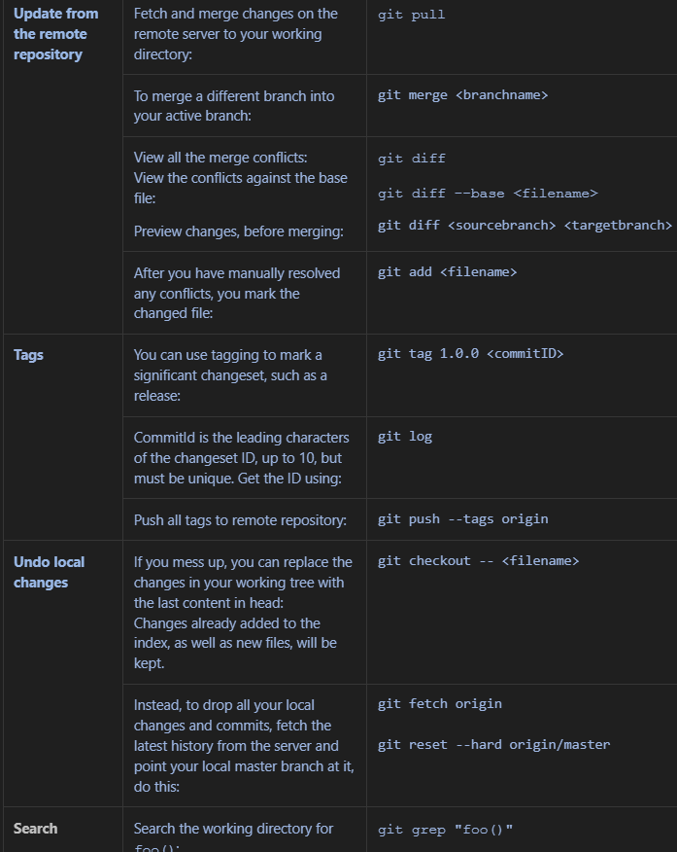

STEPS:

* You have the code
* Initialize it as Git repository (git init)
* Stash – Commit

GITHUB

create a new repo full example:

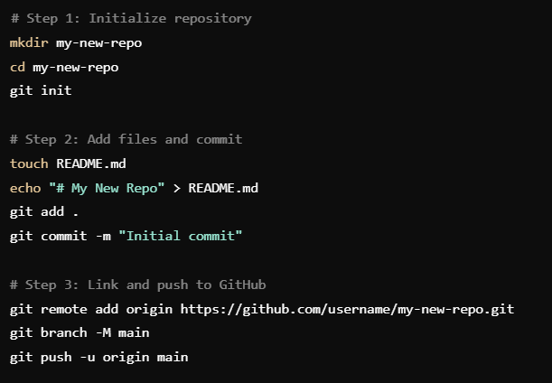

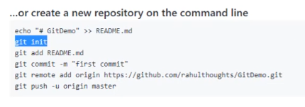

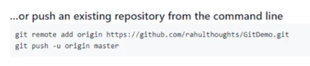

Useful terminal commands:

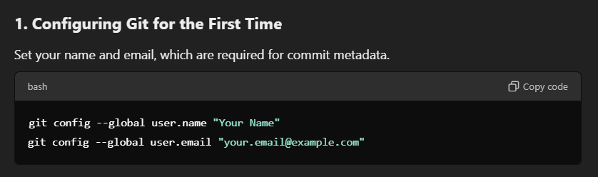

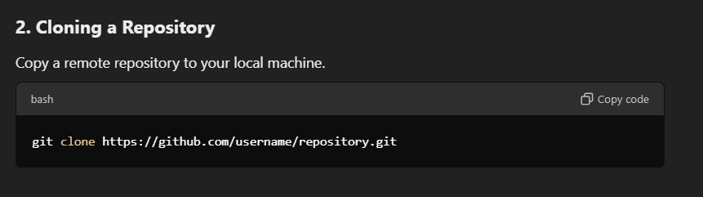

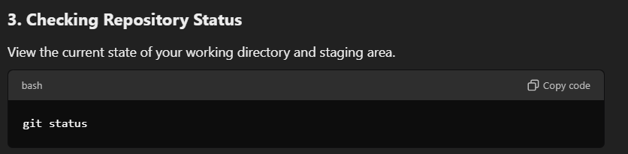

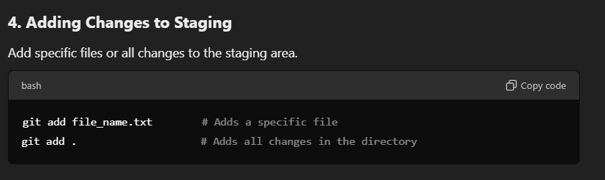

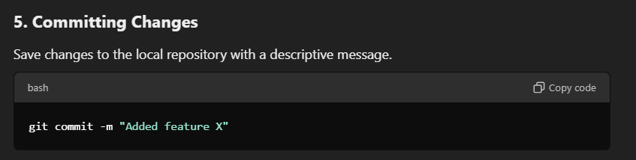

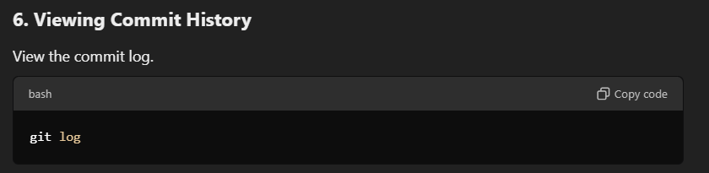

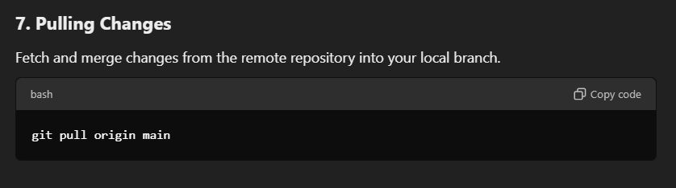

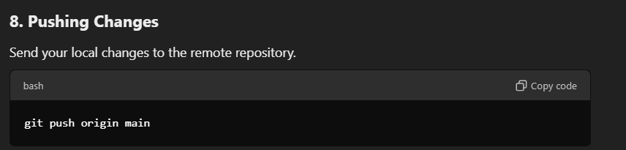

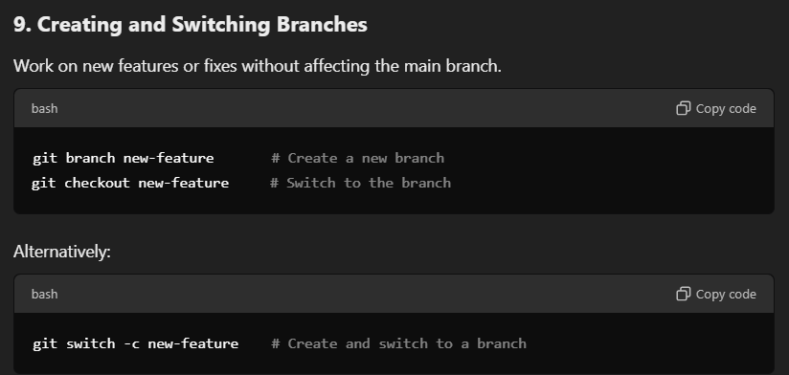

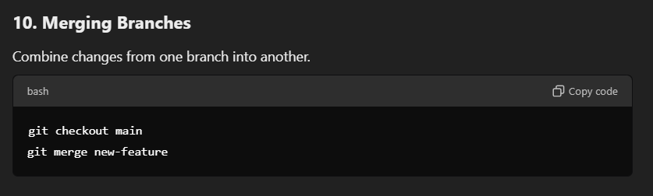

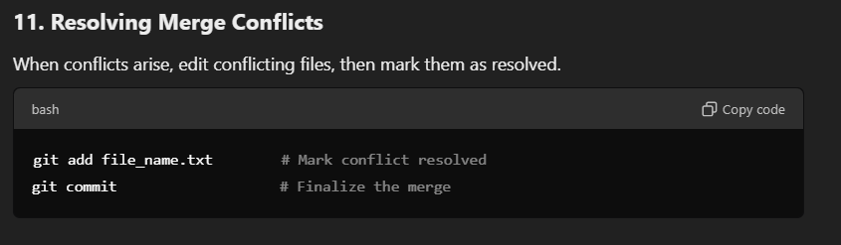

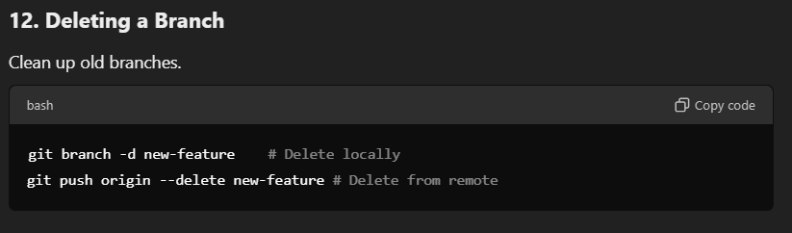

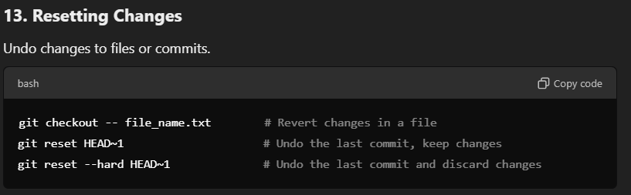

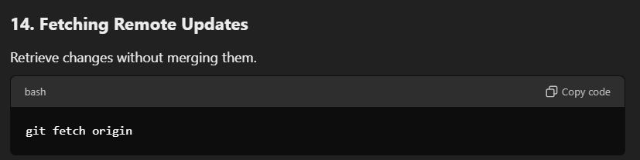

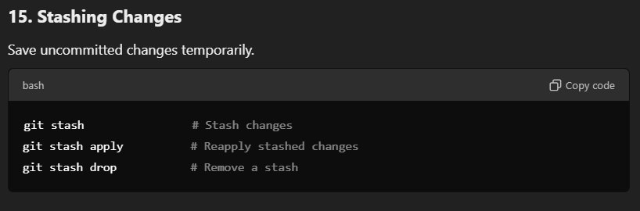

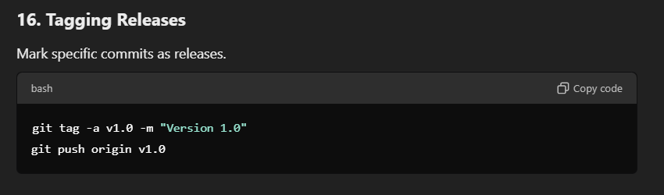

# Section 28 – CI/CD Integration of Selenium Framework with Jenkins and Github

prerequisites: Jenkins & Github sections...

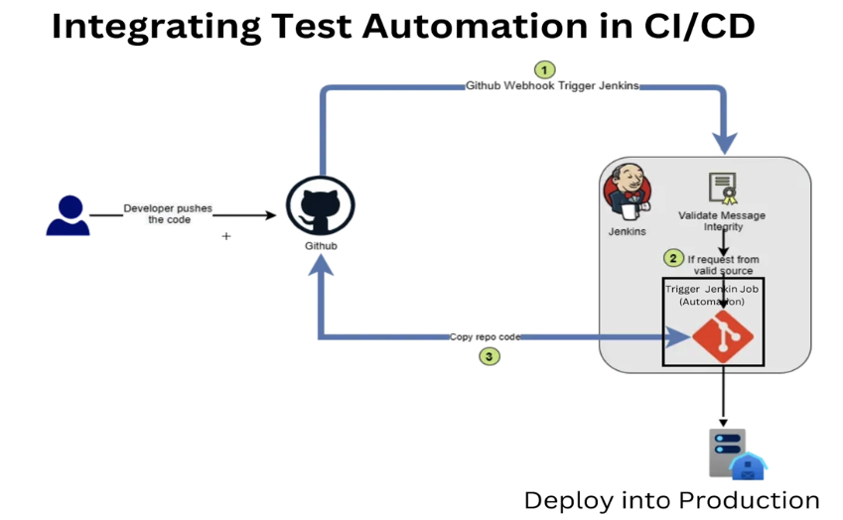

Again start with Jenkins.

Jenkins must be empty to start with.

If Jenkins folder is not empty, cut and paste all the files and folders from .jenkins folder to somewhere else for future use.

The use these commands to start Jenkins. If no port is indicated, then it will start from 8080 I suppose. We will see.



From this part on, I could not take notes. Here are some of them that I remember:

* Jenkins is a CI CD tool meaning that after every code change, code is tested automatically and deployed to the production. Now, we will simulate this. First, we will change the code, then push it to Github and it will be automatically tested and deployed!
* First step is to configure Jenkins:
  + Jenkins --> Manage Jenkins --> System

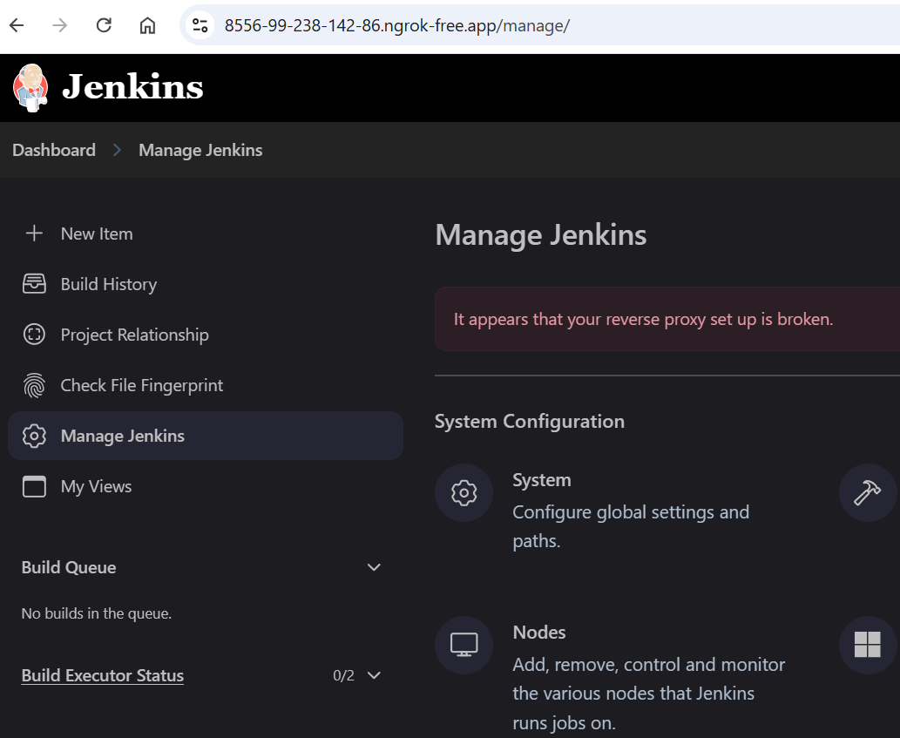

* Then scroll down to see Github settings. Click the Override Hood Url, Copy the URL, then UNCLICK it! This step is just to take the URL...

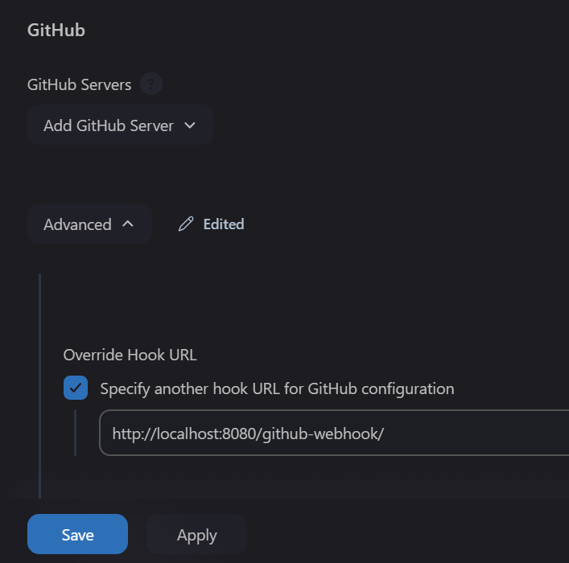

* NGROK... Take the Forwarding URL from here, paste it to github and also your browser...

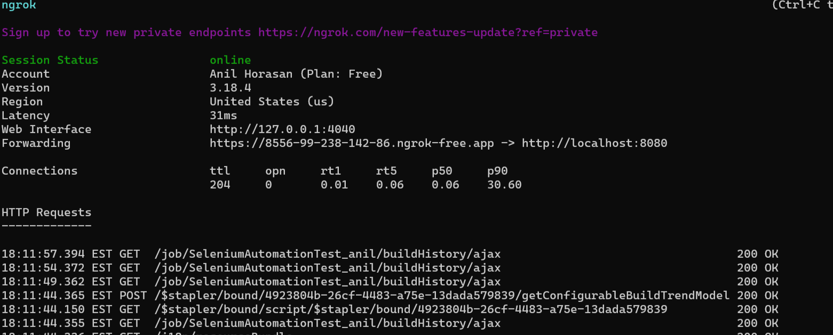

* Second step is to configure Github:
  + In github, open the repo’s settings. Click webhooks:

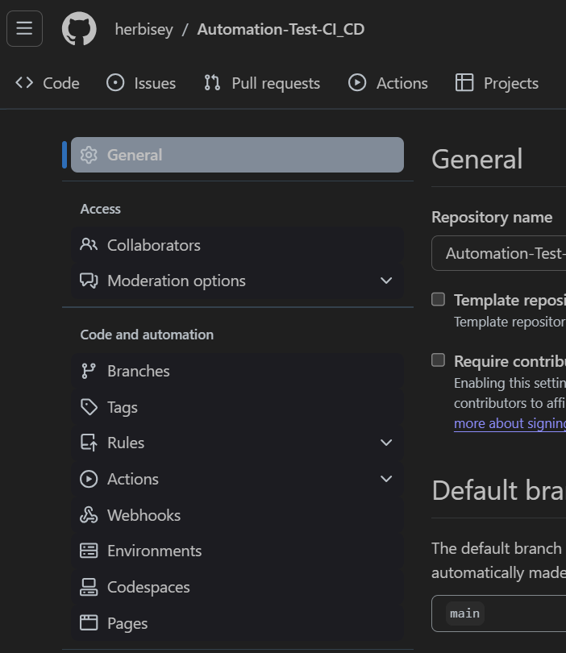

* + Payload URL is the URL you took from Jenkins, but change the starting section with the one you got from ngrok! Also Secret is your token (like credentials)

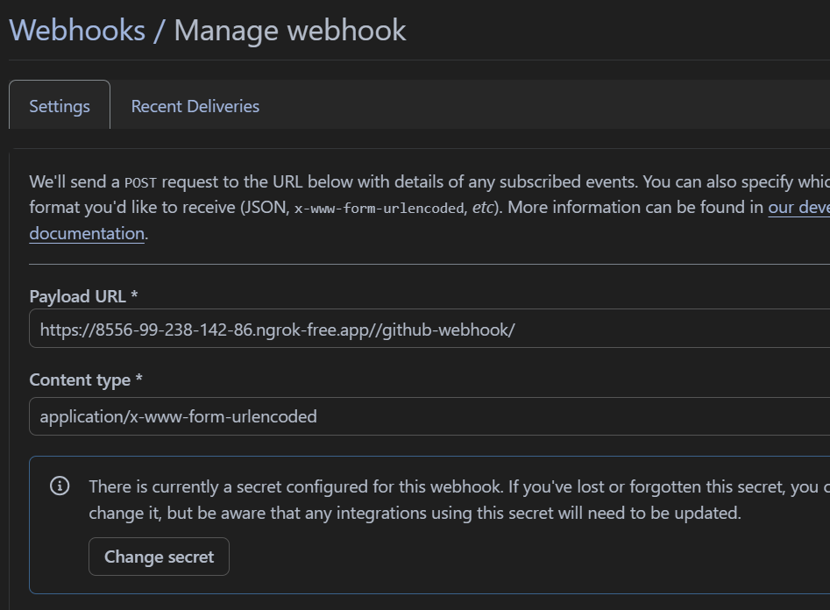

* + Disable SSL and click Active!!!

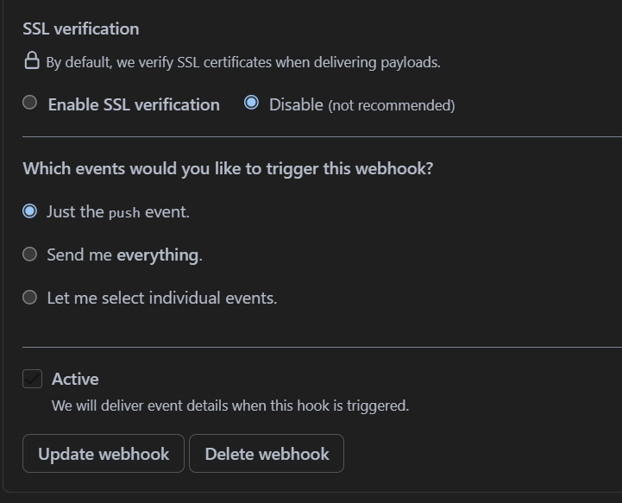

* Third step is to change the code and push to see the results!

git status

git add .

git commit -m “test”

git push origin main

* after pushing, we must see that the project is running in jenkins...

# Section 29 – Cross Browser Testing with Selenium Grid

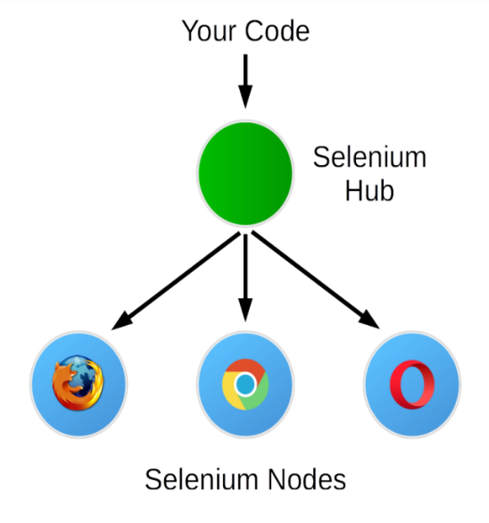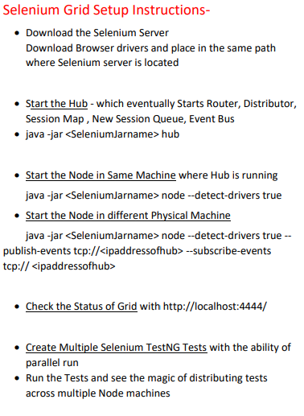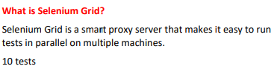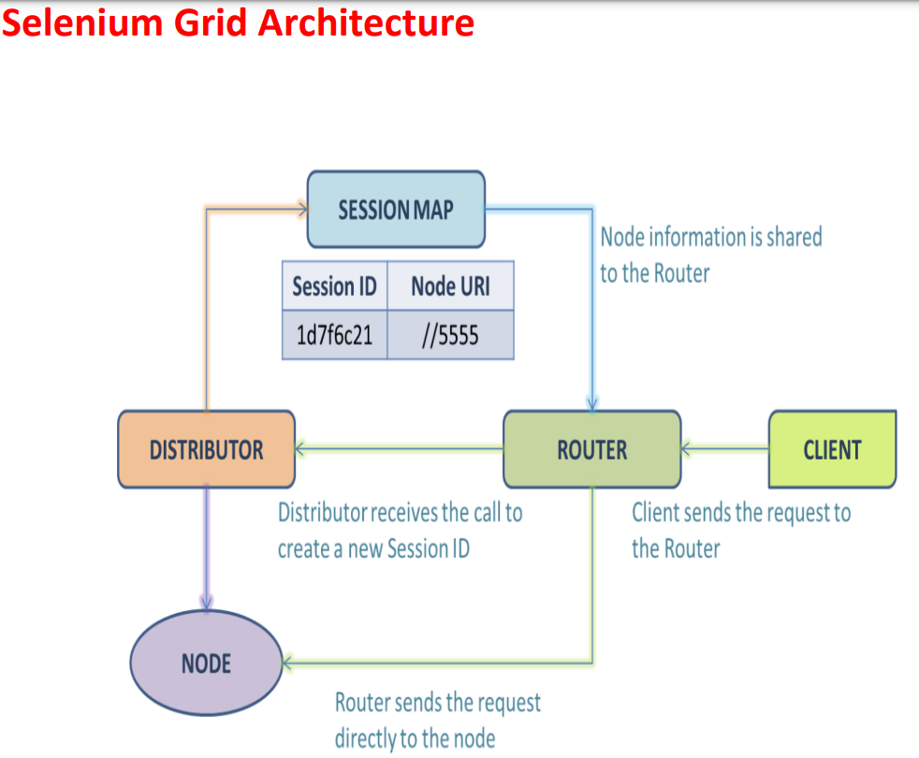

Note to myself: Changing eclipse directory: <https://stackoverflow.com/questions/66644445/changing-directory-of-stm32cubeide-projects>

FROM CHATGPT:

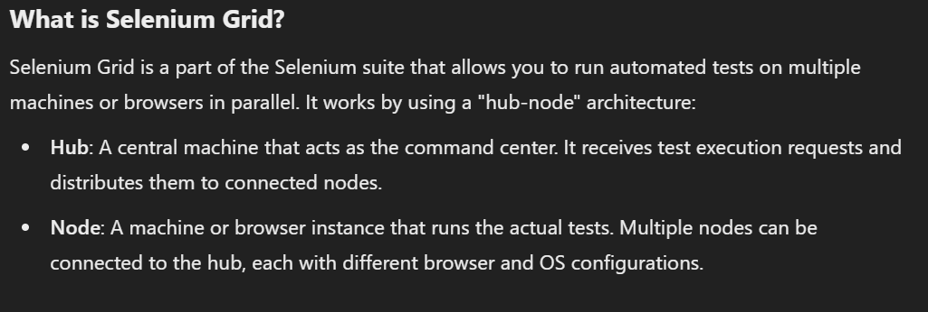

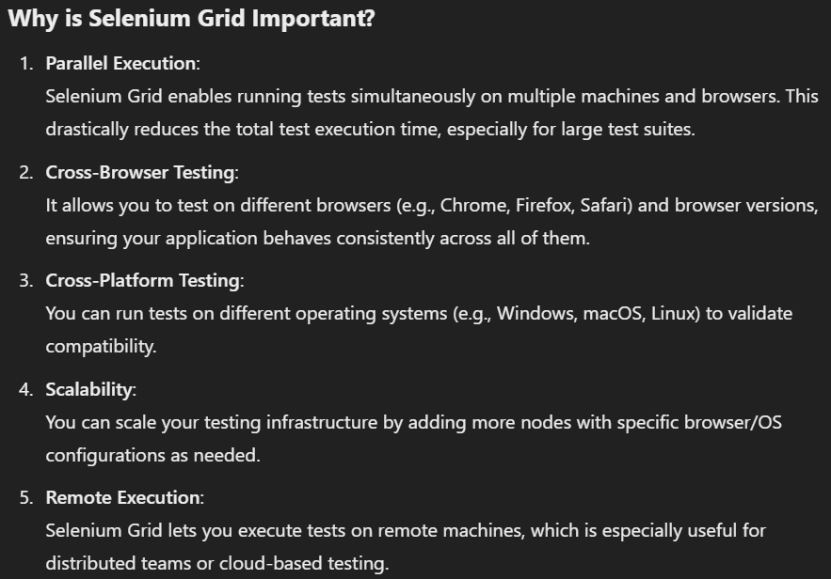

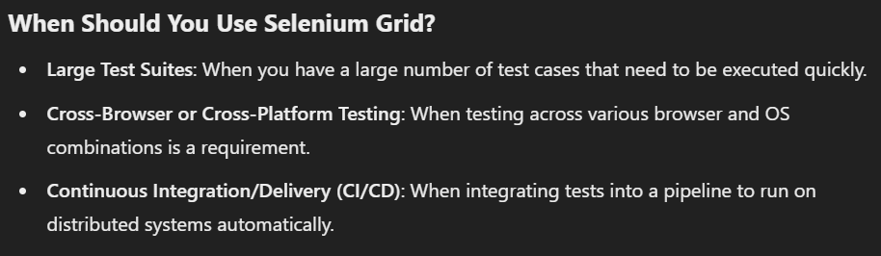

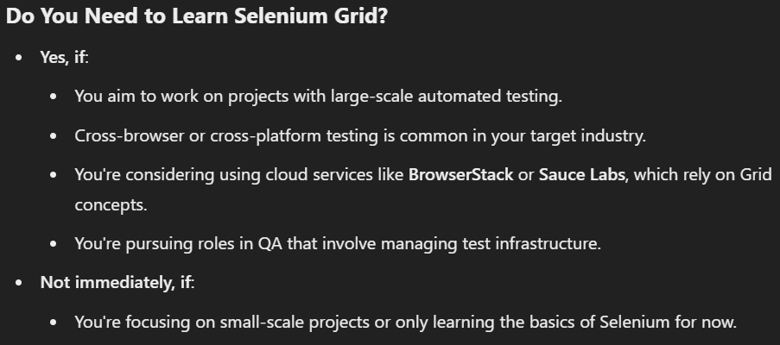

From this perspective, Now, I will just watch the videos, take notes, and get prepared for the interview questions. But I will not apply anything for now...

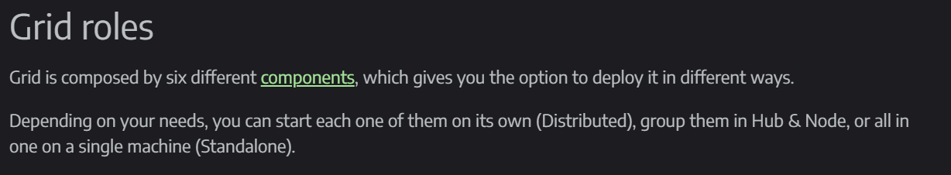

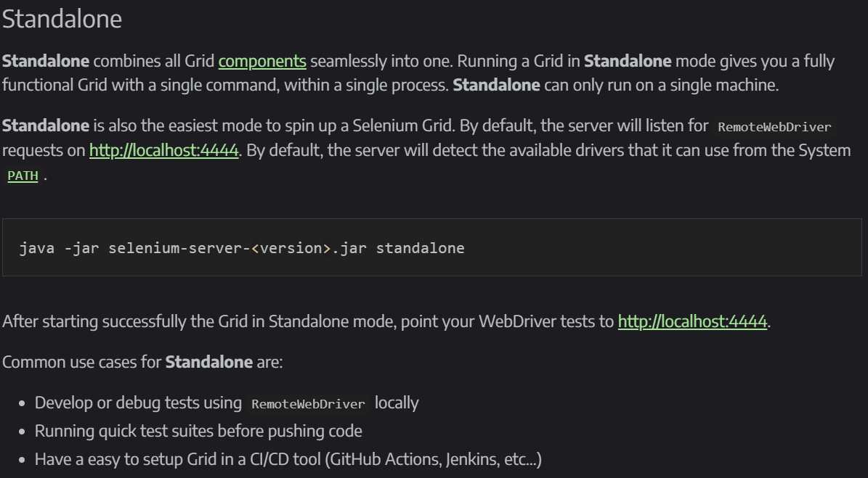

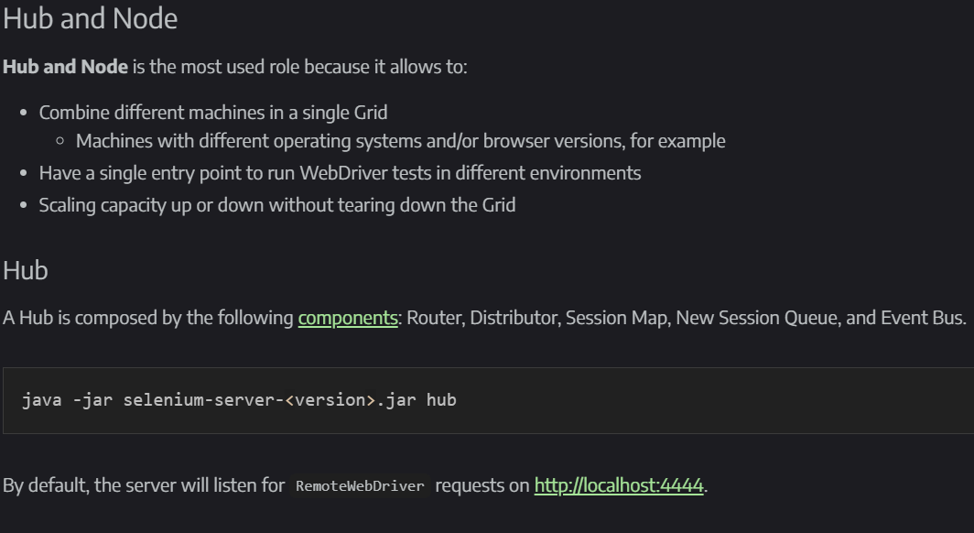

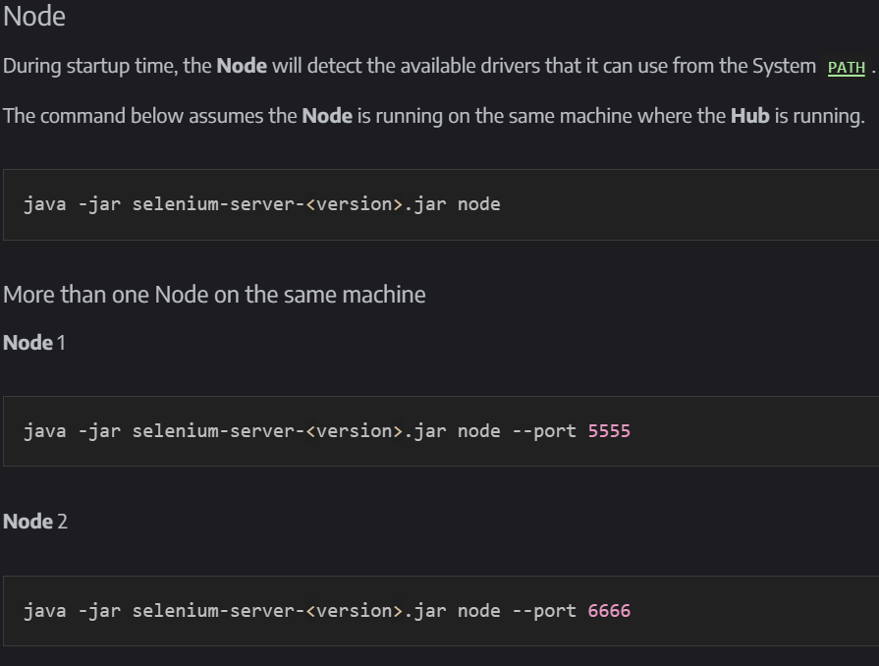

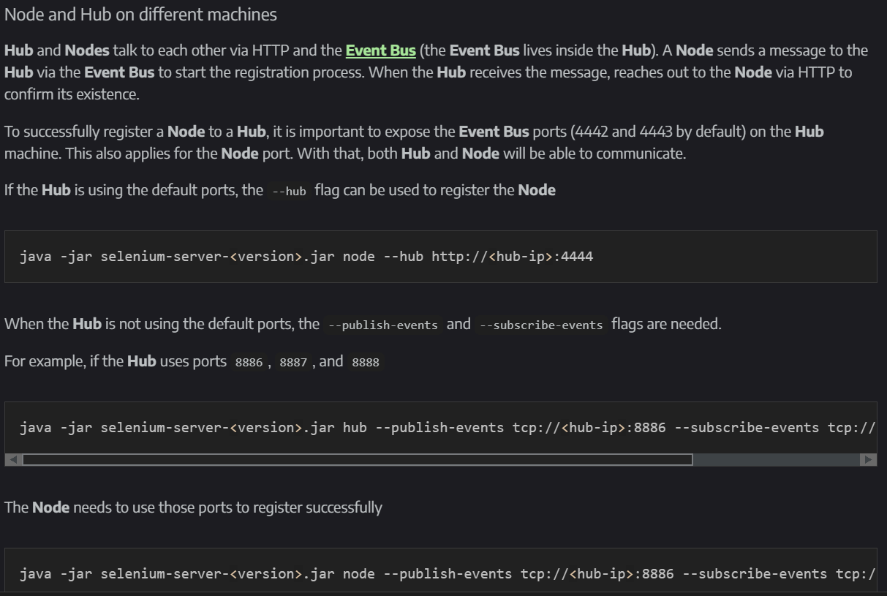

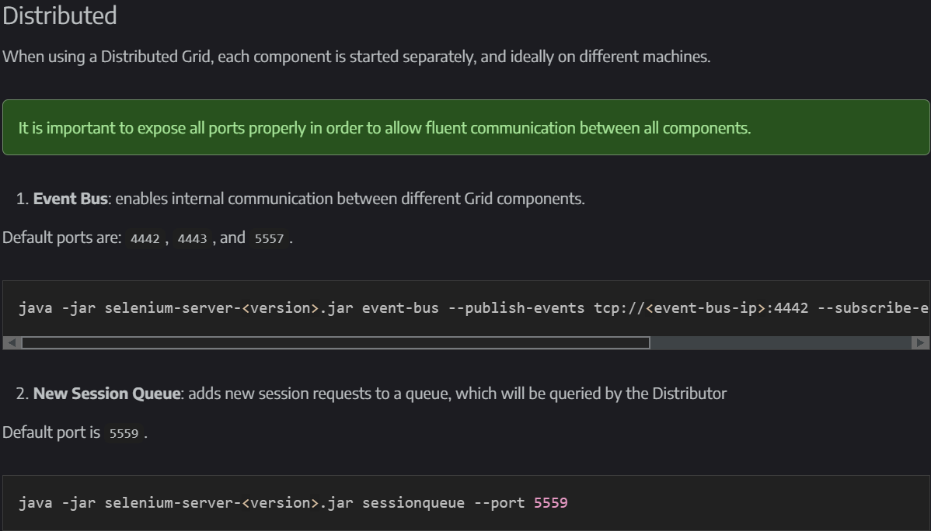

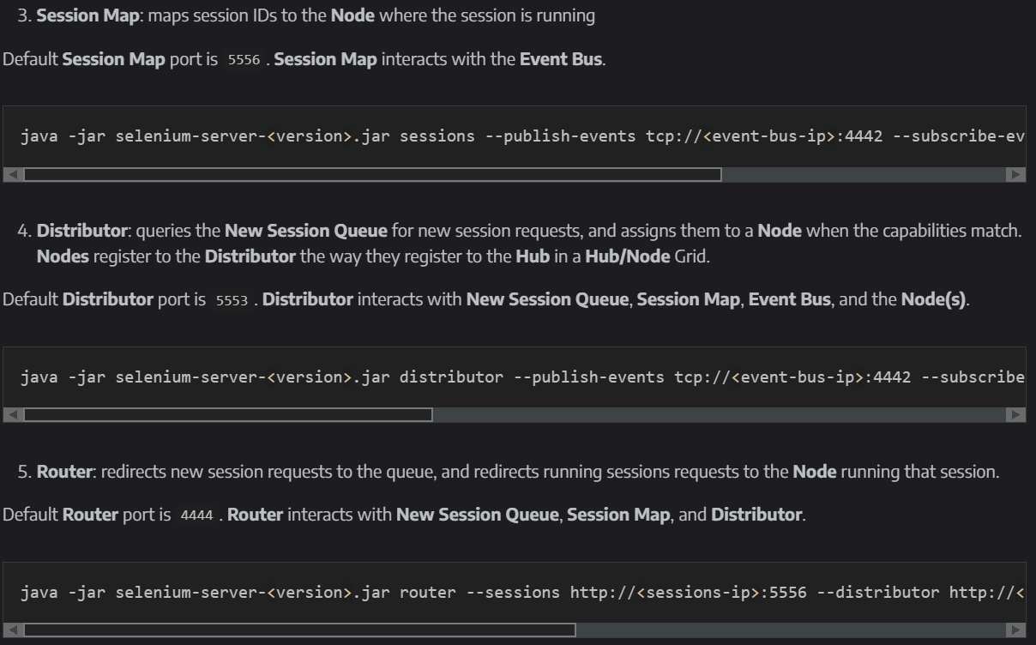

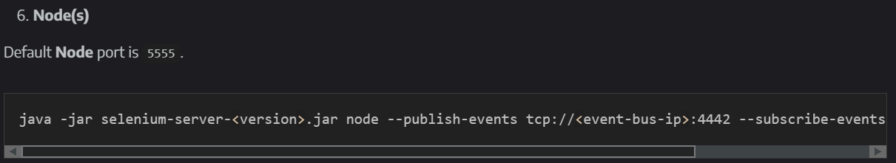

Standalone: For small and quick tests

Hub and Node: Mostly used. WE WILL EXPLORE THIS FURTHER

Distributed: Complex. Each component should be started separately. Each component: Router, Distributor, Session Map, New Session Queue, and Event Bus and nodes...

2 types of tests:

* hub and node in the same machine
* node in another machine

If node is in another machine: XPUB (publish) and XSUB(subscribe) 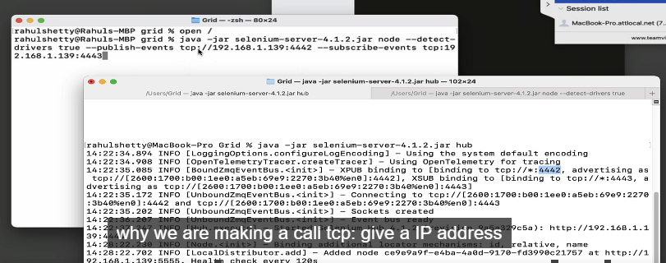

to start with our test code:

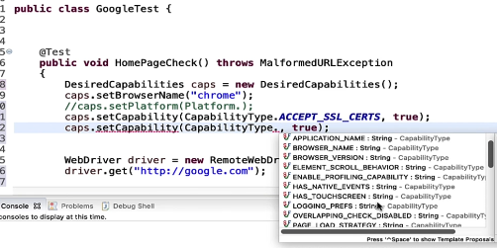

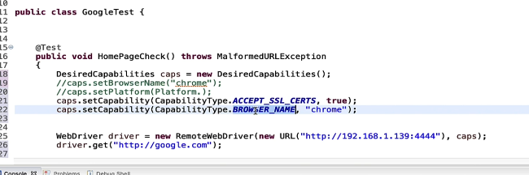

# Section 30 – Understand Excel Data Driven Testing Functions with Examples

You can download Apache POI from below official link

<https://poi.apache.org/>

You can also get more exposure about Apache POI API with selenium from below link

<http://www.guru99.com/all-about-excel-in-selenium-poi-jxl.html>

An interview question:

* How do you get data from excel in your tests?
* By using Aoache POI API...

Let us get started!

Maven Dependencies setup:

poi-ooxml and poi

**Strategy to Access Excel Data: (**Excel file --> Sheet --> Row --> Cell --> toArray**)**

Create object for XSSFWorkbook class - get hold of excel here

Get Access to Sheet

Get Access to all rows of sheet

Access to specific row from all rows

Get Access to all cells of row

Access the data from excel into arrays

Excel data:

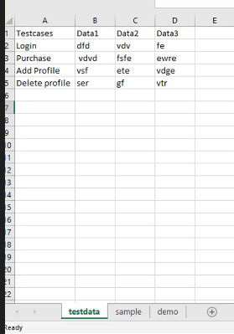

code:

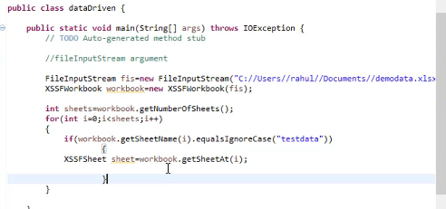

code explanation:

* FileInputStream is a java.io package that lets you use any type of file format
* XSSFWorkbook is a poi class that takes excel file as FileInputStream object and make it a usable XSSFWorkbook object.
* getNumberOfSheets() method gets the sheets. we need “test data” sheet.
* getSheetName(int x) method gets the name of the xth sheet as String.
* getSheetAt(int x) gets the xth sheet as XSSFSheet.

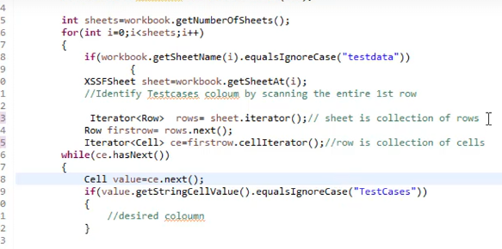

Code explanation:

* Use iterator() to iterate between rows and cells.
* We know that testcase is in the first row
* But we are not sure if it is in the first column or not. So we again check by its name.
* cellIterator() is another iterator.
* getStringCellValue() is a method to get Cell value as String.

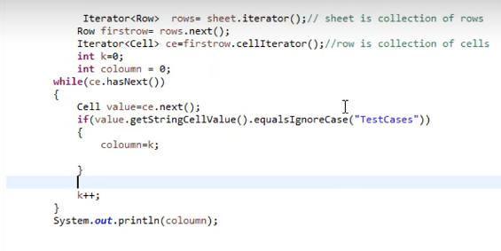

Code explanation:

* get the column of “TestCases”

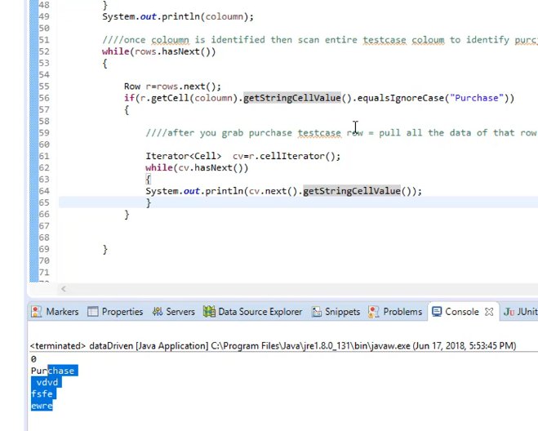

then take this code and insert it in a method that returns an ArrayList:

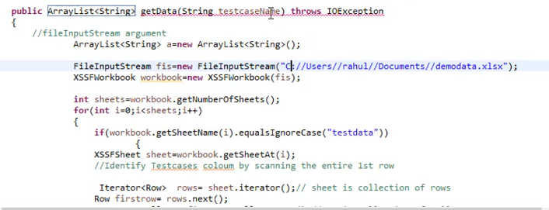

# Section 31 – Upload Download Functionalities with Selenium using External Excel Files

# Section 32 – Selenium 4 Chrome Dev Tool Protocols (CDP) Integration Concepts

# Section 33 – Database Connection to Selenium Testcases

# Section 34 – File Uploading (AUTO IT) & Downloading with Selenium

# Section 35 – (Optional) Maven Build Management Tool In-Depth Information

# Section 23 – Framework Part 7 – Common Selenium Framework OOPS Interview Questions

**INTERVIEW QUESTIONS:**

1. What are the Design Patterns you have used in writing the tests in the Framework?
2. How are reusable utilities handled within the framework?
3. Where did you use Inheritance OOPS Concept in your framework?
4. How di you drive the data from external files in the Framework?
5. Did you use Interfaces in the Framework? If so, its usage?
6. How are you achieving Encapsulation in the framework?
7. Dows your Framework support parallel runs? How are you writing Thread safe code?
8. Do you have static keywords in the framework? If so, its usage?
9. How are you sending Global Properties to your test at run time?
10. What is the mechanism you use to run only selected set of tests inside the framework?
11. How do you handle flaky tests in the Framework?
12. Does your Framework take screenshot on test failure? How did you implement it?
13. What are the Design Patterns you have used in writing the tests in the Framework?

* Page Object Model.
* All the lines in the test code is derived from page object classes. For example, login page credentials are handled by landingPage class. Then Product Catalogue class handles the add to cart methods.
* Java classes designed upon the pages to be tested!
* Mainly we used page object model, but we have also used PageFactory pattern to create objects and locators.
* 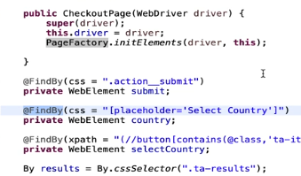
* Also last method of every page is an action method that directs us to the next page class.

1. How are reusable utilities handled within the framework?

* Two different ways:
  + Abstract components:
    - WaitForElementToAppear
    - goToCartPage
    - goToOrdersPage
  + Base Test: Test related reusable methods go into Base Test. example: initializeDriver, beforetest, afterTest. And All of the test cases will inherit BaseTest!
* How to use them? To use abstract components, abstract components class should be inherited using extends keyword. Then, super keyword is used in the constructor of the class, letting abstract class know about its objects.

1. Where did you use Inheritance OOPS Concept in your framework?

* When a method is need to be used many times, it is desirable to put these methods in an abstract or parent class so that in every class definition with extend keyword, those methods are also inherited.
* To keep the test class clean, it is also desired to take common concepts from a parent class.

1. How did you derive the data from external files in the Framework?

* PurchaseOrder.json is used to get data from external file. HashMap data structure is used to gather data from json.
* There is an annotation in TestNG called “DataProvider”. In TestNG, the @DataProvider annotation allows you to run a single test multiple times with different sets of data. This is especially useful for test cases that need to validate multiple input values or scenarios without writing separate test methods for each case.

**What is @DataProvider?**

* @DataProvider is an annotation in TestNG that enables parameterized testing. It allows you to supply multiple sets of data to a single test method, which is particularly useful in data-driven testing.

**How Does @DataProvider Work?**

* @DataProvider methods return a 2D Object[][] array, where each inner array represents a set of parameters passed to the test method.
* Each row in the 2D array corresponds to one test execution with its own set of arguments.
* TestNG will call the test method for each data set, resulting in multiple test executions with different inputs.

**Creating a Simple @DataProvider**

* Define a method annotated with @DataProvider and return a 2D array of Object. You can then link it to a test method by setting the dataProvider attribute in the @Test annotation.
* 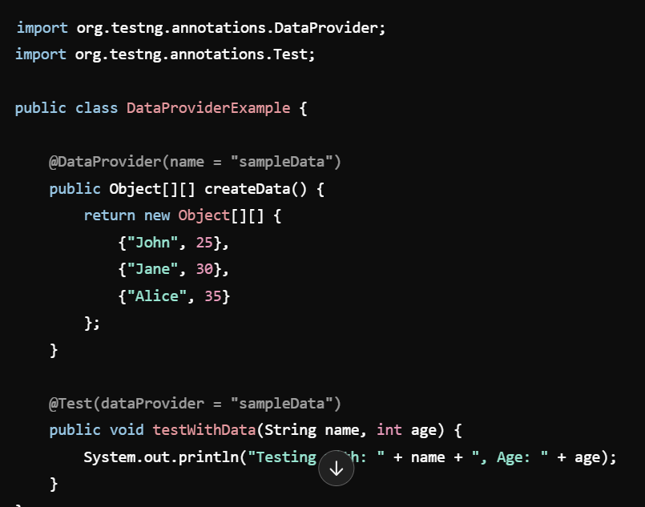

in our example:

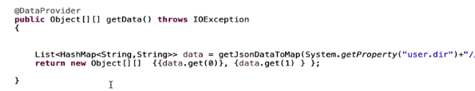

SUBQUESTIONS:

1---- **Advanced Usage of @DataProvider**

* **Providing External Data**: You can load data from external sources like Excel, databases, or JSON files by writing logic in the @DataProvider method to fetch and structure the data.
* **Parallel Execution**: You can use @DataProvider(parallel = true) to run tests with different data sets concurrently, improving execution speed in large test suites.

**2------Benefits of Using @DataProvider**

* + **Code Reusability**: The same test method can validate multiple input scenarios, avoiding redundant code.
  + **Easier Maintenance**: It’s simpler to modify test data in the @DataProvider than to change individual test cases.
  + **Data-Driven Testing**: @DataProvider is essential in scenarios where the test logic is the same, but the data varies, making it a crucial feature for automation and validation.

### Common Interview Questions about @DataProvider

1. **How is @DataProvider different from passing parameters with XML files?**
   * XML parameters are static and defined upfront, while @DataProvider is dynamic and allows for flexible, data-driven testing within the code.
2. **How would you handle different data types in a @DataProvider?**
   * @DataProvider returns an Object[][] array, allowing you to pass any data type, including complex objects, by casting them appropriately in the test method.
3. **Can @DataProvider use data from external files?**
   * Yes, you can write code in the @DataProvider method to fetch data from external sources like databases, files, or APIs.
4. **What are some limitations of @DataProvider?**
   * A key limitation is that the data is defined within the @DataProvider method, meaning large data sets may make the method bulky. For very large data, consider using lightweight file formats or other testing frameworks.
5. **How can you usse json data in your code?**
   * With HashMaps.
   * First read json to a string with the help of FileUtils.readFileToString....
   * Then, There is a dependency called Jackson Databind which converts string to hashmap
   * 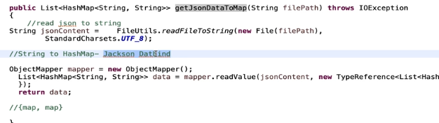
6. **What are some limitations of @DataProvider?**
   * A key limitation is that the data is defined within the @DataProvider method, meaning large data sets may make the method bulky. For very large data, consider using lightweight file formats or other testing frameworks.
7. Did you use Interfaces in the Framework? If so, its usage?

* First and the foremost, we use WebDriver objects. WebDriver is an interface as far as I know.
* There are also TestNG Interfaces. Listeners class implements an interface called ITestListener

### Key Points to Cover

1. **Why Use Interfaces in Selenium Automation?**
   * Interfaces enable abstraction, allowing you to define behaviors (methods) without specifying implementations. This makes code more modular and adaptable to changes, as you can define high-level actions in interfaces and implement them in different ways.
   * Interfaces help manage dependencies, especially in larger test frameworks where you may have multiple types of actions or elements to interact with.
2. **Common Ways Interfaces are Used in Selenium Projects**
   * **Defining Page Actions in the Page Object Model (POM)**
     + In POM, interfaces are used to define actions or behaviors for each page. This approach allows for flexibility in implementing or modifying actions without changing the core test logic.
     + For example, you might define an interface for a LoginPageActions to outline methods like login(String username, String password), navigateToLoginPage(), and getLoginStatus().
     + Implementations of LoginPageActions can vary depending on the environment (e.g., web vs. mobile) without altering the main test code.

**Abstraction of WebDriver Actions**

In large frameworks, interfaces can be used to abstract WebDriver methods. For example, you could have an ElementActions interface that defines methods for click, sendKeys, getText, etc.

* This interface is then implemented by classes that use different WebDriver instances (e.g., for different browsers or environments) or even different implementations for handling retries, error handling, or logging. •

**nhancing Reusability Across Test Cases**

* + Using interfaces for common actions, such as navigation and logging in, helps make the code reusable and maintainable. Since test cases only rely on interfaces, implementations can be swapped easily.
* **Handling Cross-Browser Testing**
  + Interfaces are particularly useful in cross-browser testing. You can define a common interface for browser actions and then create multiple implementations tailored for different browsers (e.g., Chrome, Firefox, etc.). This allows test cases to remain browser-agnostic while utilizing the correct implementation based on runtime conditions.

3- **Benefits of Using Interfaces in Selenium Automation**

* **Modularity**: Interfaces separate the definition of actions from their implementations, making it easy to modify or extend behavior without impacting test cases.
* **Easy to Mock**: Interfaces facilitate mocking and stubbing, which is useful for unit testing in a test automation project.
* **Dependency Injection**: Interfaces work well with dependency injection (e.g., using frameworks like Spring), making it easier to inject mock or alternative implementations.

4- **Real-World Example**

* If you’ve used interfaces in a real Selenium project, explain how they helped with scalability or reusability. For example, mention if you used interfaces for cross-browser compatibility or to handle different environments (web vs. mobile) without changing test case logic.
* ITestListener:

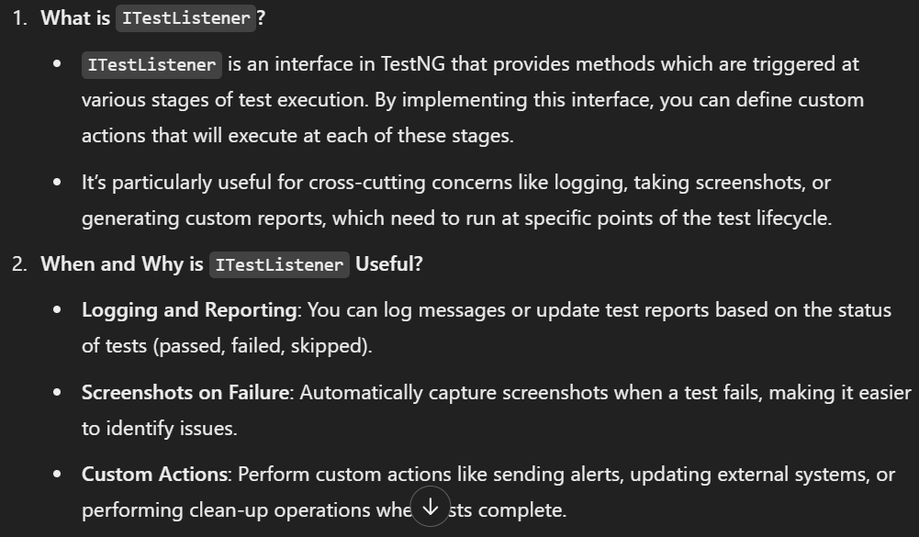

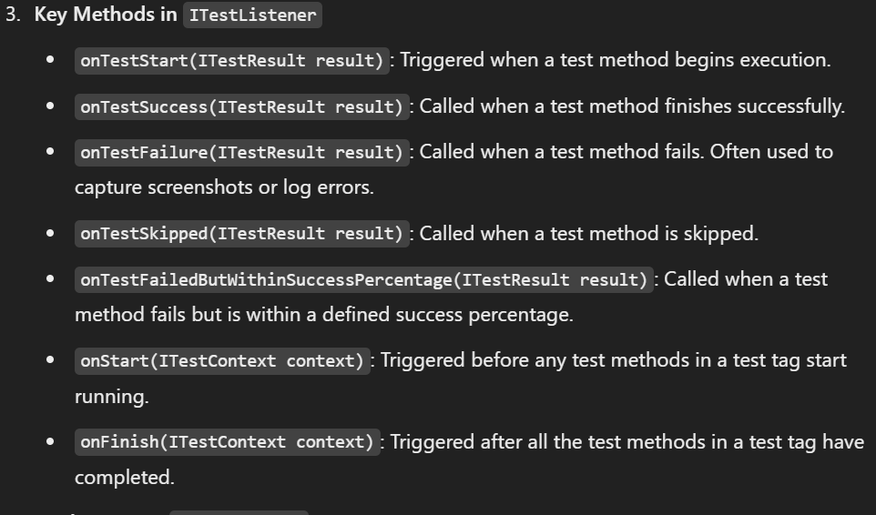

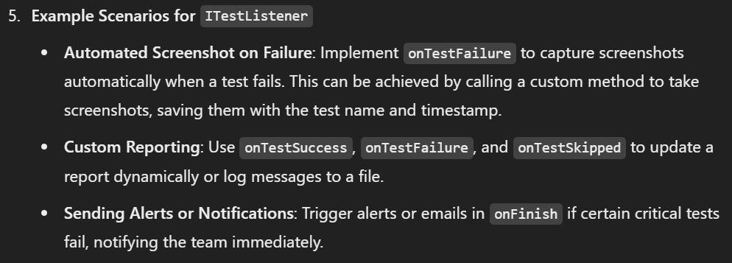

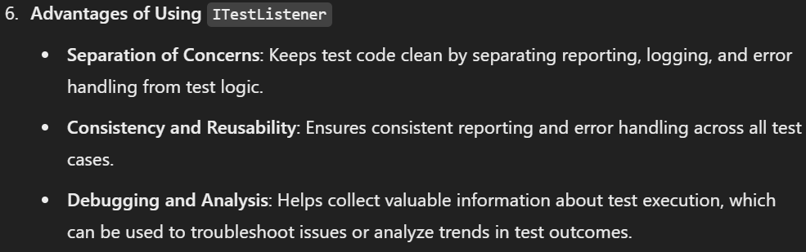

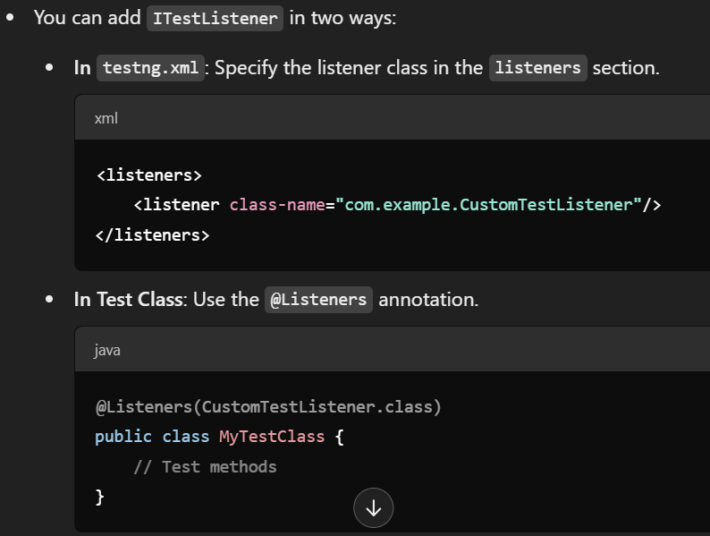

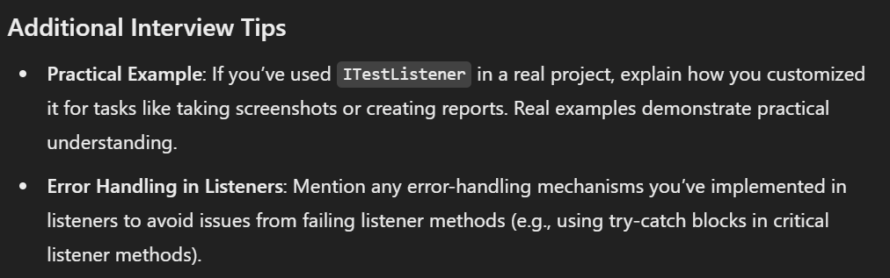

1. How are you achieving Encapsulation in the framework?

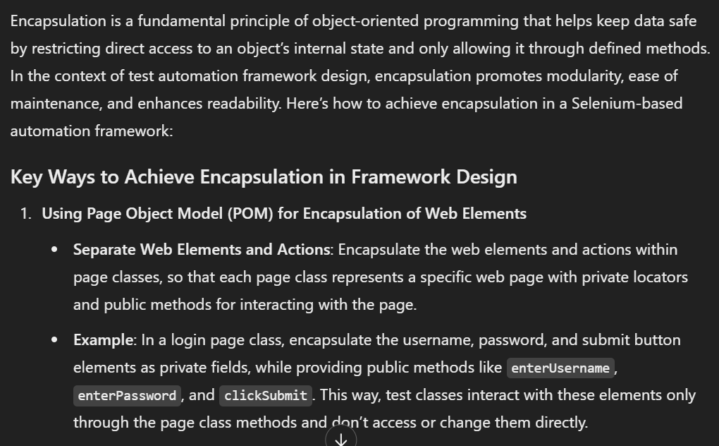

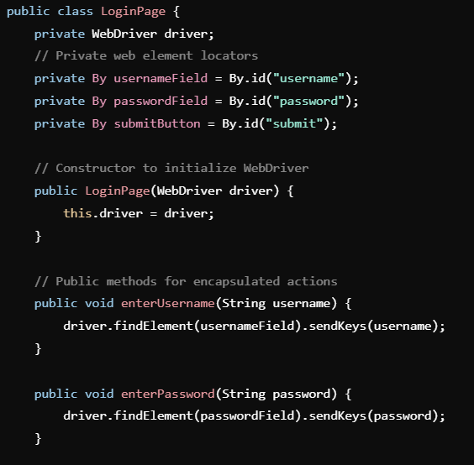

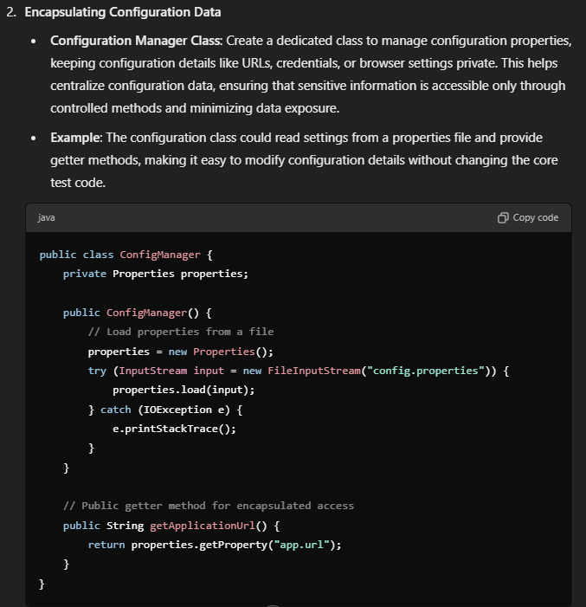

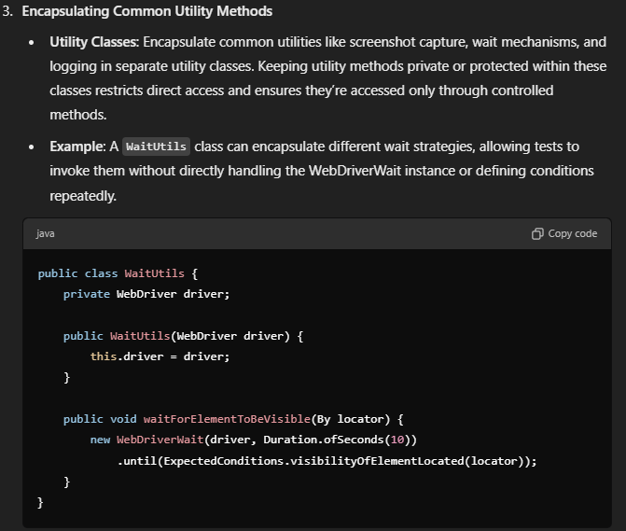

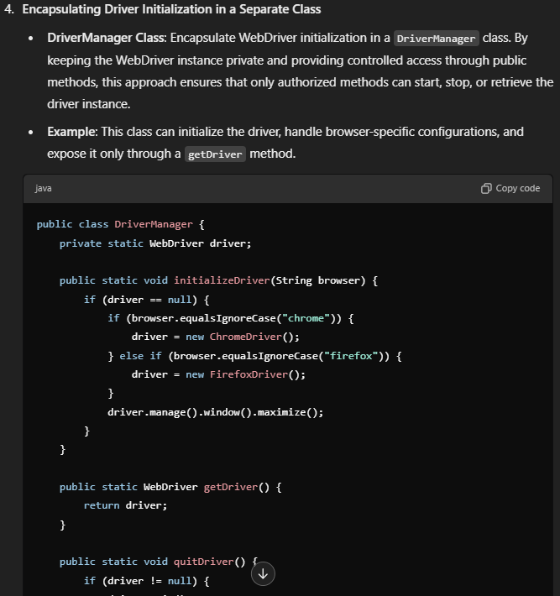

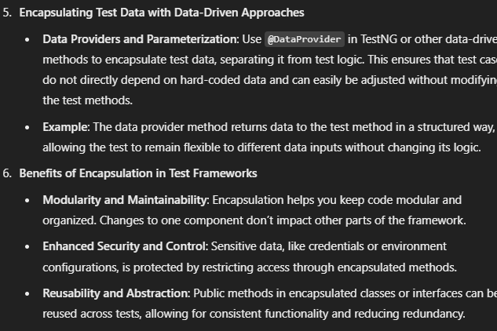

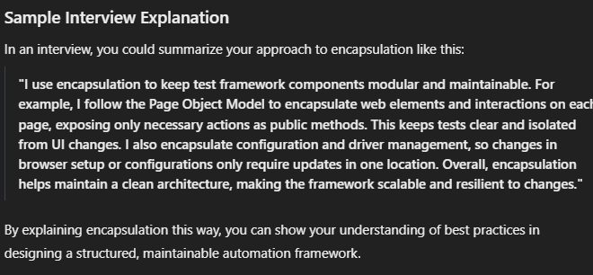

1. How does your Framework support parallel runs? How are you writing Thread safe code?

* In the testNG xml file, we can define parallel tests. In parallel tests, each test run in a separate thread. But in reporting, there can be issues. To solve this issue ThreadLocal is used to give each thread an ID:

xml:

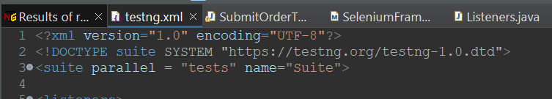

ThreadLocal:

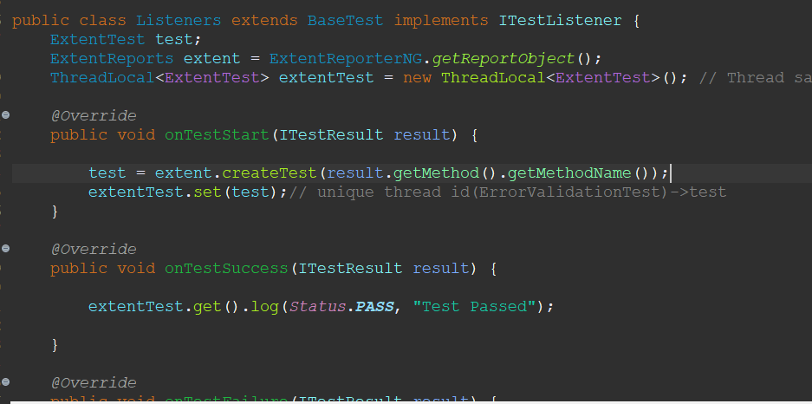

1. Do you have static keywords in the framework? If so, its usage?

* You should not use static keyword for configuration variables like WebDriver object. You can use static keyword in never changing data to decrease disk space usage, but for concurrency issues, static keyword should be carefully used.

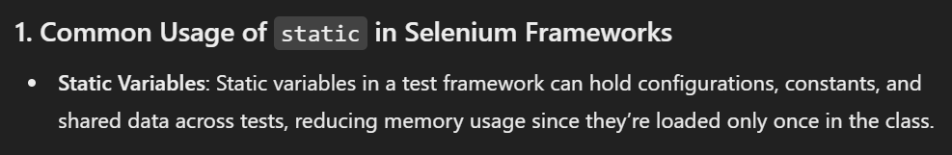

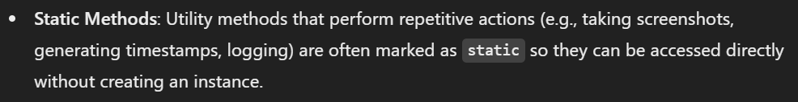

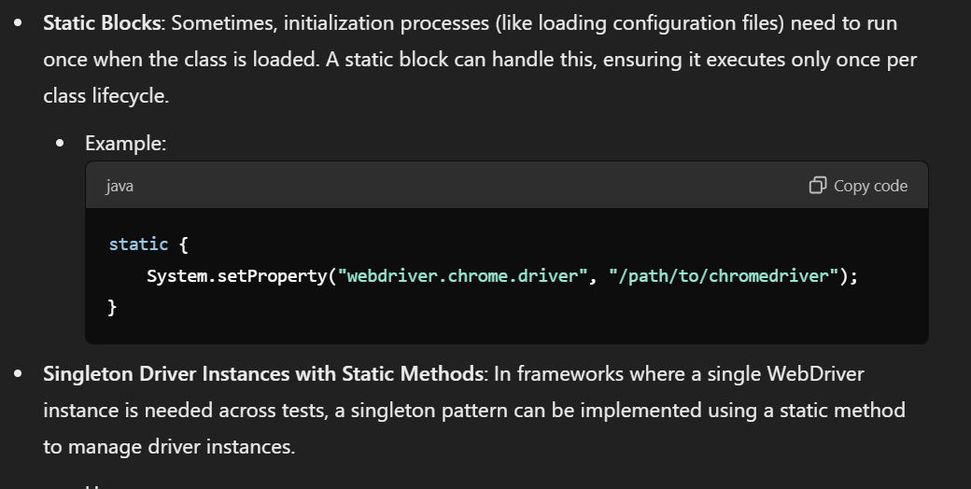

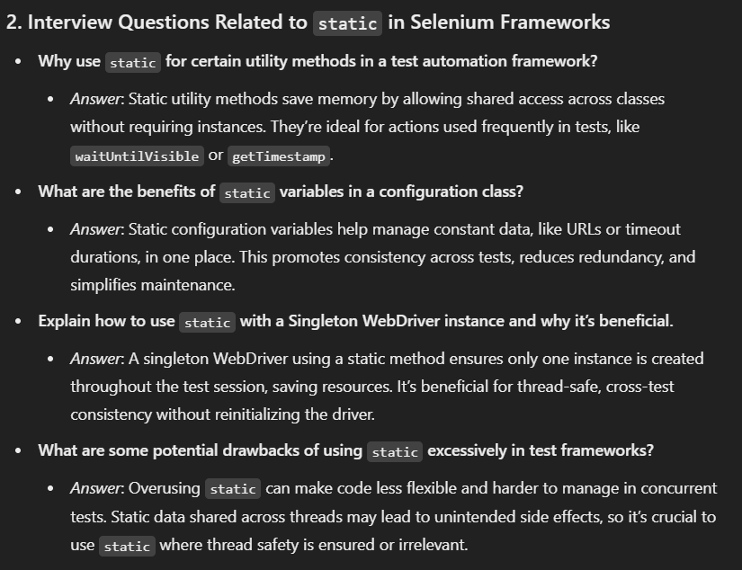

1. How are you sending Global Properties to your test at run time?

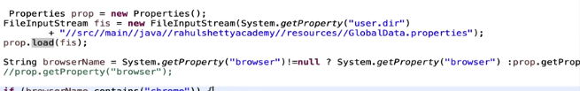

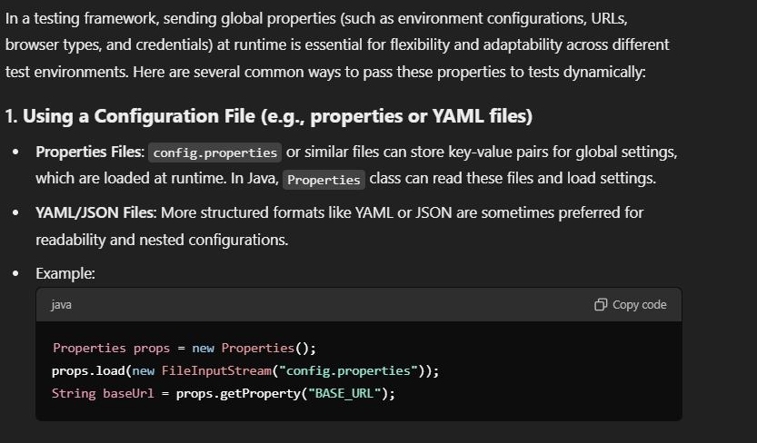

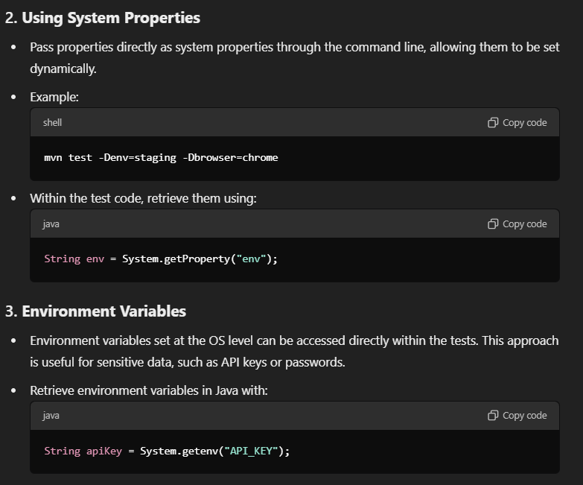

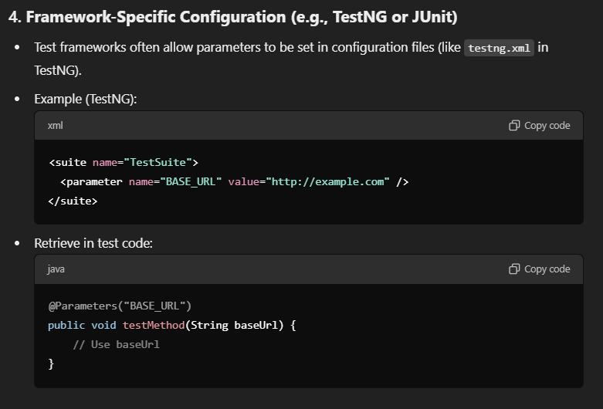

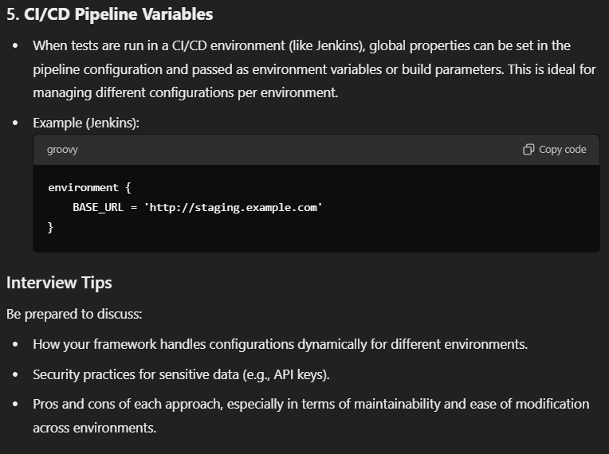

1. What is the mechanism you use to run only selected set of tests inside the framework?

There are 6 different ways for it:

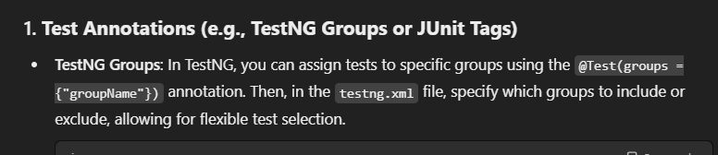

Groups

First, tag the class with the group name:

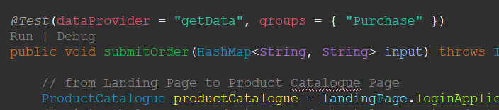

Then in testNG xml file (in your test suite),

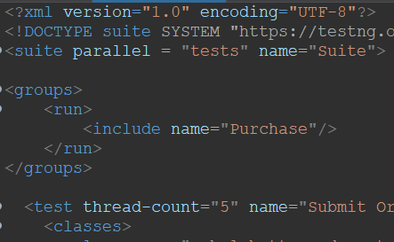

in pom.xml file, you should create the profile for the group:

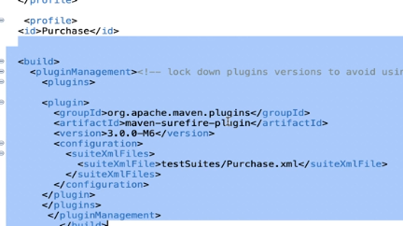

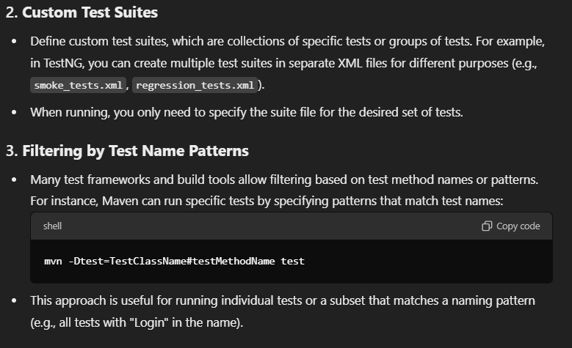

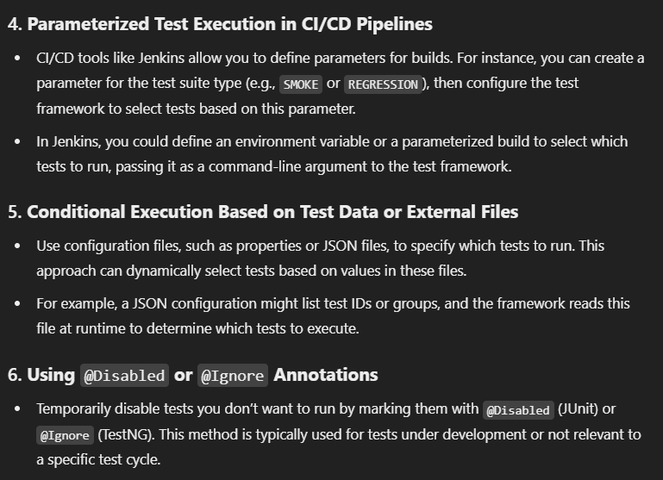

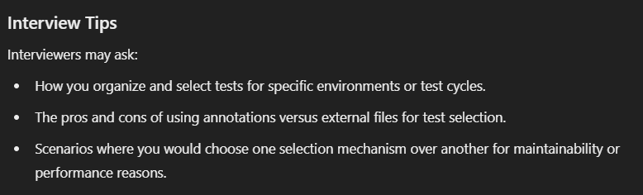

1. How do you handle flaky tests in the Framework?

Using Retry mechanism

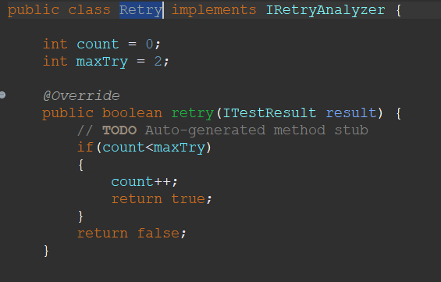

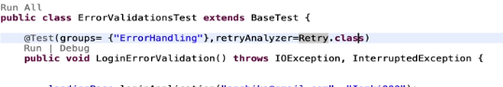

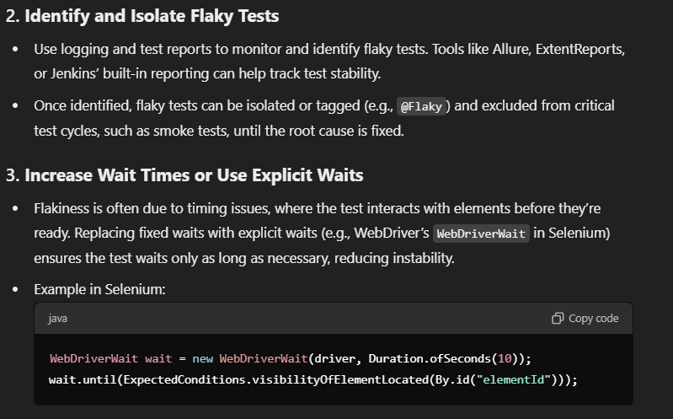

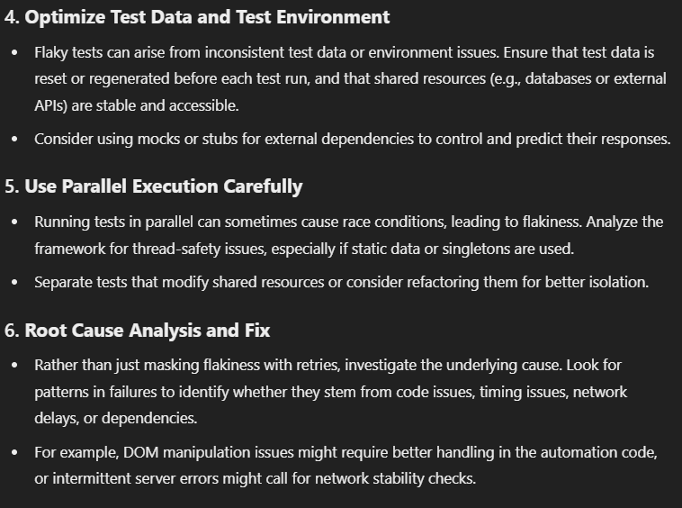

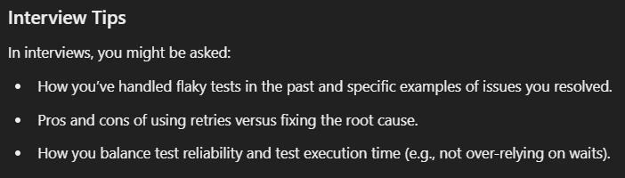

1. Does your Framework take screenshot on test failure? How did you implement it?

Can use a try and catch block. Whole test goes into try block, if code fails, catch block takes the screenshot. But this is not the right way.

Correct way is to use ITestListener’s onTestFailure(ITestResult result) method.

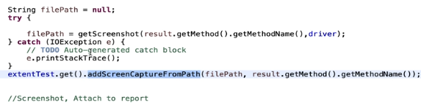

1. Explain Framework Architecture.

This is the whole process...

**OTHER QUESTIONS:**

1. What does Singleton mean in Testing?

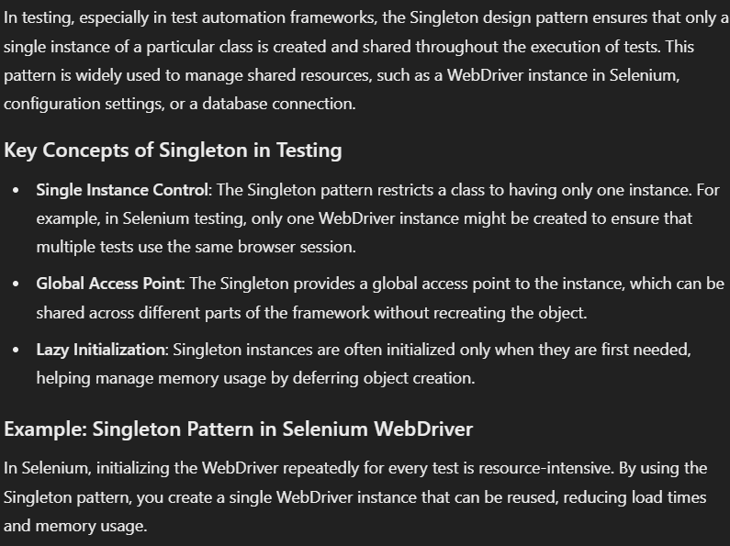

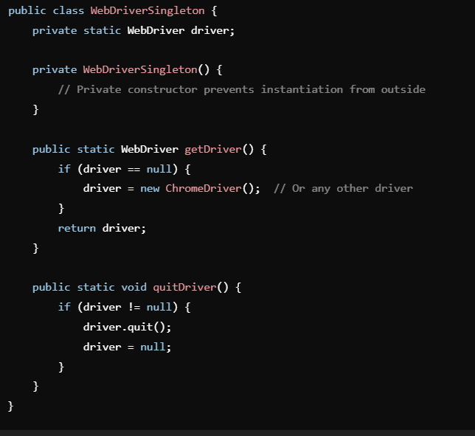

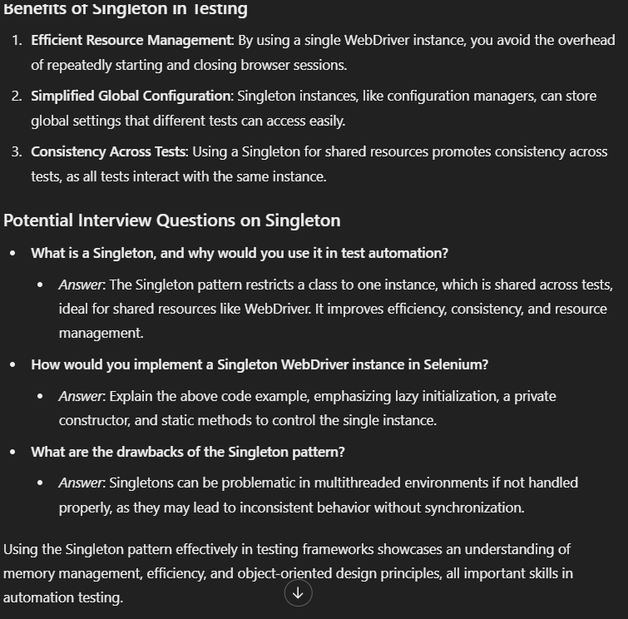

1. TestNG vs Junit?_

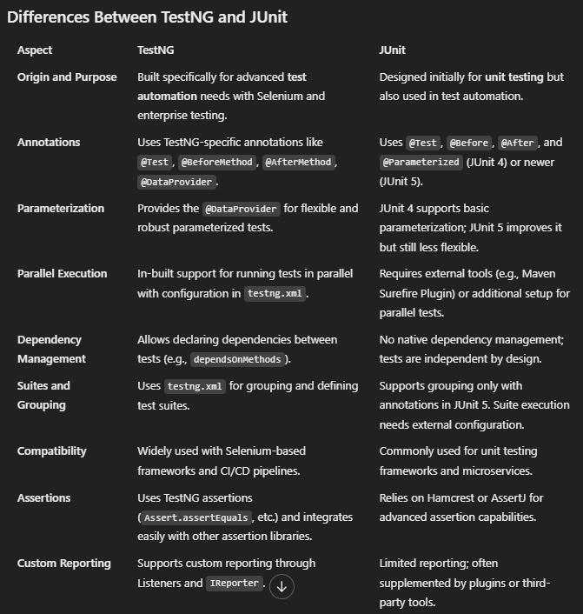

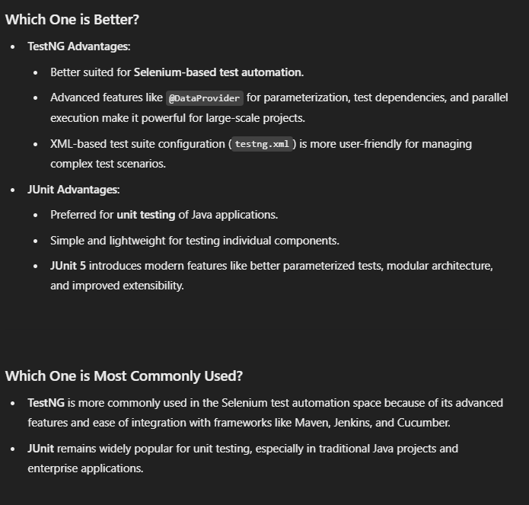

1. What is proxy?

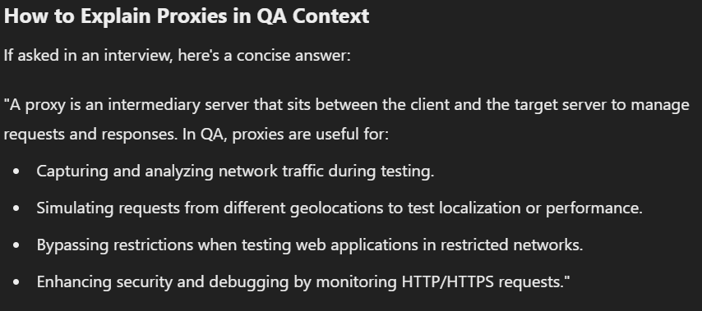

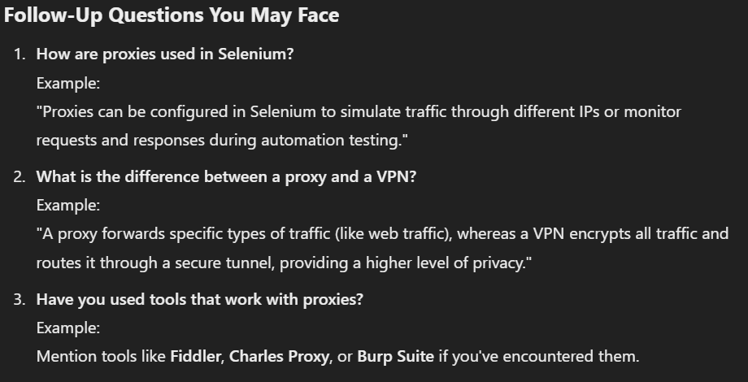

1. adf
2. ads
3. fadsf
4. adsf

# Section 23 – Framework Part 6 – Test Execution from Maven & Integration with Jenkins CI/CD

# Section 23 – Framework Part 6 – Test Execution from Maven & Integration with Jenkins CI/CD

# Section 23 – Framework Part 6 – Test Execution from Maven & Integration with Jenkins CI/CD

## 68. Handling Java Alerts using Selenium Webdriver

dfd

## 68. Handling Java Alerts using Selenium Webdriver

dfd

TODO:

* Chapter06_02 code does not work for some reason. Go and correct it if you can!
  + Line 66 is one problem...
* What does this @test mean?

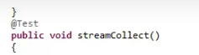

* asd
* f